

Blood Bank Management System

Project Documentaton

Name: Vivek Tamang

College ID: 00175893

College: Softwarica college of it and e-commerce

batch: 23

date: 01/11/2019

2019

**Table of Contents**

**Acknowledgment** 3

**Abstraction** 4

**Chapter 1 Introduction** 5

Introduction to the project 5

System Background 5

Overview of the project 5

Justification 5

Aims and objectives 5

**Chapter 2 Analysis** 6

Introduction 6

Feasibility Study 6

SRS (Software Requirement Specification): 7

Functional requirements: 7

Non-functional requirements: 8

Hardware specification: 9

Use Case Diagram 10

System Architecture 10

**Chapter 3: Design** 13

Structural Modeling 13

Final Class Diagram 13

Data Flow Diagram 13

Behavioral Modeling 14

Activity Diagram 14

Sequence Diagram 16

Data Modelling 19

Data Dictionary 19

ER Diagram 21

UI Modelling 22

Prototyping 22

**Chapter 5 Testing** 26

Blackbox Testing. 26

**Chapter 6 Other Project Issues** 52

Limitation of the project 52

Risk Management 52

Configuration Management 54

**Chapter 7 Future Work** 56

**Conclusion** 57

# **Acknowledgment**

First of all, I would like to thank my college Softwarica College of IT and E-Commerce for providing such a challenging and learning project which can also help me adjusting in the real IT market and also increases my knowledge about various programming language.

Secondly, I would like to keep a deep sense of gratitude and esteem to my tutor Mr. Sudeep Lal Bajimaya who is a respected teacher of this college for his hard work and dedication in helping his students in any sorts of problems faced by them. The timely and academic advice with meaningful logics has helped me to accomplish this task.

In addition to this, I would like to thank my parents and family member for being such a supportive and encouraging person who provided me every bit of requirement that was required to complete the project.

At Last, I would like to refer to all of the individuals that has helped me in solving any sorts of difficulties and supported me in finishing the project.

Name: Vivek Tamang

NCC ID: 00175893

Kathmandu Nepal

# **Abstraction**

**Blood Bank Management System** is a web application which provide the platform for the blood donor and the blood needy people to get the blood type need. The main aim of the project is to build a blood bank management system that manage the data and information of the blood bank so that the users could store, edit, retrieve and view data and information easily.The blood bank management system provides an integrated set of features to manage the data and information about the donors and events of blood donation**.**

In that way, I have allowed the particular assignment to fulfil the project. To develop a project, I have used MySQL for database and Laravel framework. Use the valid WBS to breakdown the phases into sub phrases, so that the context can be better understood and seen. Appropriate and sensitive time assessment in order to give me a better view of when to complete the task. To monitor my project, I have used the suitable Gantt outline. The frame configuration is examined and monitored with the objective that the frame works as it should. In this way, I have completed my project with certain limitation.

# **Chapter 1 Introduction**

## Introduction to the project

Blood Bank Management system is a platform where a needy can get donor information any time. Also it helps to manage the data and information about the donors and events of blood donation.

## System Background

There were all only paper based works on for the Blood bank management system. All the data and information’s of donor and receivers and local events are only registered on registers.

## Overview of the project

The Blood Bank Management System going to be developed has admin login for the management of the page. Anyone can add them as donor if they are interested to donate and needy can search donor as per the required blood group. It show the graphical reports on available donor according to the blood groups and so on.

## Justification

The project being developed is very useful. It is because:

* Needy can find required blood group donor easily.
* It has very user friendly environment.
* Donors can register themselves.
* Shows reports on blood group and donors

## Aims and objectives

The main aim of the project is to build a blood bank management system that manage the data and information of the blood bank so that the users could store, edit, retrieve and view data and information easily.

And the objectives are:

* Better HCI
* Efficiency
* Secure user login for admin
* Reduce corruption
* The system prevents blood issue if cross-match is not done or fails

# **Chapter 2 Analysis**

## Introduction

The term Analysis in software development means the process to inspect of data and documentation in detail to understand the system for providing basis to solve problem. In this phase, first step is to gather the necessary requirements for the system, which is the foundation for the proposed project. For the analysis phase, various diagrams are used such as use case diagram and class diagram to visualize the gathered requirements. This process of visualizing the requirements is known as system modelling.

## Feasibility Study

Feasibility study is performed to determine whether the solution considered to accomplish the requirements is practical and workable in the software.

Technical feasibility

It deals with technical resource of the project such as type of technology is used to develop project, process or technique.

Economic feasibility

It deals with the budget require for the development of the project.

Operational feasibility

It is use to identify the importance of certain problem and how to solve. It takes action accordingly to track that problem.

Legal Feasibility

It helps to know the country constitution provide permission to create such website or not.  By the help of that software, it tracks personal detail or not.

Time

When client provides software to build, the time is firstly fixed. It is our major concern to finish the development of the software in time. If due to some difficulties, project will not be able to finish in time, the developer team has to pay fine to client based on agreement. Therefore, the company major concern is to make proper plan and develop the software in time.

Social

Social factor is also matter to concern while creating software. Does it affect people directly/indirectly or not? While creating the project it also focuses that how does it affect a particular community, races, and castes?

Therefore, proper analysis is done when the developer is creating project and client must focus on that parts.

## SRS (Software Requirement Specification):

Software Requirement Specification also known as requirements document is a detailed description of a software system to be developed with its functional and non-functional requirements. It is an agreement between customer and contractor. This may include the use cases of how the user is going to interact with software system. A good SRS defines how software system will interact with all internal modules, hardware, and communication with other program and human interaction with wide range of real-life scenarios.

### Functional requirements:

|  |  |  |  |  |
| --- | --- | --- | --- | --- |
| ID | Title | Description | Rational | Dependency |
| FR01 | Registration | If new to the system the user can create a new account with this function | To create a new personal account. | N/A |
| FR02 | Login | The user can login to the system with their username and password. | To login to their account. | FR01 |
| FR03 | Logout | With this function a user can logout of their account after login. | To logout of their account. | FR02 |
| FR04 | Edit profile | After logging in the user can edit any personal information. And admin can edit all information. | To edit information on their account. | FR02 |
| FR05 | Search | Search donors | Search donor with their name. |  |
| FR06 | Delete | Users or admin can delete any information or even their own account in the system with this function. | To delete information and account in the system. | FR02 |
| FR07 | Request Blood | This function allows users to request the blood needed. | Request for the blood needed |  |
| FR08 | View Requests | This function allows donor to view the list of requested blood. | View list from the database. | FR07 |
| FR09 | View Donor Details | This function allows users to view list of donors with contact and blood group. | View list from the database. |  |

### Non-functional requirements:

a) **Performance**: here the system must have a good response time, throughput, utilization etc. These are the things that determine the performance of the system, in order to run the software smoothly a good performance of the system is very crucial.

b) **Usability**: the software cannot be fully useable if It isn’t user friendly. This means the software must make users feel comfortable and be simple and easy to use.

c) **Reliability**: users have to trust the system, even after using it for a long time. In other words, the users must be able to rely on the software for a long time.

d) **Security**: the software must be able to provide high security along with providing the services, as it is suppose to the users. Example a secure system can be gained by the authorization and authentication during login.

e) **Supportability**: the software/ website should support in all kind of devices or screen size of the users. I.e. the website must be responsive or supportable in all kind of screen resolution.

f) **Availability**: the system should be available whenever the user wants to user it. The system must be able to run in every platform as well.

2.4.3 MOSCOW prioritization:

I have down the **MoSCoW prioritization** for all the functional requirements that I have listed above. The definition of MoSCoW gives more insight to the importance and priority of the requirements. The full form and description of MoSCoW:

**Must Have**: must have means that the function is guaranteed to be in the software.

**Should Have**: this means that the function/ requirement is important but is not vital.

**Could Have**: this means that the requirement is decided to be in the system but is not much important even if it’s not delivered.

|  |  |  |  |  |
| --- | --- | --- | --- | --- |
| ID | Requirement | MOSCOW | Rational | Remarks |
| M01 | Registration | Must have | To create a new personal account. |  |
| M02 | Login | Must have | To login to their account. |  |
| M03 | Logout | Must have | To logout of their account. |  |
| M04 | User role check | Could have | To check their role in the organization. |  |
| M05 | Edit profile | Could have | To edit information on their account. |  |
| M06 | Search | Must have | Can search donors. |  |
| M07 | Delete | Could have | To delete information and account in the system. |  |
| M08 | Request Blood | Must Have | Request Blood needed. |  |
| M09 | View Requests | Must Have | To view the requested blood by donor. |  |
| M10 | View Donor Details | Must Have | To view the list of donors with contact information. |  |

### Hardware specification:

Employee management system or EMS should be able to work on a computer with the following minimum hardware specifications:

OS: Windows XP/Vista/7/8 and Linux

CPU: Pentium III (700MHz) and above

Memory: 128 MB and above

Capacity: 4GB of hard drive

Others: Network interface card, mouse, keyboard, and monitor

2.4.5 Software specification:

Since the Blood Bank management system is a web-based application, there must be internet connection.

## Use Case Diagram

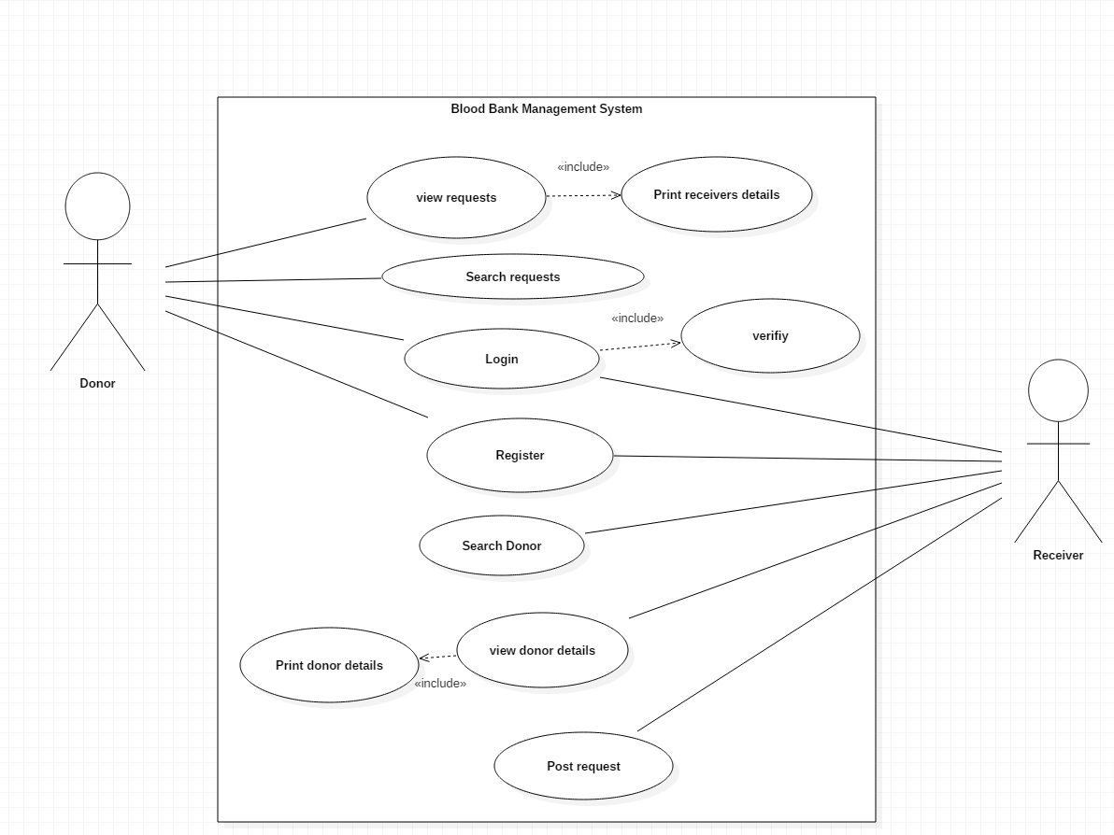

## System Architecture

System Architecture

This system used the three tier-architecture. 3-tier application is described as the software architecture that contains the three major logical computing. This architecture is very flexible and provides many benefits in the developmental environments because of the independent relationship between all three tiers. For example, the user interface can be changed without affecting the functional and data access logic.

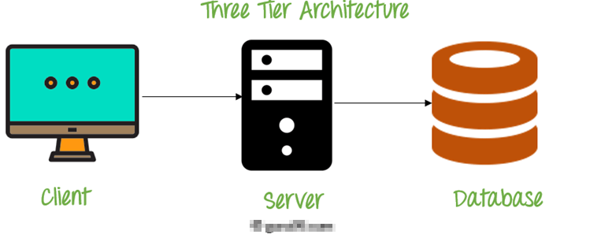

**Client** **Tier**: The presentation layer is the front-end layer in the system architecture. This contains the User Interface (UI). This is the graphical view that can be accessed with web browser or web-based application, which displays the contents, that interacts with the user.

This tier is mostly written in web technology like HTML, JavaScript, CSS, or web frameworks.

**Server Tier**: This layer contains all the functional and business logic that helps to run the system. This tier is developed using core programming languages such as Java, .Net, C++, and many more.

**Data Tier**: This tier comprises of database. This tier is responsible for managing all the data and make them accessible whenever required by the system. MySQL, Oracle and many other databases are some of the example of this tier. (Anonymous, 2019)

Design Pattern

Design pattern is widely used by the software developer as a way of solving the problem that occurred during the development phase. There are many design patterns and they are categorized according to their behavior.

Bike Showroom Management System uses MVC pattern. Since the system is web-based application and uses 3-tier architecture, this pattern will help a lot in characterizing between the components used in the system. MVC stands for **M**odel **V**iew **C**ontroller. These three components communicate with each other to give fully functional application. This pattern is very loosely coupled and reliable to use.

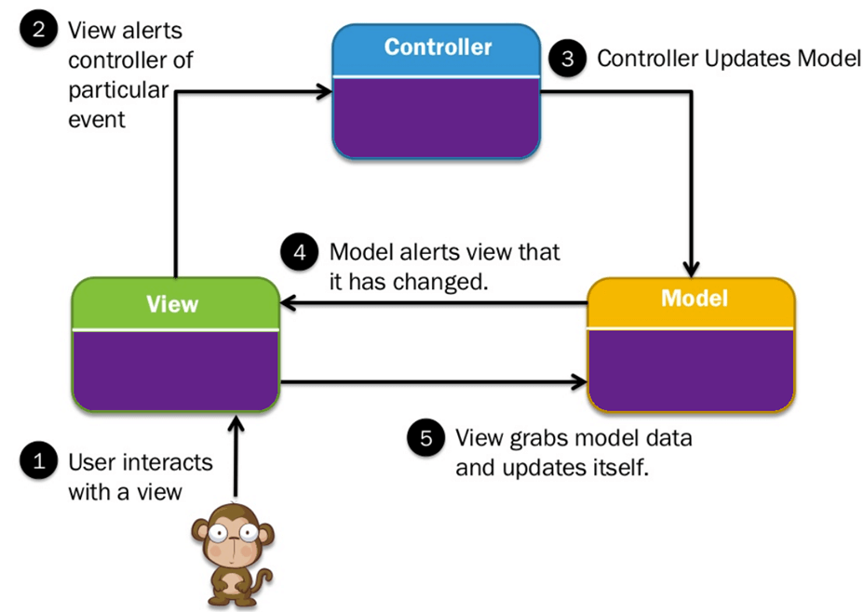

**Model:**  It contains pure application data that does not concern UI or presentation. It has the main business logic.

**View:** View represents the graphical components of the system which user sees.

**Controller:**  This act both as model and as view. It controls the flow of data into the model and updates the view as per the logic. View is updated when model changes and model is updated with user view manipulation.

# **Chapter 3: Design**

Design is the process of defining software methods, functions, objects, and the overall structure and interaction of your code so that the resulting functionality will satisfy user requirements.

## Structural Modeling

### Final Class Diagram

A class diagram in the [Unified Modeling Language (UML)](https://en.wikipedia.org/wiki/Unified_Modeling_Language) is **a type of static structure diagram** that describes the structure of a system by showing the system's classes, their attributes, operations (or methods), and the relationships among objects.

**Justification:**

1. It can be easily understand by programmers.
2. Base for component and deployment diagrams.
3. It gives the detail insight into the structure of the systems.

**Notation Used:**

|  |  |  |  |
| --- | --- | --- | --- |
| Syntax | Construct | Explanation | Remarks |
|  | Class | A description of a set of objects that possesses some attributes, operations, methods, relationships etc. |  |
|  | Association | Used to represent the relationship between classes that possesses connections among their instances. |  |
|  | Aggregation | Association of special nature where objects are assembled creating more complex object. |  |

### Data Flow Diagram

Data flow diagrams are used to graphically represent the flow of data in a business information system. DFD describes the processes that are involved in a system to transfer data from the input to the file storage and reports generation.

Justification:

1. Logical information flow of the system
2. Determination of physical system construction requirements
3. Simplicity of notation

## Behavioral Modeling

### Activity Diagram

Activity diagram is essentially an advanced version of flow chart that modeling the flow from one activity to another activity. Activity diagram in [UML](https://en.wikipedia.org/wiki/Unified_Modeling_Language) diagram is to describe dynamic aspects of the system.

**Justification:**

1. Identify candidate use cases, through the examination of business workflows
2. Model workflows between/within use cases.
3. Model complex workflows in operations on objects.
4. Model in detail complex activities in a high level activity Diagram.

**Notation Used:**

|  |  |  |
| --- | --- | --- |
| Notation | Name | Reason |
|  | Start | It shows the starting point of the workflow. |
|  | Action | It represents the action of the object. |
|  | Control flow | It represents the transitions of one action state to another one. |
|  | Decision | It represent a decisions with alternate paths which is represented by diamond shape. |
|  | End | It shows the end of the workflow. |
|  | Fork | Splits the behavior into a set of parallel or concurrent flows of activities. |
|  | Join | Bring back together a set of parallel or concurrent flow of activities. |

**Activity Diagram:**

**For user:**

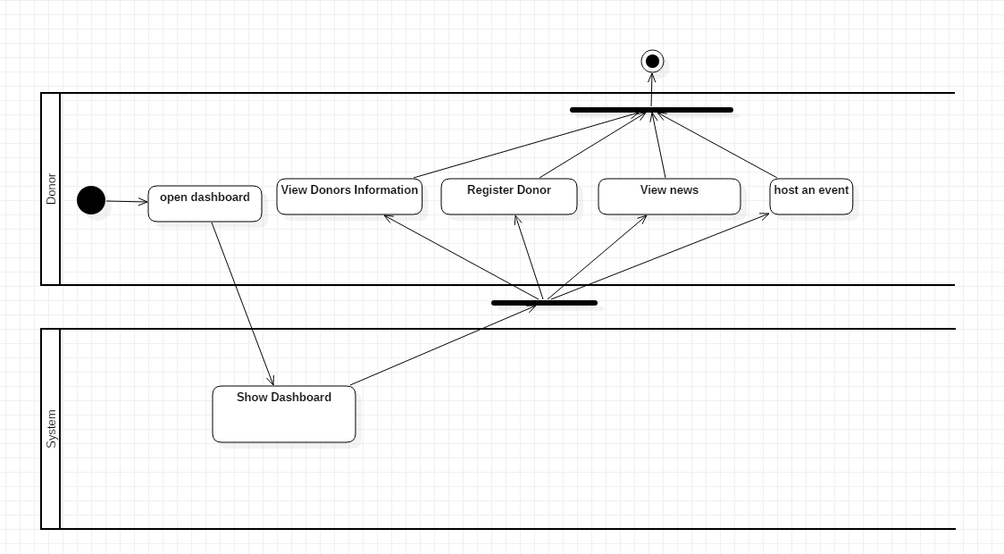

In the above diagram, User first login to the system. System show the dashboard only when the credentials provided by the system is correct otherwise it return to login page. When user is logged in, he can check inbox and reply if there is any message, they can post request, view requests and view donors etc. As they view donor and receiver they can select the receivers and donors and get contact and send the message to receivers and donors automatically by system when selected.

**For Admin:**

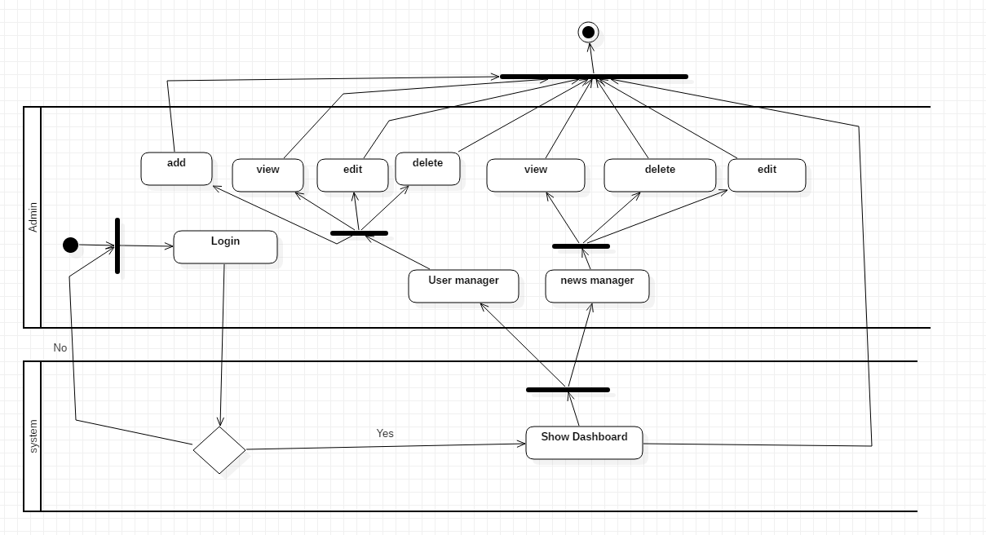

From the above activity diagram for admin, it is clear that admin has login system as we have for the users. Admins can perform CRUD function on all users details and web contents.

### Sequence Diagram

Sequence Diagrams in UML are interaction diagrams that detail how operations are carried out. They capture the interaction between objects in the context of a collaboration. Sequence Diagrams are time focus and they show the order of the interaction visually by using the vertical axis of the diagram to represent time what messages are sent and when.

**Justification:**

1. Model high-level interaction between active objects in a system
2. Logic associated with the function or method is modeled.

Notation used:

|  |  |  |
| --- | --- | --- |
| **Notations** | **Name** | **Notation Description** |
|  | Lifeline | A lifeline represents an individual participant in the Interaction. |
|  | Call Message | Message that represents an invocation of operation of target lifeline. |
|  | Return message | Message that represents the pass of information back to the caller of a corresponded former message. |
|  | Self-message | It shows the invocation of message of the same lifeline. |

Diagram:

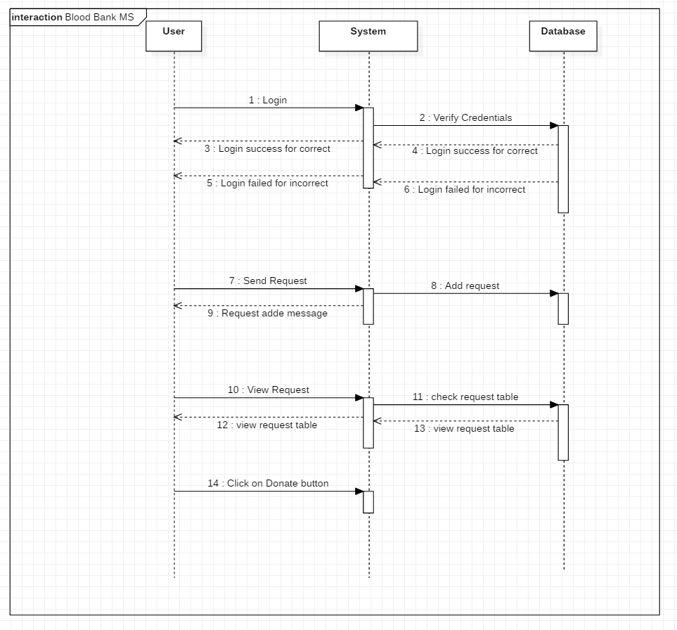

From the above diagram, it is clear that when user login, they can enter into their accounts only if the credential provide are correct otherwise they cannot. When user send request by filling the form then the system add a request in a request table in database. Users send message to view the requests, system checks in database and respond as database responded and displays the requested table. When user click the button on the request table the status of the request is changed.

## Data Modelling

### Data Dictionary

Donate Table

|  |  |  |  |  |
| --- | --- | --- | --- | --- |
| **Column Name** | **Type** | **Length** | **Nullable** | **Key** |
| id | Integer | 10 | Not Null | Primary Key |
| dob | date |  | Not Null |  |
| Email | Varchar | 30 | Not Null |  |
| First_name | Varchar | 50 | Not Null |  |
| Last_name | Varchar | 30 | Not Null |  |
| Phone | Varchar | 250 | Not Null |  |
| Occupation | Varchar | 50 | Null |  |
| Provience | Varchar | 200 | Not Null |  |
| Gender | Varchar | 255 | Not Null |  |
| Blood_type | Varchar | 40 | Not Null |  |
| Zip_code | Varchar | 255 | Not Null |  |
| Allergies | Varchar | 255 | Null |  |
| Disease | Varchar | 255 | Not null |  |
| Donate before | Varchar | 255 | Not null |  |
| Medication | Varchar | 255 | Not null |  |
| City | Varchar | 255 | Not null |  |
| Created_at | Date |  | Not null |  |
| Updated_at | date |  | Not null |  |

Table Host

|  |  |  |  |  |
| --- | --- | --- | --- | --- |
| **Column Name** | **Type** | **Length** | **Nullable** | **Key** |
| id | Integer | 10 | Not Null | Primary Key |
| Org | Varchar | 255 | Not Null |  |
| Title | Varchar | 255 | Not Null |  |
| Email | Varchar | 30 | Not Null |  |
| Time | Varchar | 30 | Not Null |  |
| Dob | Varchar | 50 | Not Null |  |
| Phone | Varchar | 30 | Not Null |  |
| City | Varchar | 50 | Null |  |
| Provience | Varchar | 250 | Not Null |  |
| Zip_code | Varchar | 250 | Not Null |  |
| Description | Varchar | 250 | Not Null |  |
| Created_at | Date |  | Not null |  |
| Updated_at | Date |  | Not null |  |

Table Services

|  |  |  |  |  |
| --- | --- | --- | --- | --- |
| **Column Name** | **Type** | **Length** | **Nullable** | **Key** |
| id | Integer | 10 | Not Null | Primary Key |
| Title | Varchar | 250 | Not Null |  |
| Long_des | Varchar | 250 | Not Null |  |
| status | Varchar | 30 | Not Null |  |
| Created_at | Date |  | Not null |  |
| Updated_at | Date |  | Not null |  |
| Date | Date |  | Not null |  |
| Time | Varchar | 255 | Not null |  |

Table news

|  |  |  |  |  |
| --- | --- | --- | --- | --- |
| **Column Name** | **Type** | **Length** | **Nullable** | **Key** |
| Id | Integer | 10 | Not Null | Primary Key |
| Created at | Date |  | Not Null |  |
| Updated at | Date |  | Not Null |  |
| Title | Varchar | 250 | Not Null |  |
| Slug | Varchar | 250 | Not Null |  |
| Image | Varchar | 250 | Not Null |  |
| Writer | Varchar | 250 | Null |  |
| Short_des | Varchar | 250 | Not Null |  |
| List | Varchar | 250 | Not Null |  |
| Sub_heading | Varchar | 250 | Not null |  |
| About_title | Varchar | 250 | Not Null |  |
| About_des | Varchar | 250 | Not null |  |
| Publish_date | Date |  | Not null |  |
| Status | Varchar | 250 | Not null |  |

Table Users

|  |  |  |  |  |
| --- | --- | --- | --- | --- |
| **Column Name** | **Type** | **Length** | **Nullable** | **Key** |
| Id | Integer | 10 | Not Null | Primary Key |
| Username | Varchar | 255 | Not Null |  |
| Email | Varchar | 255 | Not Null |  |
| Email_verified_at | Varchar | 255 | Not Null |  |
| Password | Varchar | 255 | Not Null |  |
| Full_name | Varchar | 255 | Not Null |  |
| Contact_no | Varchar | 255 | Not Null |  |
| Address | Varchar | 255 | Not null |  |
| Gender | Varchar | 30 | Not Null |  |
| Remember_token | Varchar | 255 | Null |  |
| Created at | Date | 255 | Not Null |  |
| Updated_at | Date | 255 | Not null |  |
| Status | Varchar | 255 | Not null |  |

### ER Diagram

An entity relationship diagram (ERD) shows the relationships of entity sets stored in a database. An entity in this context is an object, a component of data. An entity set is a collection of similar entities. These entities can have attributes that define its properties. An entity relationship diagram (ERD) shows the relationships of entity sets stored in a database. An entity in this context is an object, a component of data. An entity set is a collection of similar entities. These entities can have attributes that define its properties. ER diagrams are used to sketch out the design of a database.

## UI Modelling

### Prototyping

Home Page

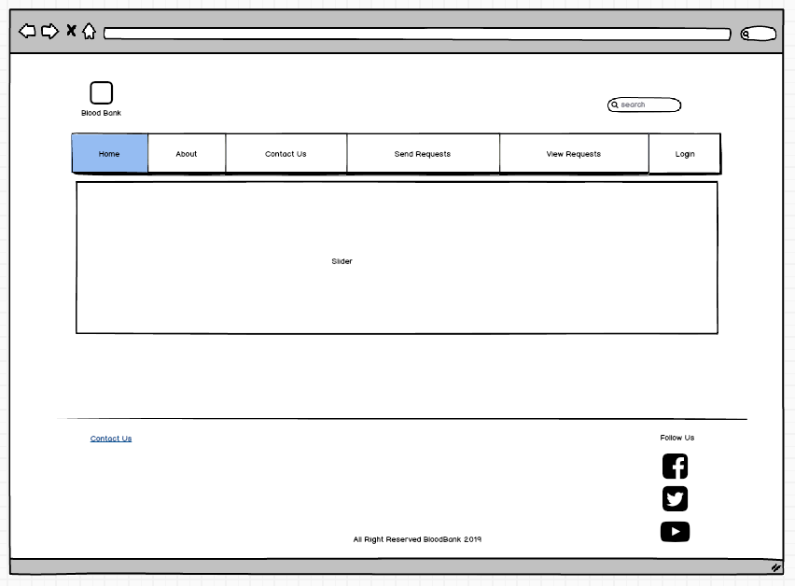

Login Form

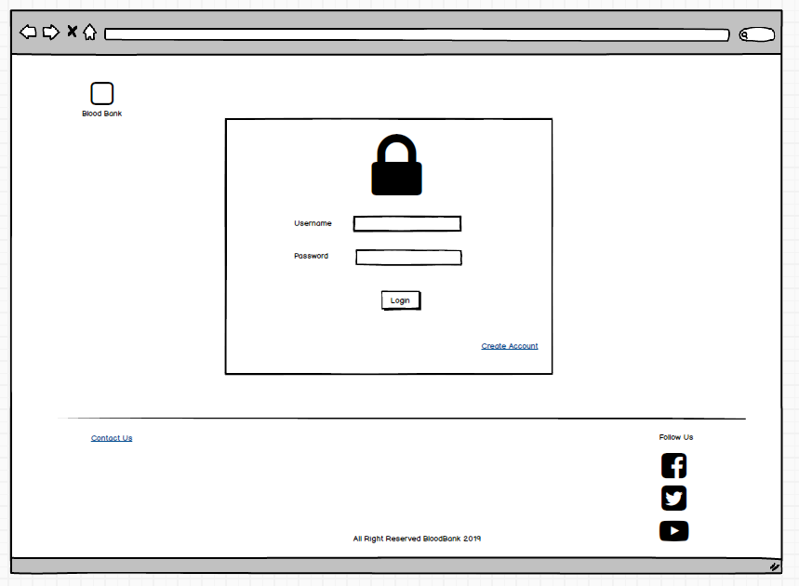

Register

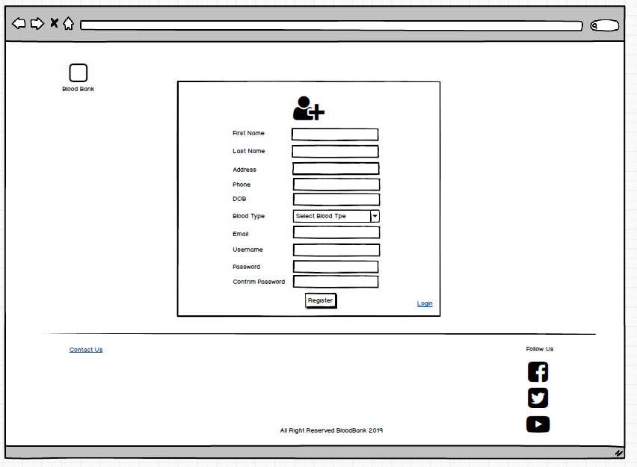

View Requests

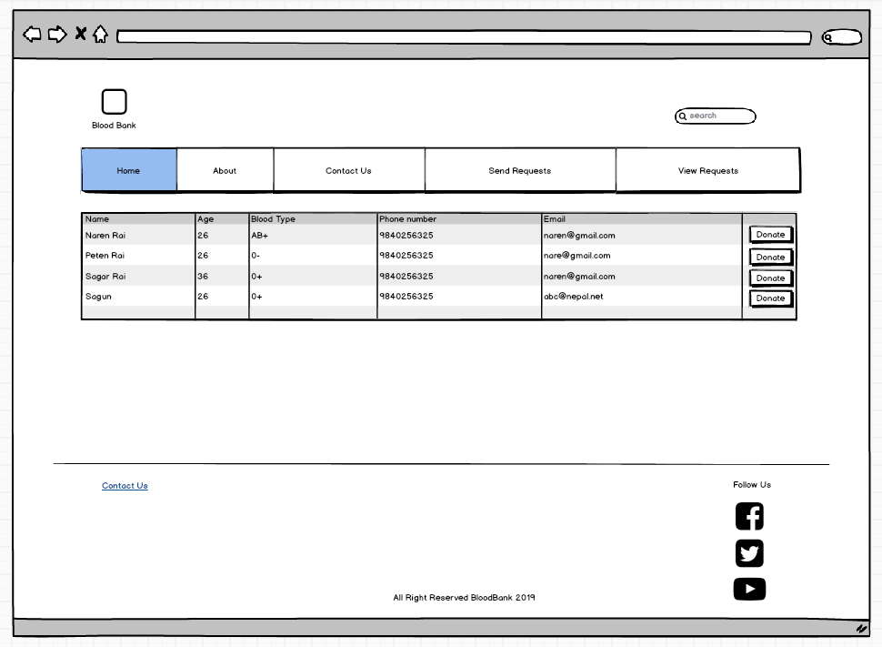

# **Chapter 5 Testing**

## Blackbox Testing.

Test Case name: Test Admin Login

Module name: Admin Login

Created by: Vivek Tamang

Date of Creation: 30/09/2019

|  |  |  |  |  |  |  |
| --- | --- | --- | --- | --- | --- | --- |
| Test case id | Test scenario | Test description | Test data | Expected | Actual | Status |
| Admin_Login_01 | Admin Login | Enter the admin email and password to login to admin panel. | Email: root@session.dev  Password: root | Open dashboard. | As expected | pass |

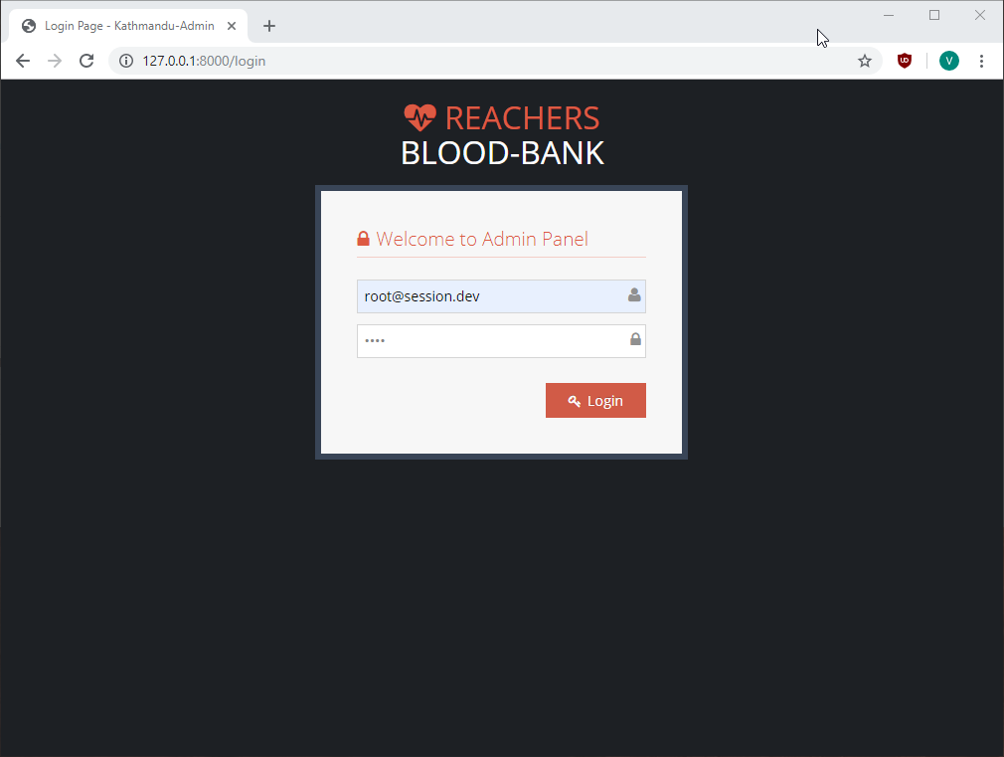

Figure 1: Login Page

Test Case name: Test User Manger in Admin Pannel

Module name: User Manger

Created by: Vivek Tamang

Date of Creation: 30/09/2019

|  |  |  |  |  |  |  |
| --- | --- | --- | --- | --- | --- | --- |
| Test case id | Test scenario | Test description | Test data | Expected | Actual | Status |
| User_Manager_01 | User Manger in Admin Panel | Click on “List” of user manager to view users (Admins) |  | List of users appear. | As expected | pass |
| User_Manager_02 | User Manger in Admin Panel | Click delete button |  | Delete user | As expected | Pass |
| User_Manager_03 | User  Manger in Admin Panel | Update User information |  | User information updated | As expected | Pass |
| User_Manager_04 | User Manger in Admin Panel | Add user | Username: Chris  Full Name: Chris Tomlin  Contact number: 9845632148  Email: [chris012@hotmail.com](mailto:chris012@hotmail.com)  Password Field: root  Address: Berlin  Gender: Female  Status: Active. | User Added | As expected | Pass |

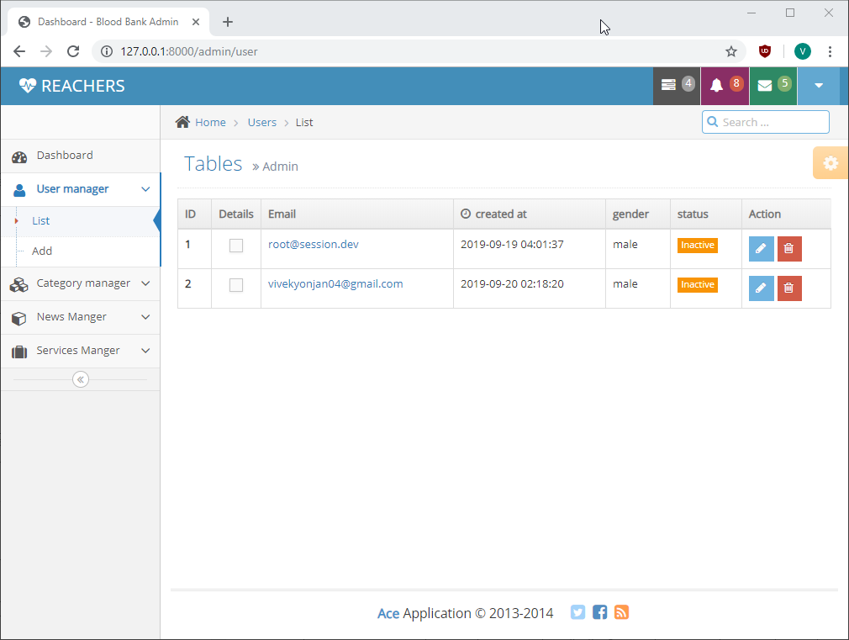

Figure 2: View user list

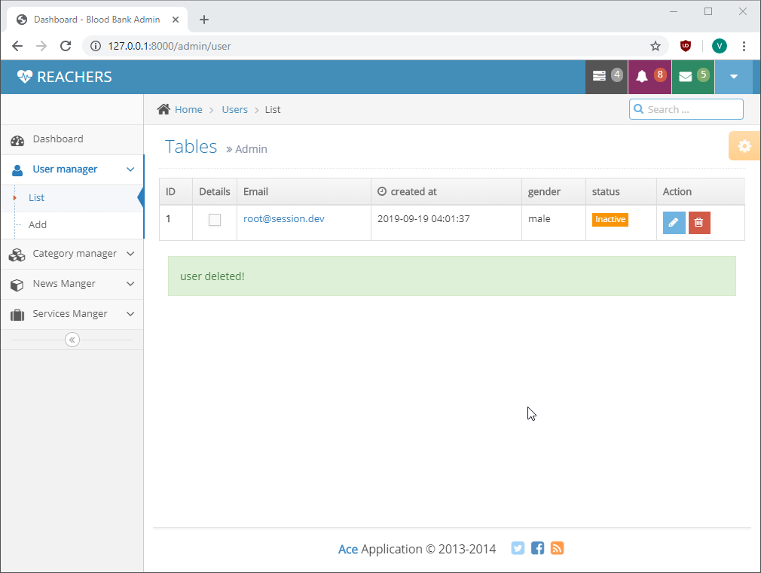

Figure 3: User deleted

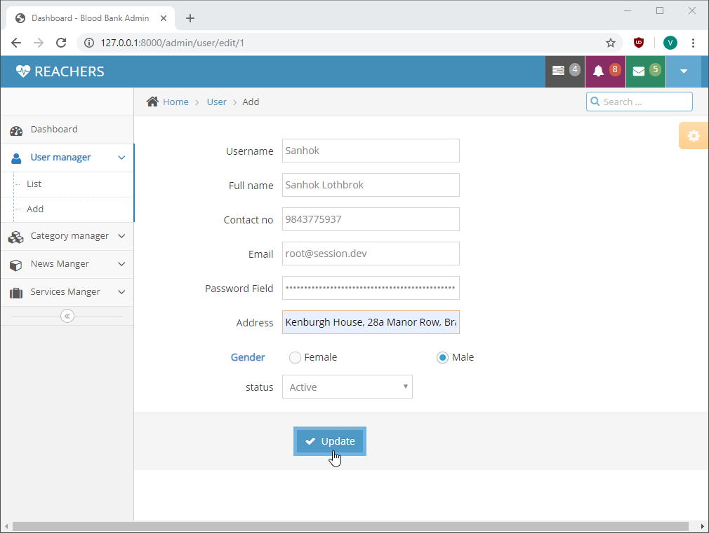

Figure 4: Update User

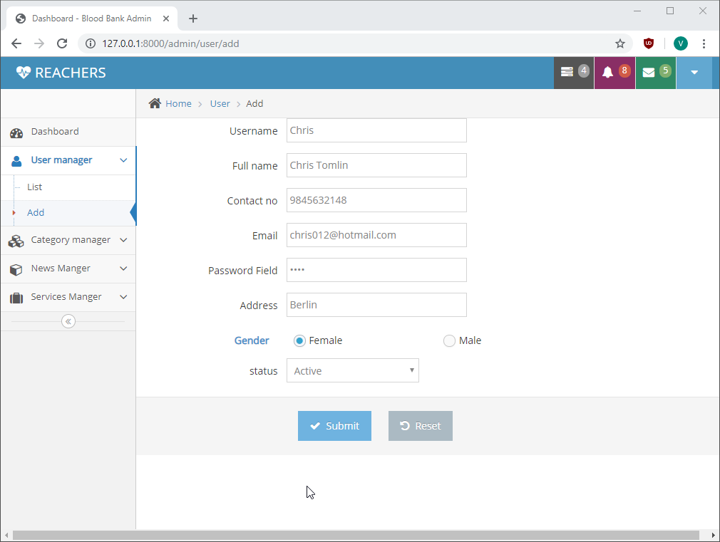

Figure 5: Add User

Test Case name: Test Service Manager

Module name: Service Manager

Created by: Vivek Tamang

Date of Creation: 30/09/2019

|  |  |  |  |  |  |  |
| --- | --- | --- | --- | --- | --- | --- |
| Test case id | Test scenario | Test description | Test data | Expected | Actual | Status |
| Service_Manager_01 | Service Manager in Admin Panel | Click on “Delete” button of Donor’s Information | First Name: Vivek  Last Name: Tamang  Email: [vivekyonjan04@gmial.com](mailto:vivekyonjan04@gmial.com) | Delete donor information | As expected | pass |
| Service_Manager_02 | Service Manager in Admin Panel | Click on “Delete” button of Event Host | Organization: Socheye  Title: Raktadan-Jivandaan | Delete event | As expected | Pass |

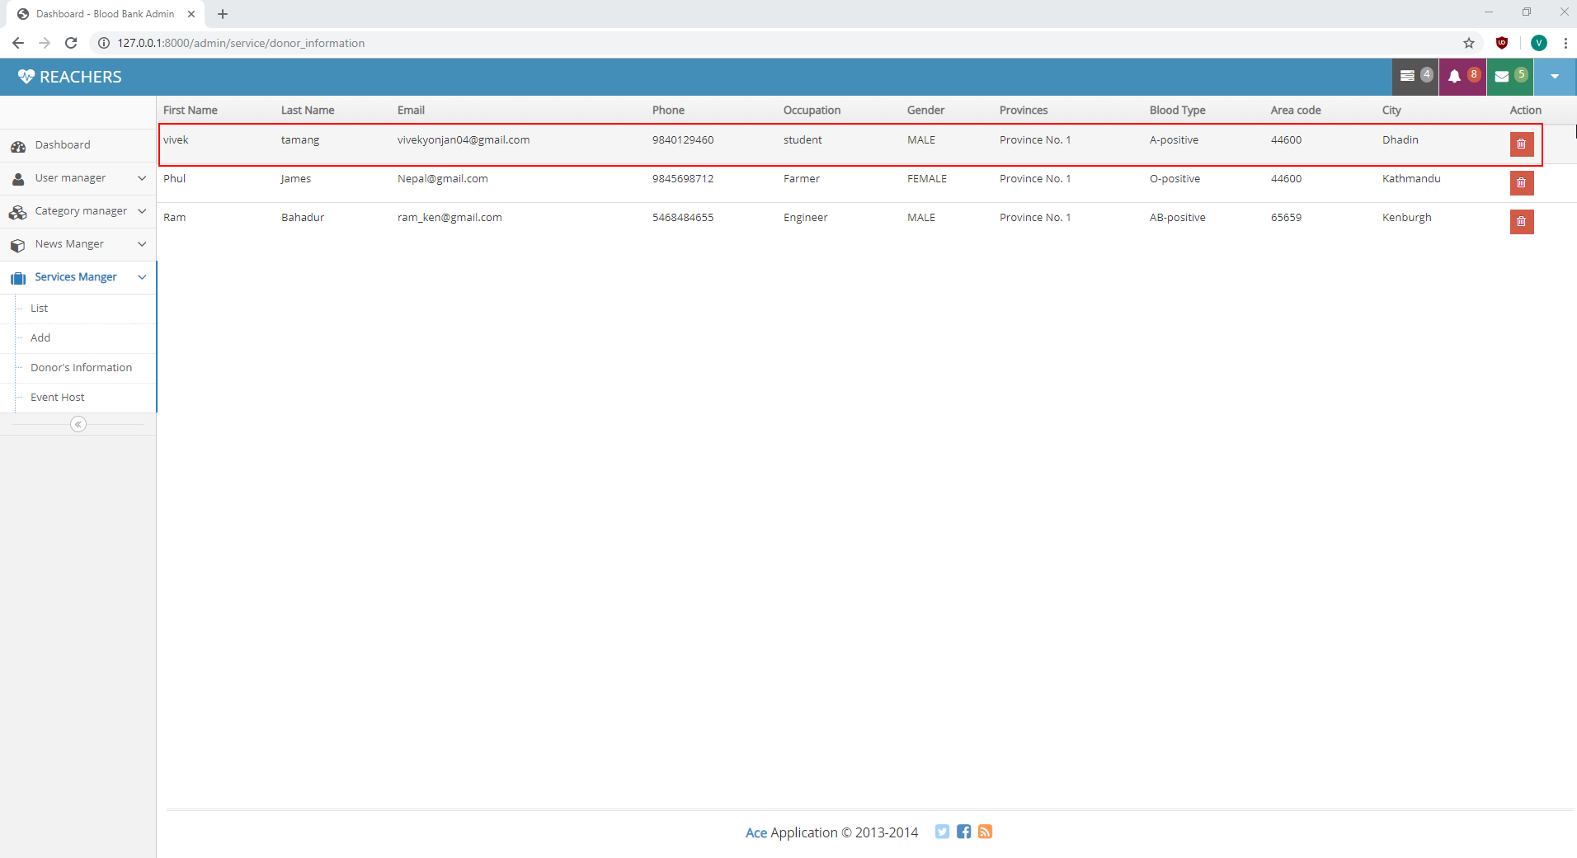

Figure 6: Before Deleting Information

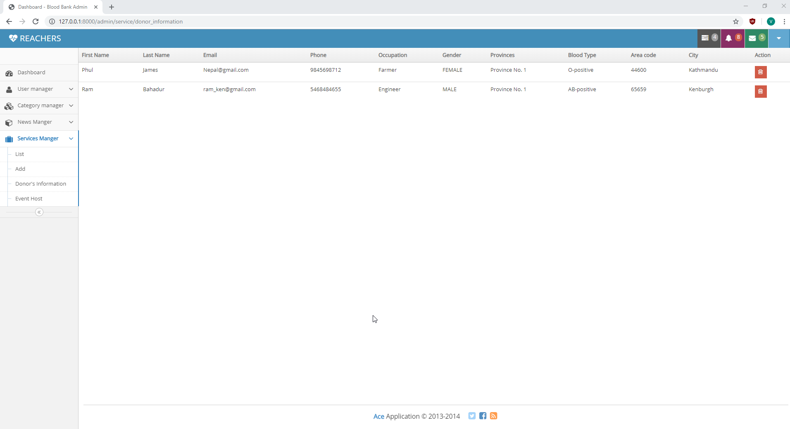

Figure 7: After Deleting information

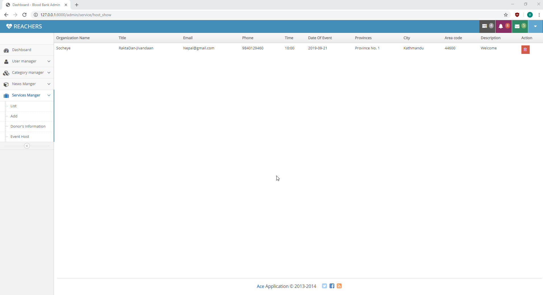

Figure 8: View list of Event host

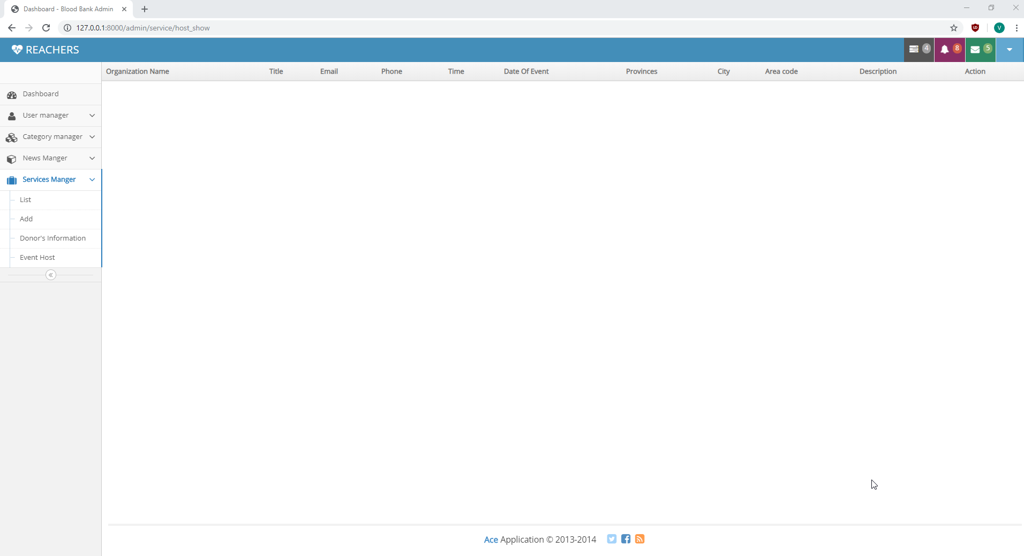

Figure 9: After deleting event

Test Case name: Test News Manager

Module name: News Manager

Created by: Vivek Tamang

Date of Creation: 30/09/2019

|  |  |  |  |  |  |  |
| --- | --- | --- | --- | --- | --- | --- |
| Test case id | Test scenario | Test description | Test data | Expected | Actual | Status |
| News_Manager_01 | News Manager in Admin Panel | Click on “List” to view News |  | View news | As expected | pass |
| News_Manager_02 | News Manager in Admin Panel | Click on “Add” to add news |  | News form open | As expected | Pass |
| News_Manager_03 | News Manager in Admin Panel | Click on “Delete” button |  | Delete news | As expected | Pass |

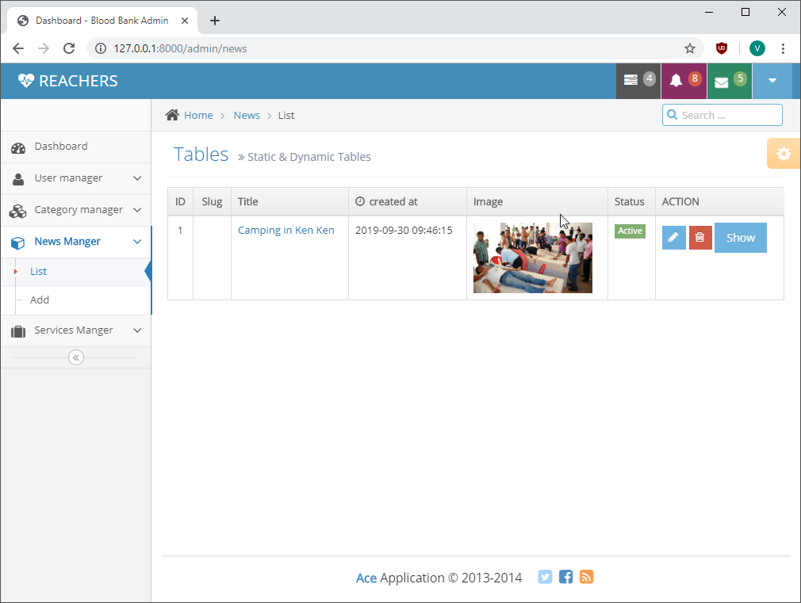

Figure 10: View News

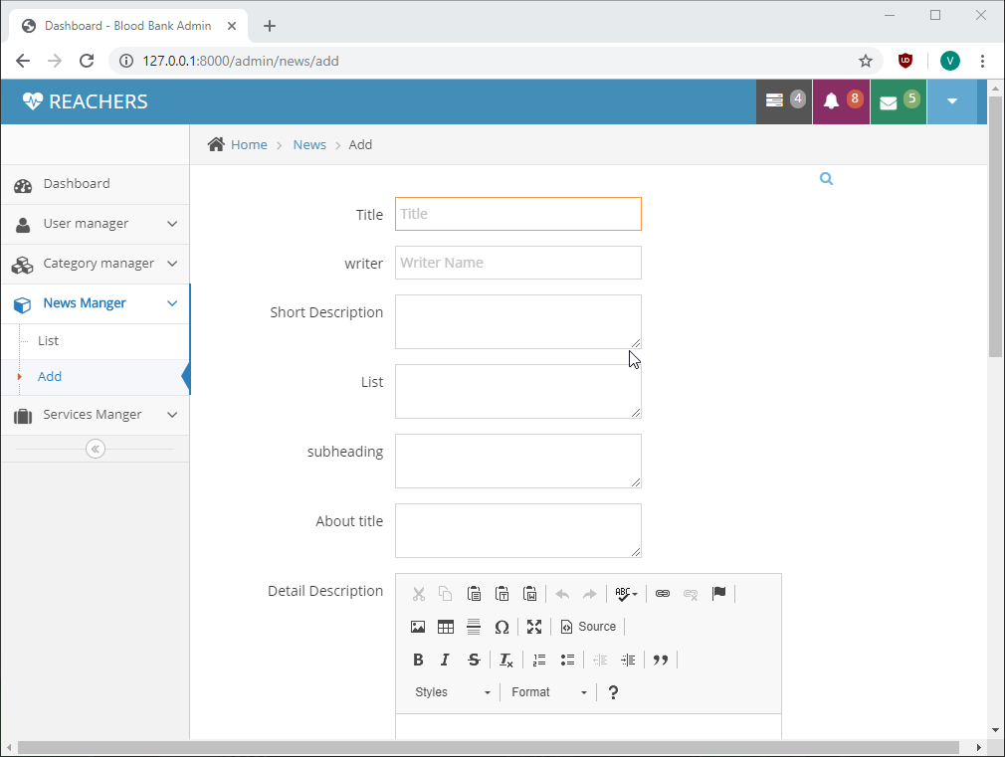

Figure 11: Add News

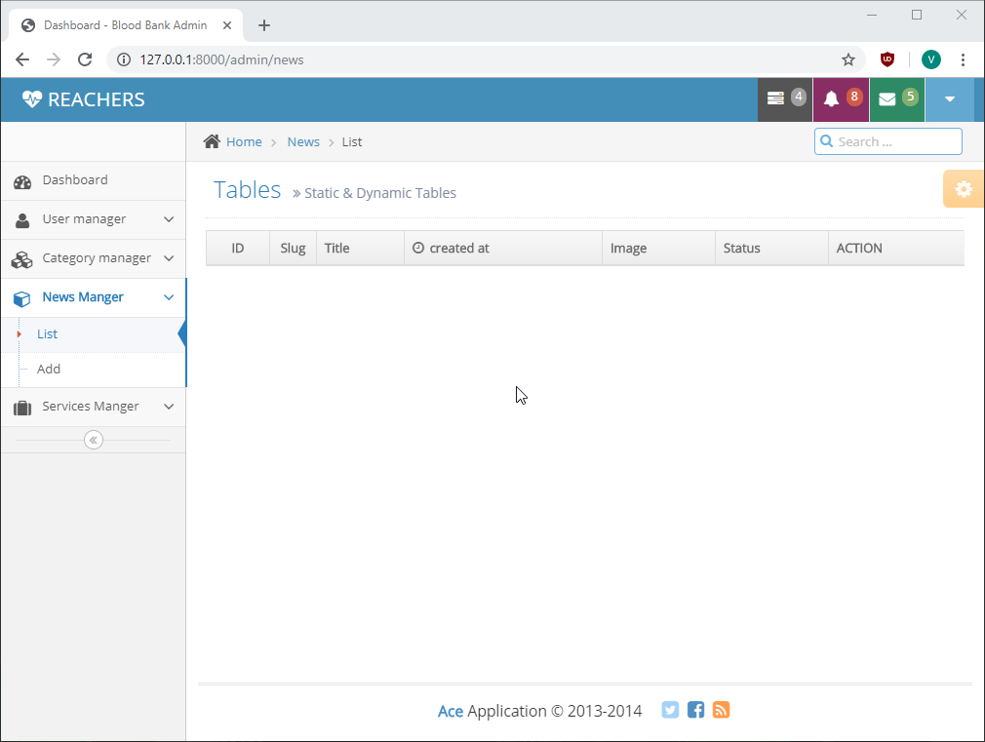

Figure 12: After news is deleted

Test Case name: Test Donor Registration

Module name: Donor Registration

Created by: Vivek Tamang

Date of Creation: 30/09/2019

|  |  |  |  |  |  |  |
| --- | --- | --- | --- | --- | --- | --- |
| Test case id | Test scenario | Test description | Test data | Expected | Actual | Status |
| Donor_Registration_01 | Register Donor | Add donor information | Donor’s Name: Ram Bahadur  Email: [ram_ken@gmail.com](mailto:ram_ken@gmail.com)  Gender: male  DOB: 08/09/1995  Phone number: 5468484655  Address:  City: Kenburgh  Provience: Provience no 1  Zip code: 65659  Occupation: Engineer  Blood Type: AB positive  Did you ever donate blood before?  Ans: No  Do you suffer of any diseases?  Ans: No  Do you have allergies?  Ans: No  Do you take medication?  Ans: No | Add donor information and show in the find donor page. | As expected | pass |

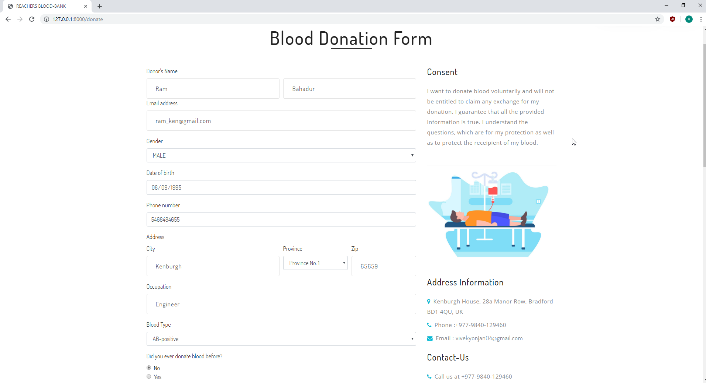

Figure 13: Donation Form 01

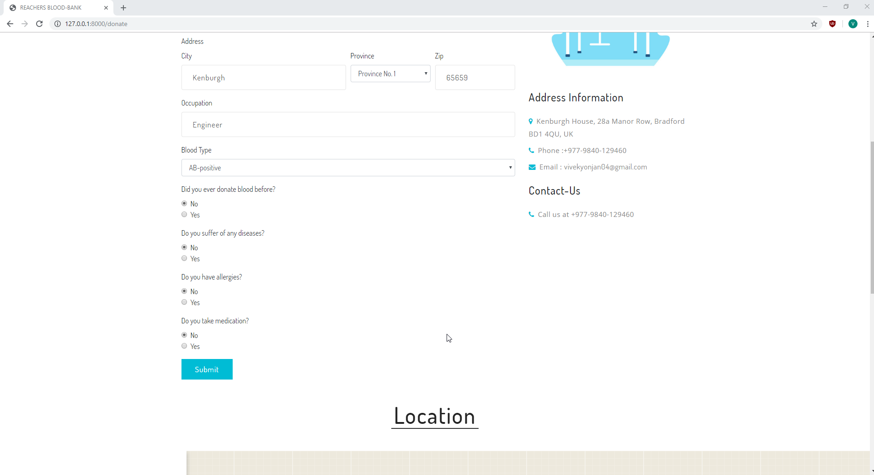

Figure 14: Donation Form 02

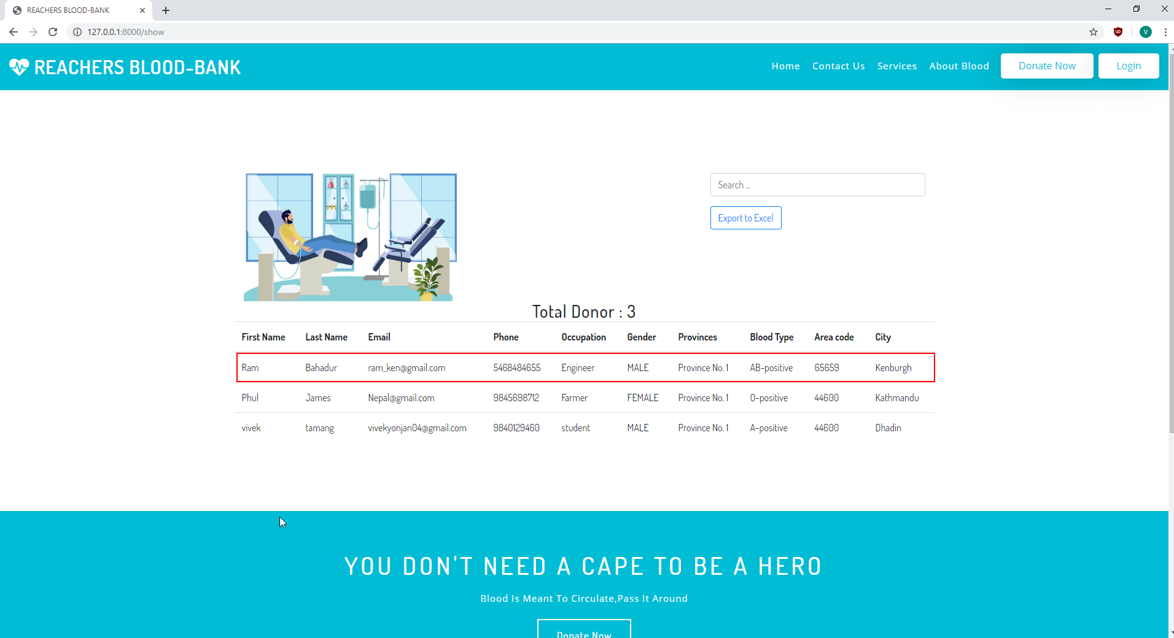

Figure 15: Door Information List

Test Case name: Test Nav Bar

Module name: Nav Bar

Created by: Vivek Tamang

Date of Creation: 30/09/2019

|  |  |  |  |  |  |  |
| --- | --- | --- | --- | --- | --- | --- |
| Test case id | Test scenario | Test description | Test data | Expected | Actual | Status |
| Nav_Bar_01 | Test Nav Bar | Click all the nav bar item |  | Open the page according to the nav bar item clicked | As expected | pass |

Test Case name: Test Home Page

Module name: Home Page

Created by: Vivek Tamang

Date of Creation: 30/09/2019

|  |  |  |  |  |  |  |
| --- | --- | --- | --- | --- | --- | --- |
| Test case id | Test scenario | Test description | Test data | Expected | Actual | Status |
| Home_page_01 | Test home page | Click on “Donor’s info” button |  | Open donor information table | As expected | Pass |
| Home_page_02 | Test home page | Click on “Donate now “button |  | Open Donor form. | As expected | Pass |

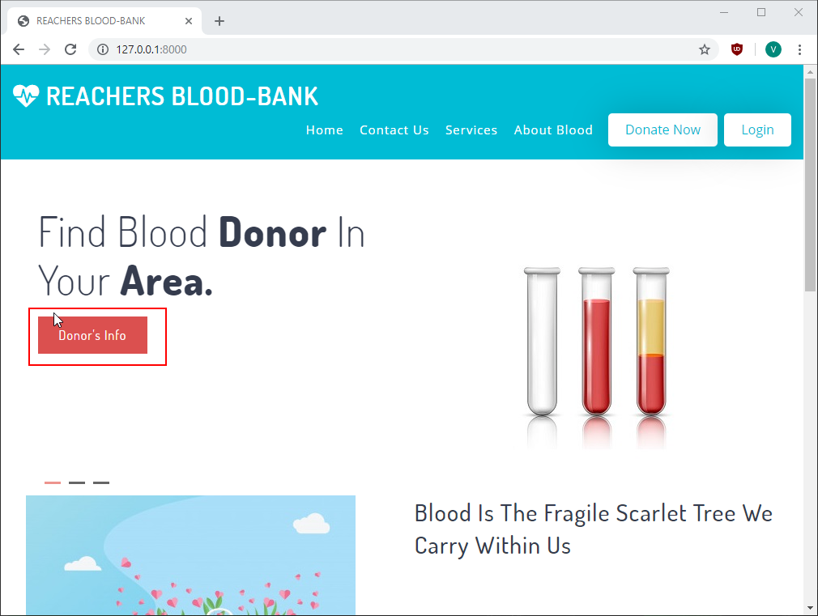

Figure 16: Donor Information Button

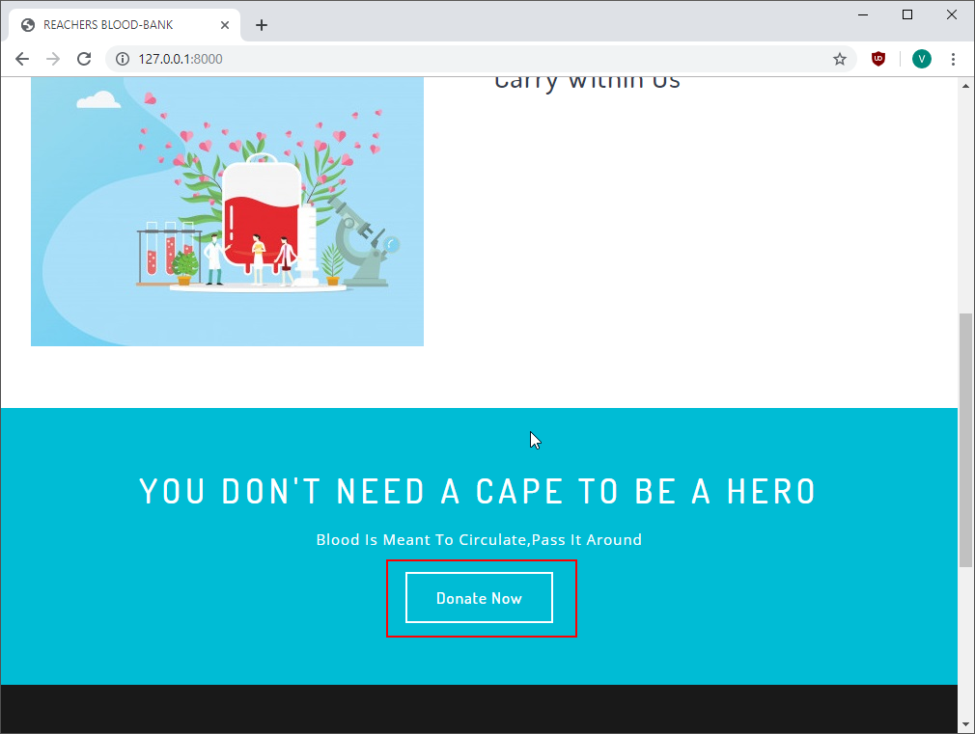

Figure 17: Donation Form Button

Test Case name: Test Services Page

Module name: Services Page

Created by: Vivek Tamang

Date of Creation: 30/09/2019

|  |  |  |  |  |  |  |
| --- | --- | --- | --- | --- | --- | --- |
| Test case id | Test scenario | Test description | Test data | Expected | Actual | Status |
| Services_page_01 | Test services page | Click on the listed service icon  button |  | Open page according to the service listed such as when click on host an event form of it should open. | As expected | Pass |
| Services_page_02 | Test services page | Enter feedback and click on feedback button |  | Send feedback to the admin. | Feedback not sent. | fail |

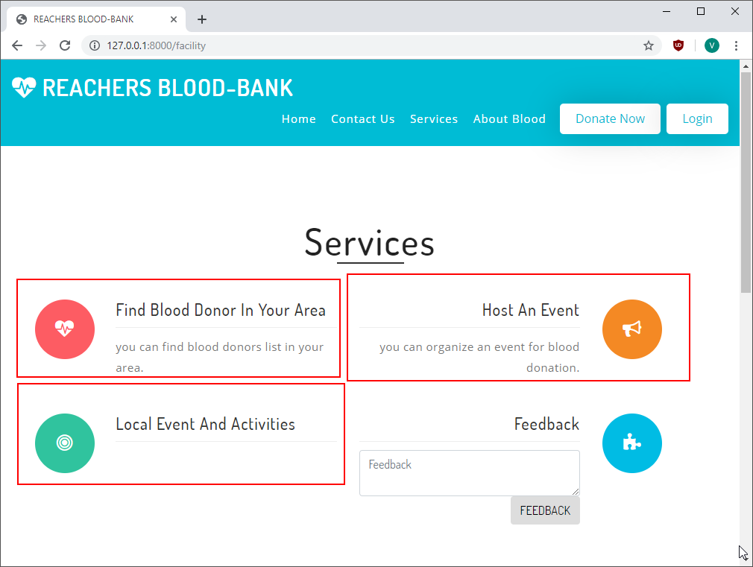

Figure 18: Services

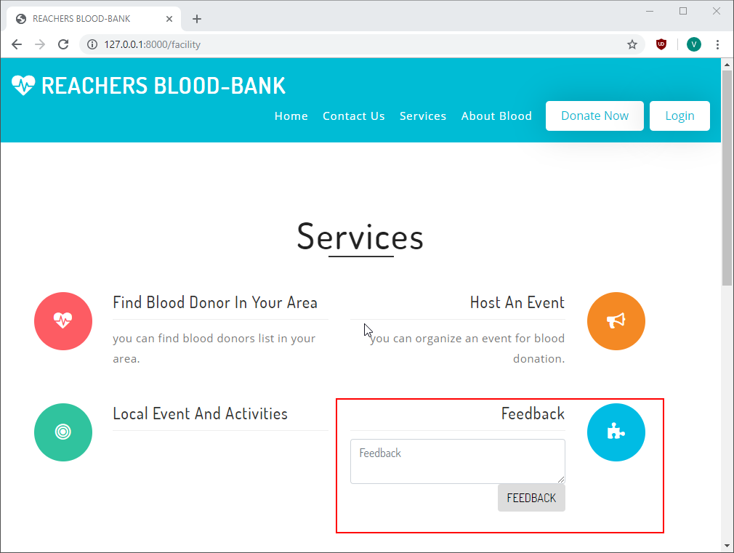

Figure 19: Feedback

Test Case name: Test About Blood Page

Module name: About Blood Page

Created by: Vivek Tamang

Date of Creation: 30/09/2019

|  |  |  |  |  |  |  |
| --- | --- | --- | --- | --- | --- | --- |
| Test case id | Test scenario | Test description | Test data | Expected | Actual | Status |
| About_Blood_page_01 | Test About Blood Page | Download charts in png, jpeg format |  | Download the charts | As expected | Pass |
| About_Blood_page_02 | Test About Blood Page | View chart in full screen |  | View chart in full screen | As expected | Pass |

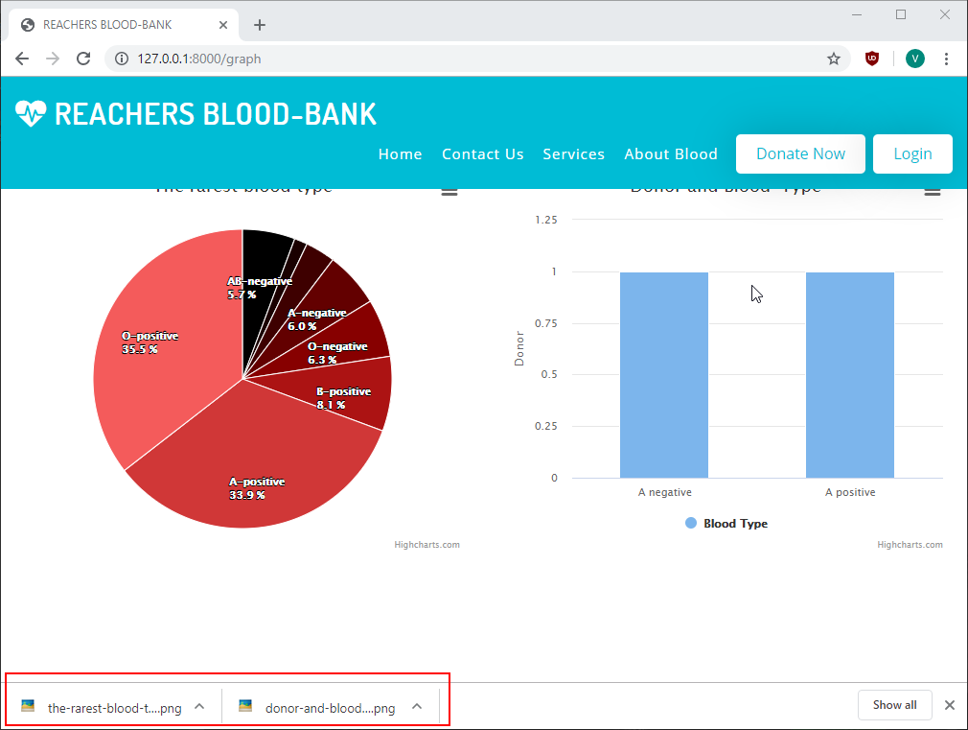

Figure 20: Download charts

Test Case name: Test Contact Us Page

Module name: Contact Us Page

Created by: Vivek Tamang

Date of Creation: 30/09/2019

|  |  |  |  |  |  |  |
| --- | --- | --- | --- | --- | --- | --- |
| Test case id | Test scenario | Test description | Test data | Expected | Actual | Status |
| Contact_Us_page_01 | Test Contact Us Page | Fill the contact form and submit | Name: Rahul Tamang  Phone number: 9843283563  Email: [rahul_tamang@gmail.com](mailto:rahul_tamang@gmail.com)  Subject: Request  Message: I need 0 negative blood. Please contact me. | Send Message to the admin | Message not sent to the admin | Fail |

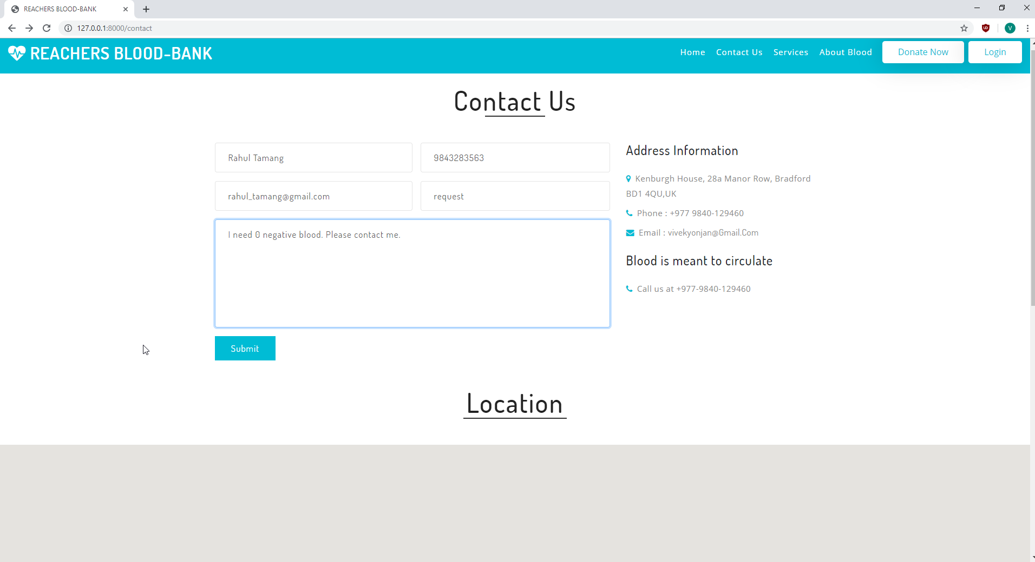

Figure 21: Contact Us Page

Test Case name: Test Items in footer

Module name: Items in footer

Created by: Vivek Tamang

Date of Creation: 30/09/2019

|  |  |  |  |  |  |  |
| --- | --- | --- | --- | --- | --- | --- |
| Test case id | Test scenario | Test description | Test data | Expected | Actual | Status |
| Items_in_footer_01 | Test the links to the social media and email | Click on the icon of the social media in footer |  | Open the social media pages when the icon of the respective social media is clicked. | Did not open as expected | Fail |

# **Chapter 6 Other Project Issues**

Project issue during the project are:

* There was a problem in adding news and other inserting option, caused due to improper database connection which was solved by the help of my teacher.
* While working on charts according to the donor blood group, there was an issue which was solved by the help of my friends.

## Limitation of the project

* There is only login for the admin but not for the donors and the receivers.
* As anyone can register as donor, there is a huge risk of getting fraud.
* As anyone can view donor’s information, there is a chance of fake needy calls.

## Risk Management

Risk Management includes identifying and analyzing risks and find the response to reduce risk impact or to stay proactive as well. Risk management is mandatory in any field to achieve goals.

Following steps can be taken for risk management;

* Risk Identification
* Risk analysis
* Risk Evaluation
* Treating the risk
* Monitoring the Risk

The risk management process helps to determine the risk level by the combination of possibility and the impact from the table below. The likelihood and the impact indicates the nature of the risk.

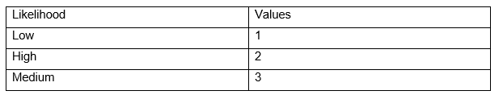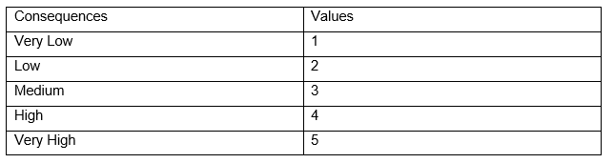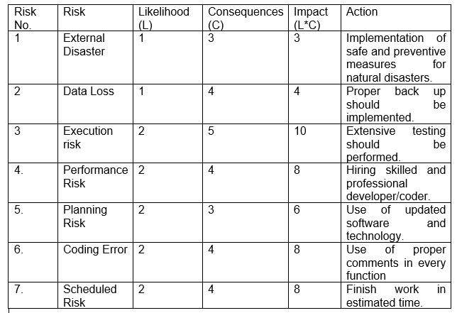

**External Disasters:**

External Disasters is unpredictable so safe and preventive measures should be implemented.

**Data Loss**

Data can be lost due to unexpected hardware or software crash. So proper backup must be kept.

**Execution Risk**

Sometimes project may not work properly while executing so proper testing must be done in time.

**Planning risk**

The updated and best software and hardware must be chosen during planning.

**Performance Risk**

Skilled and professional must be hired to get quality solution.

**Coding Error**

While doing complex functions, coding error might be faced.

**Scheduled Risk**

Proper planning on schedule must be done so that developers can complete the project on time and able to provide the quality solution.

## Configuration Management

Configuration management (CM) is a systems engineering process for establishing and maintaining consistency of a product's performance, functional, and physical attributes with its requirements, design, and operational information throughout its life.

It helps to classify documenting functional capabilities, individual configuration items and interdependencies.

Link: https://github.com/vivekyonjan04/CP

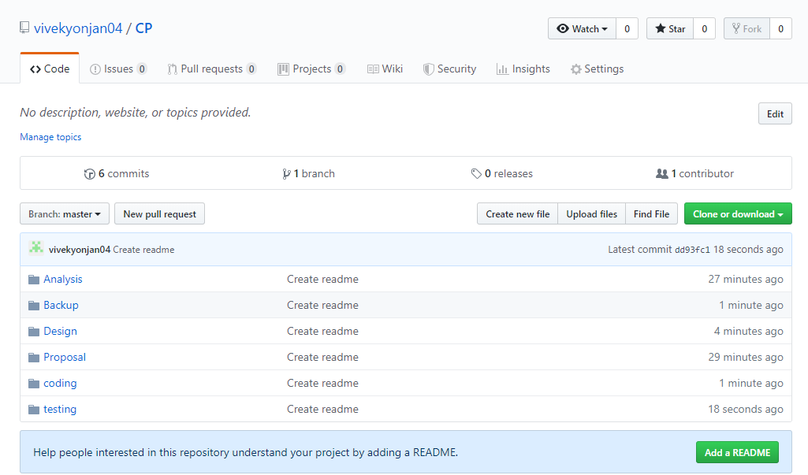

# **Chapter 7 Future Work**

* Donor and Needy login and register system.

To protect the data of the needy and the donors, donor and Needy login and register system can be added in the future.

* Notification Pop-up in screen

Notification for any actions can be added in future that reminds or give alert to users.

* Chatting system

As it consumes a lot of time to implement the chatting system for the donor and needy, it is considered as the future work.

# **Conclusion**

The project has been completed using Laravel framework for design and MySql for the database. Many other process and tools for analysis, design and testing are taken or used to complete the project on time with certain limitations. Use of the proper WBS to breakdown the phases into sub phrases are done so that the context can be understandable. In order to give quality software on estimated time, suitable and sensitive time valuation are done.

# **Appendix**

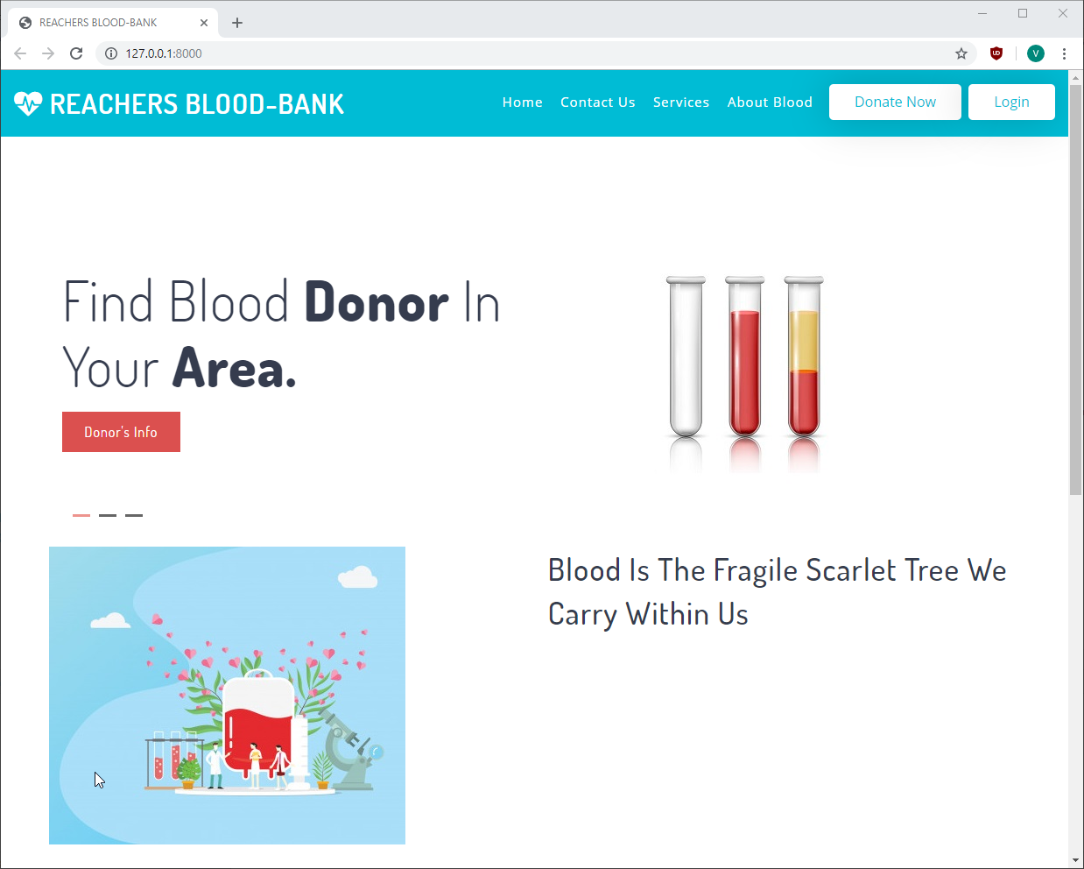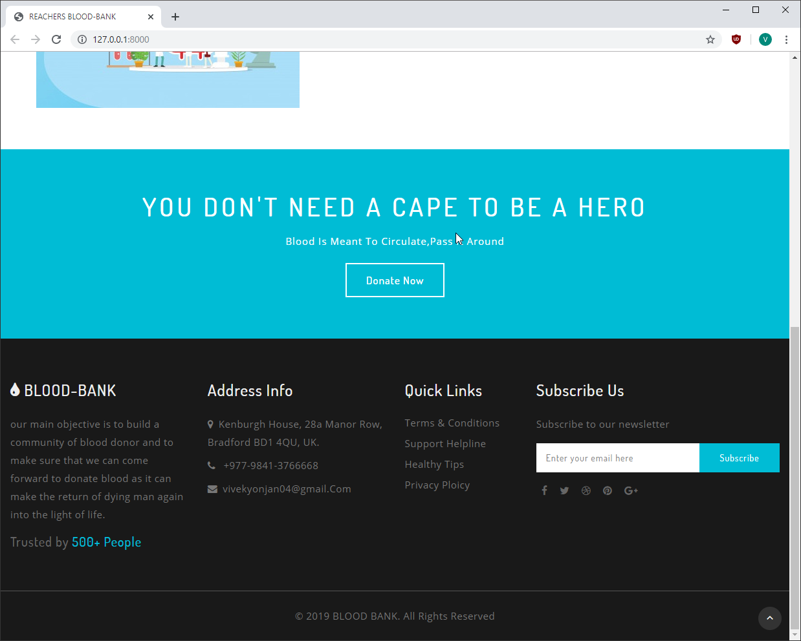

**Code for header:**

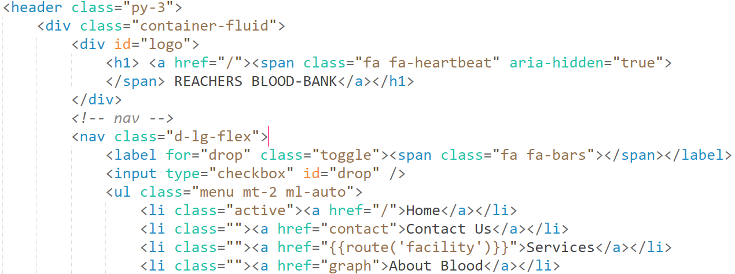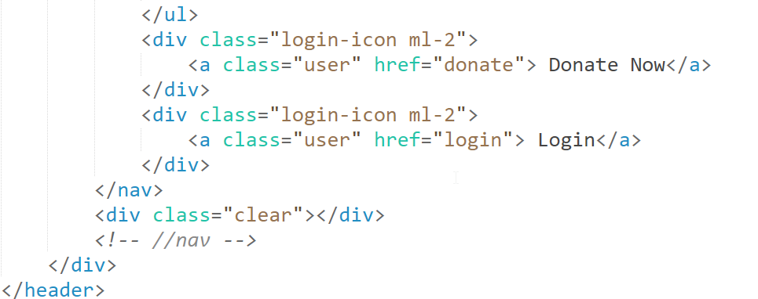

**Code for footer:**

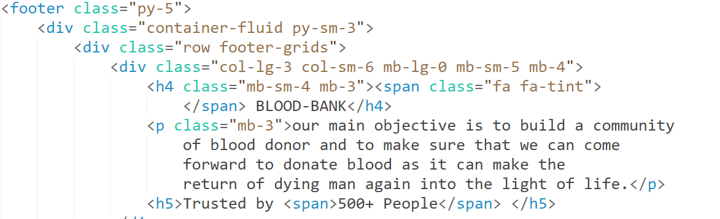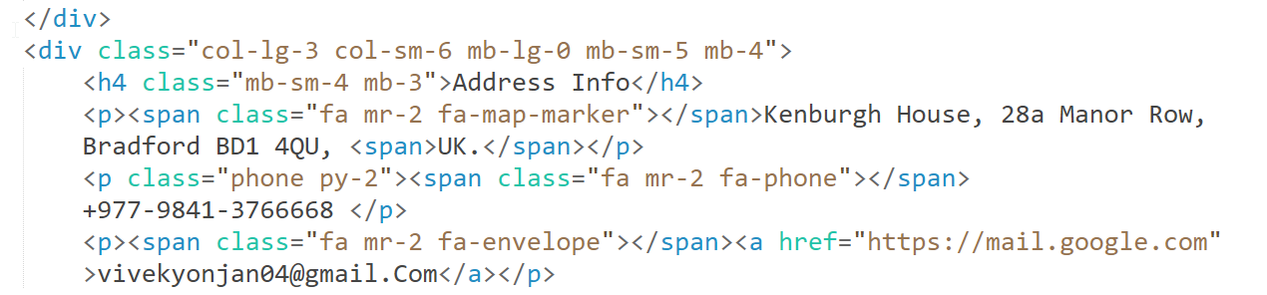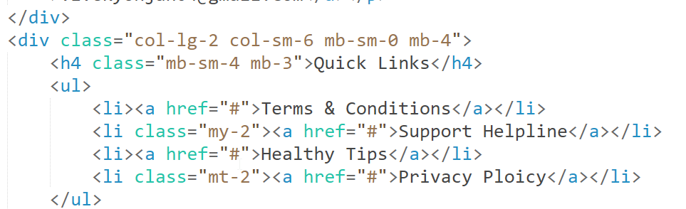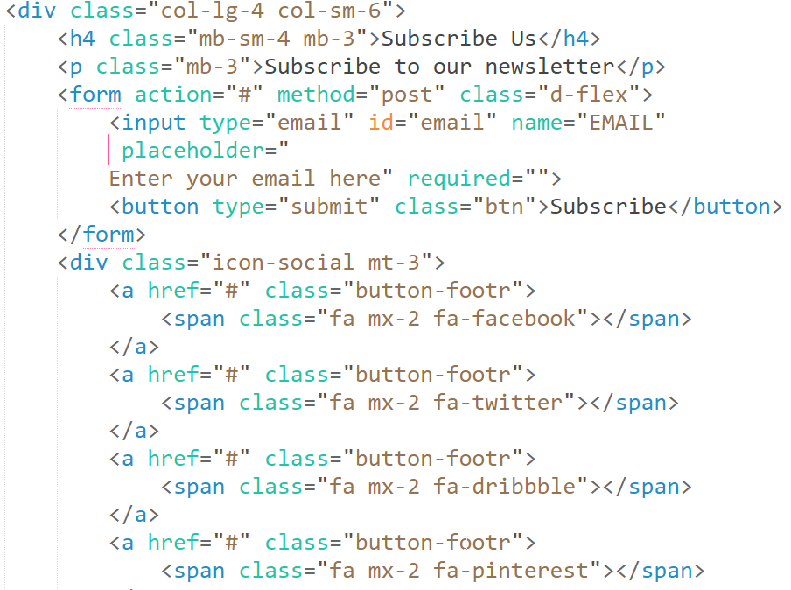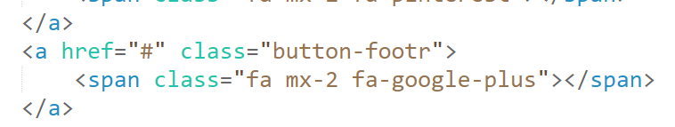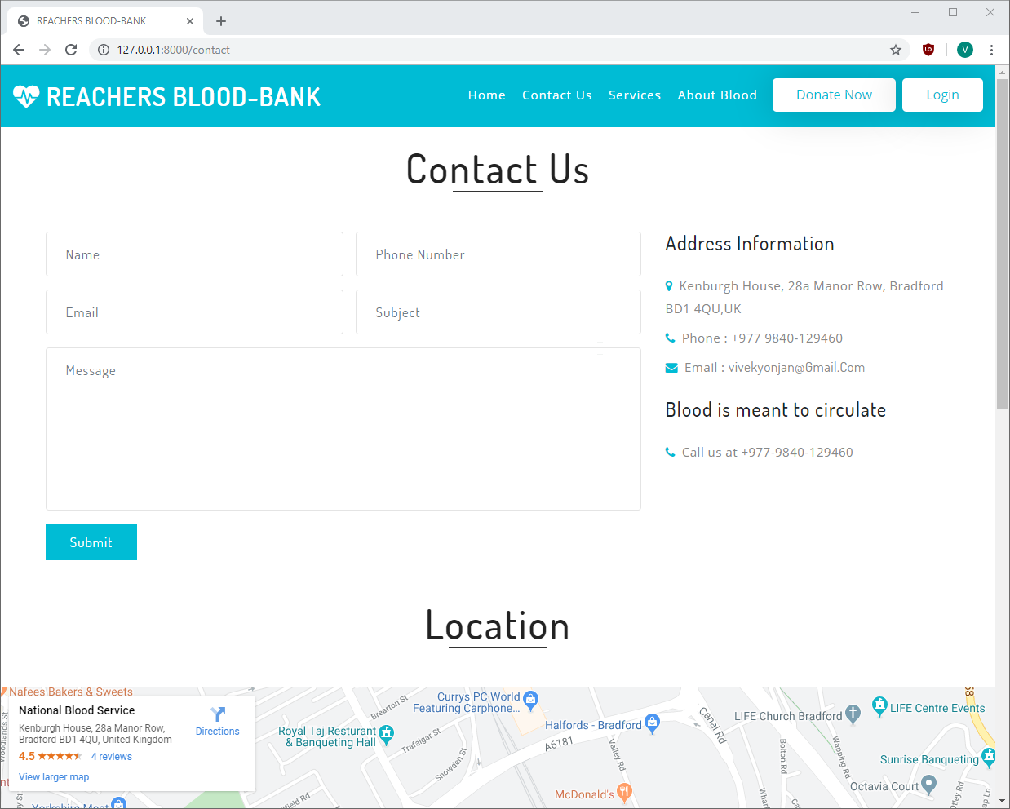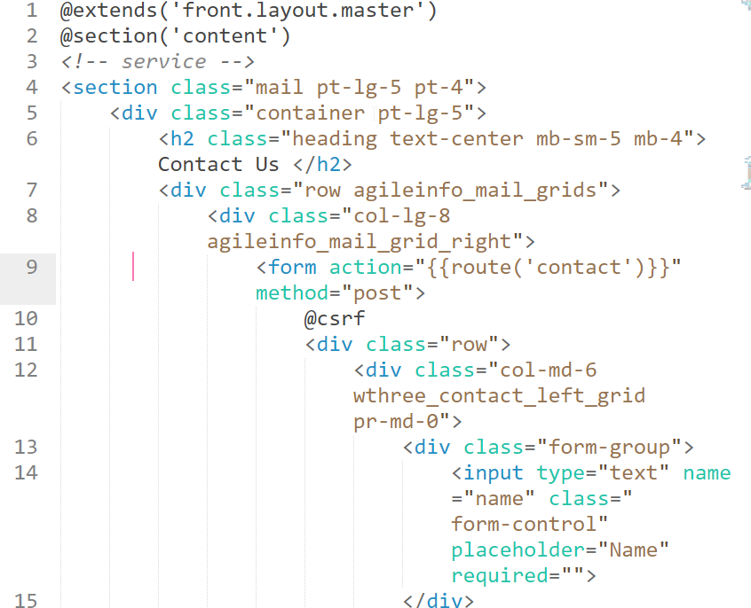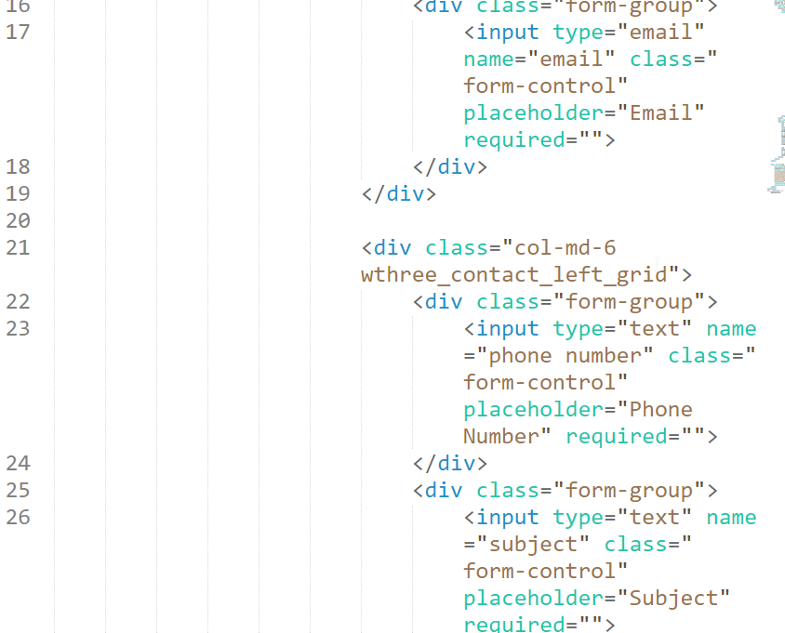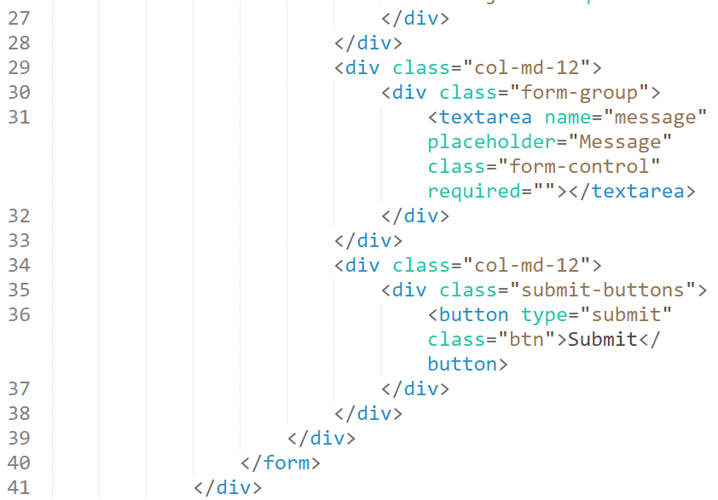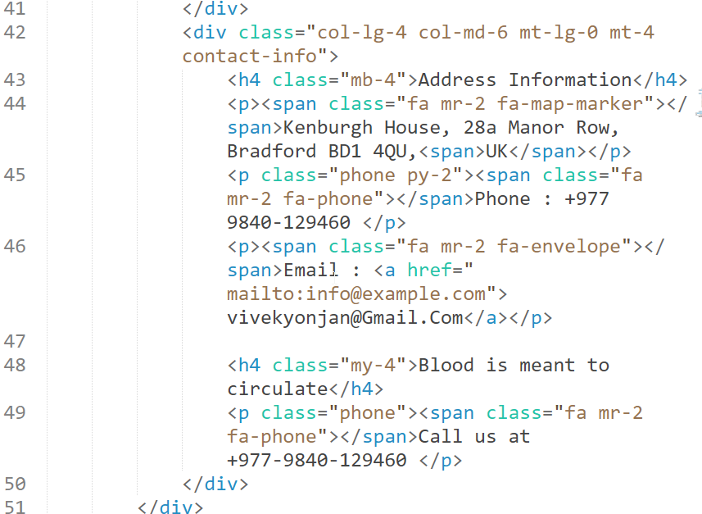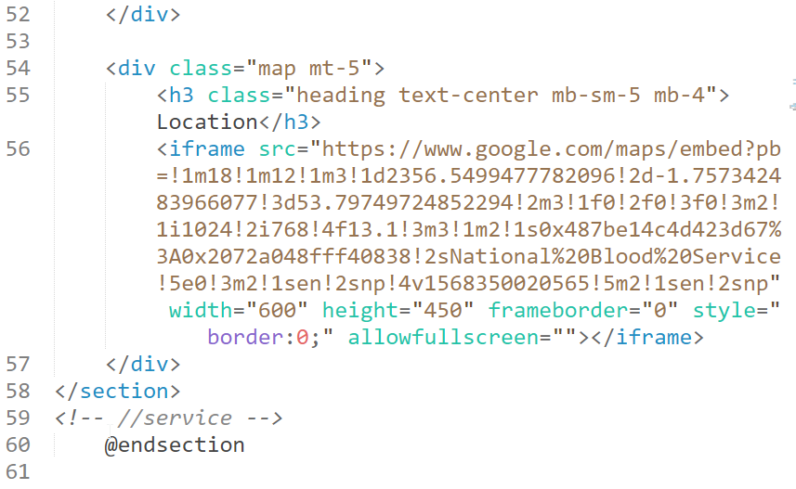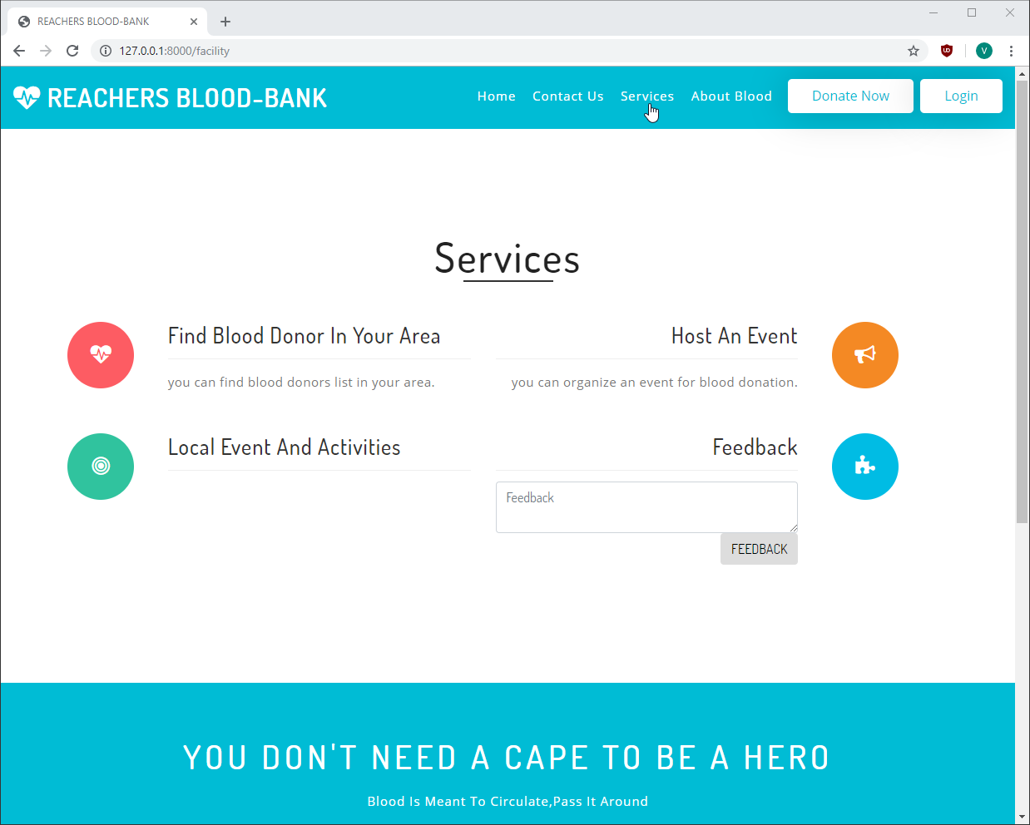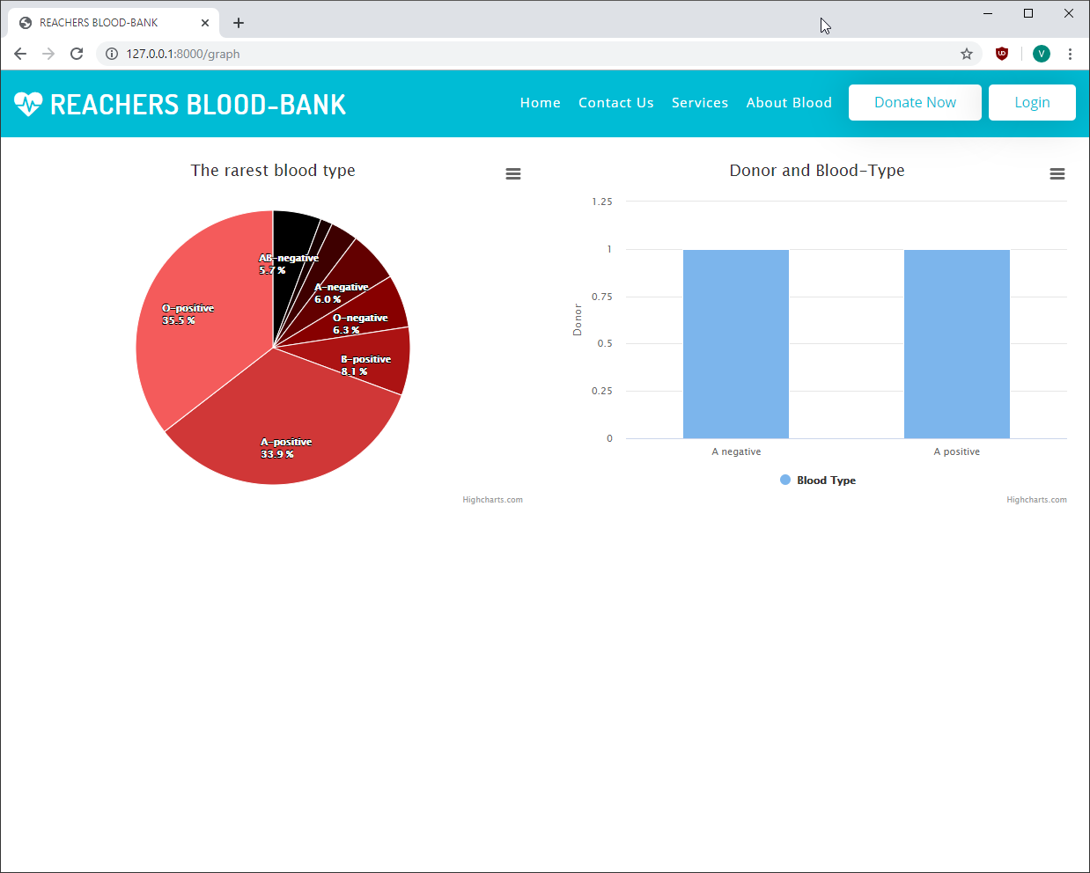

**Code for the graph:**

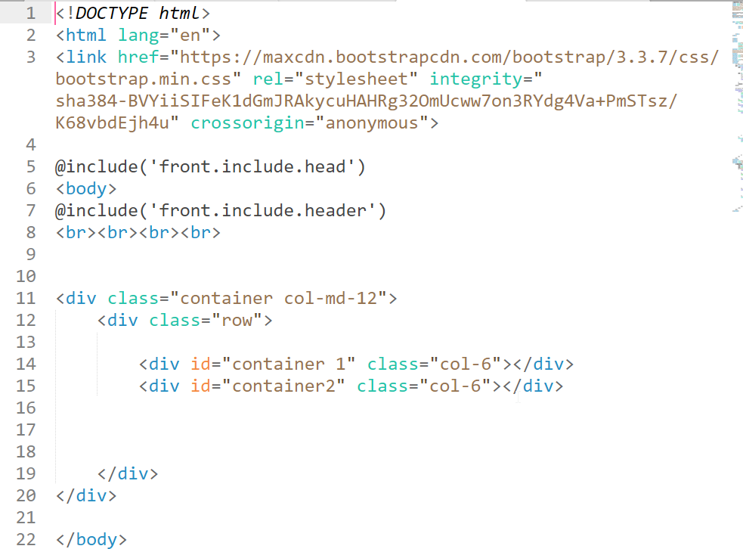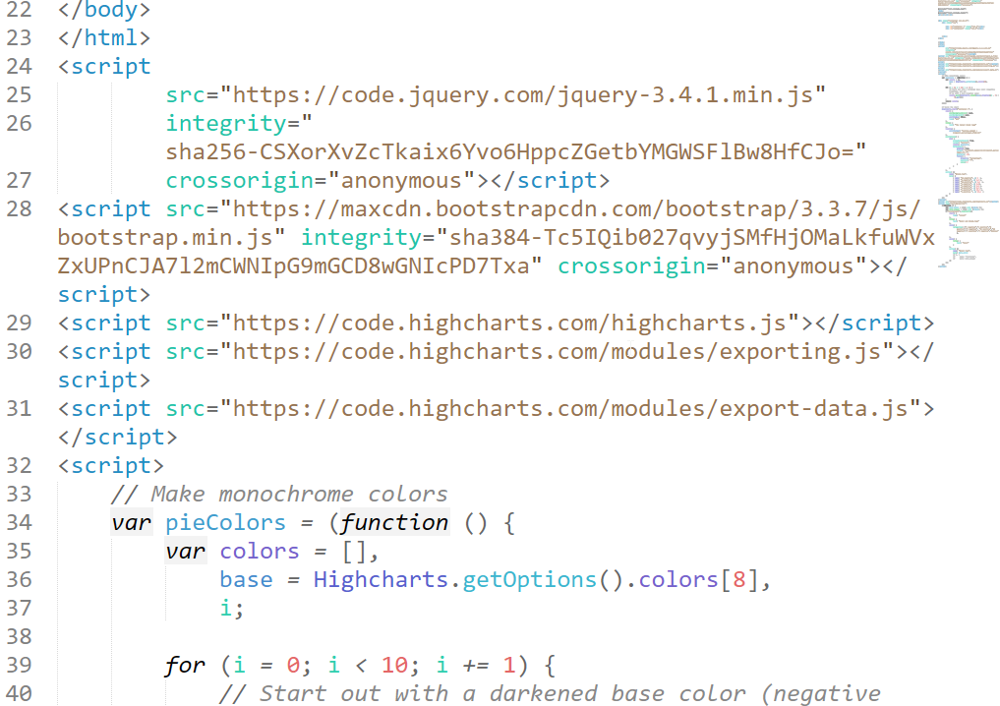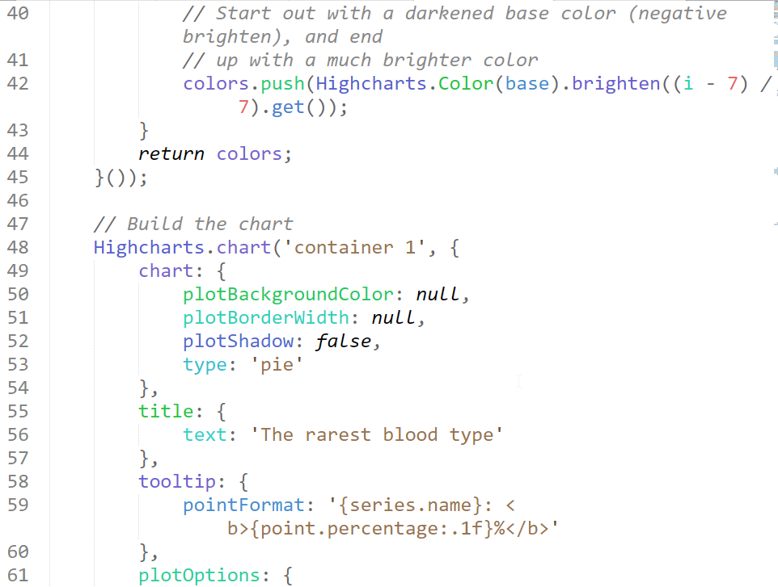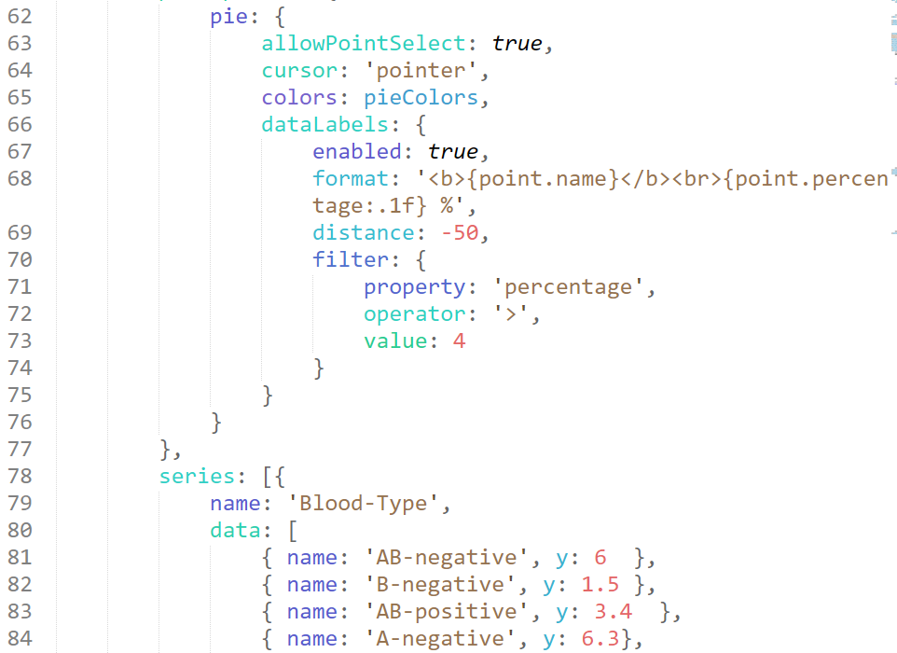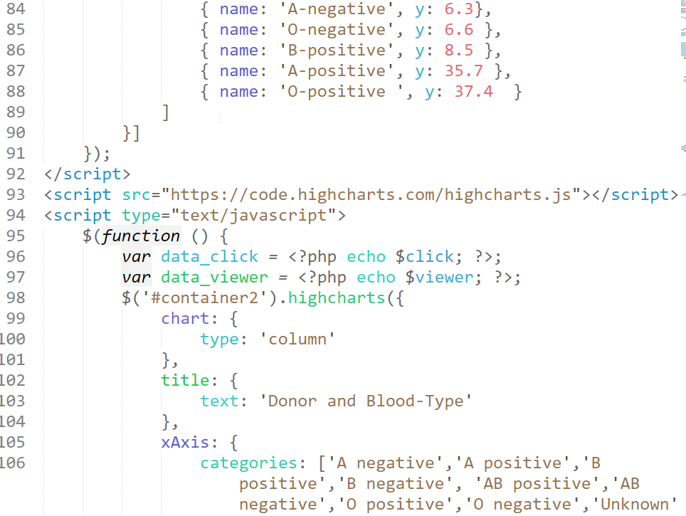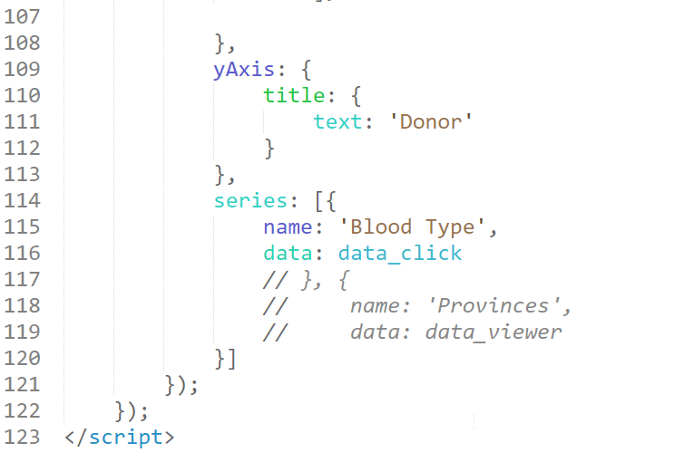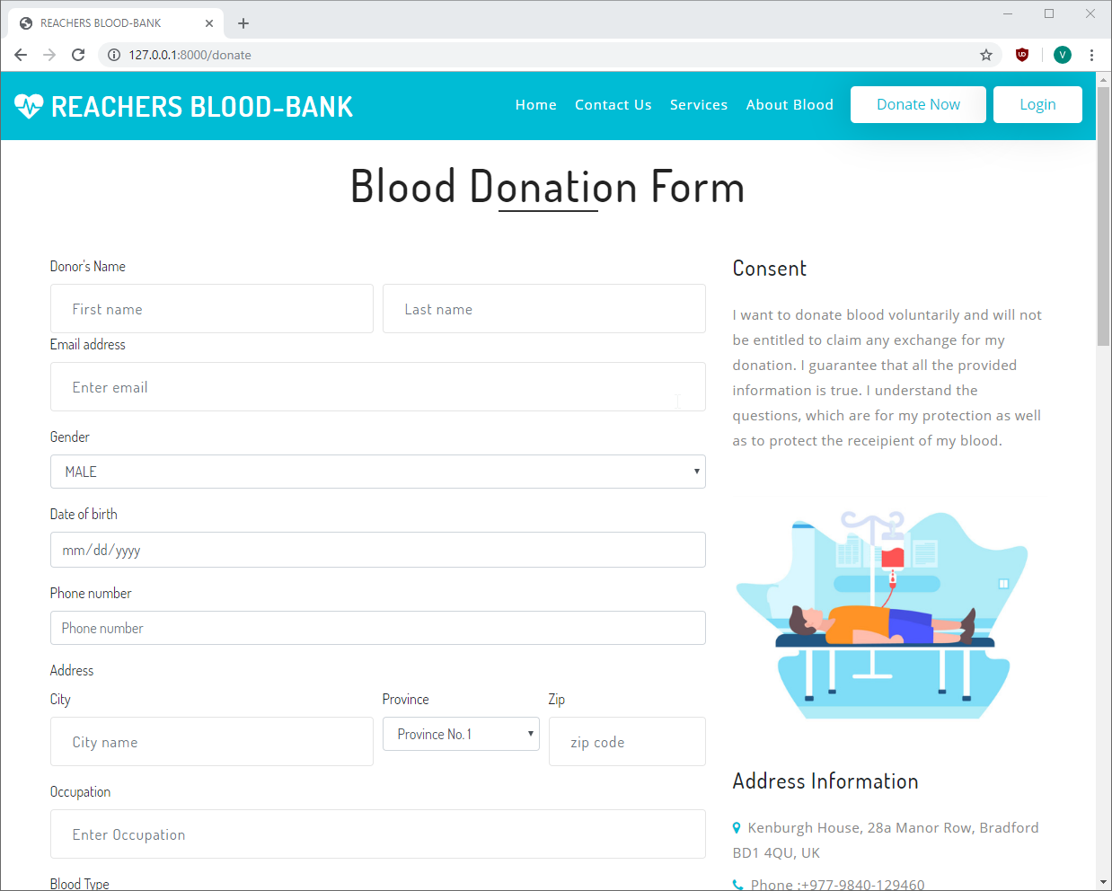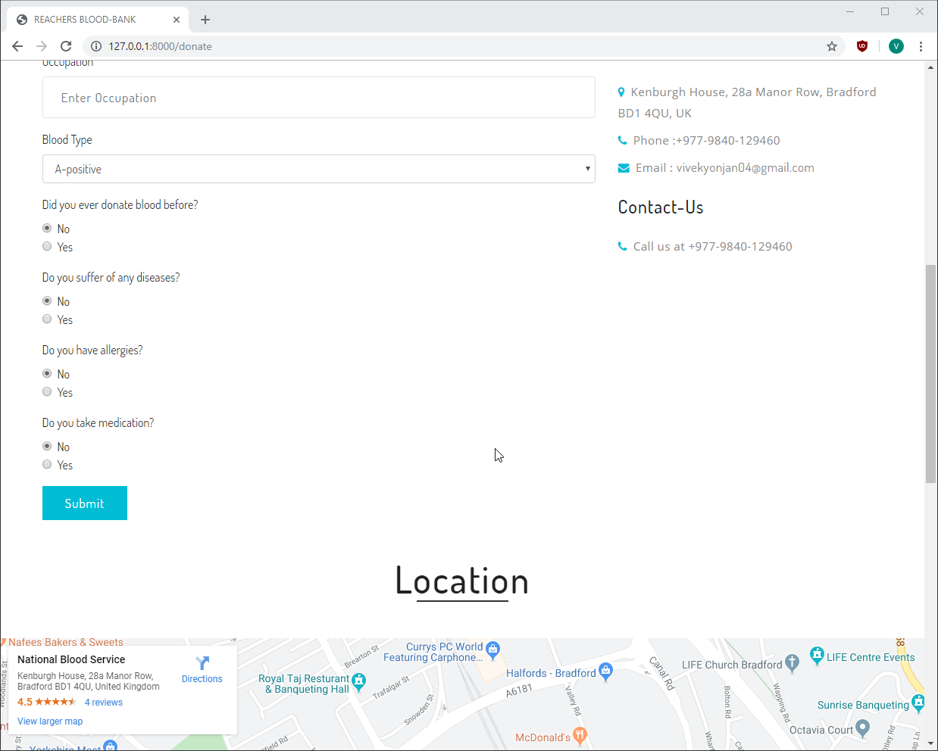

**Code for the Form and the page**

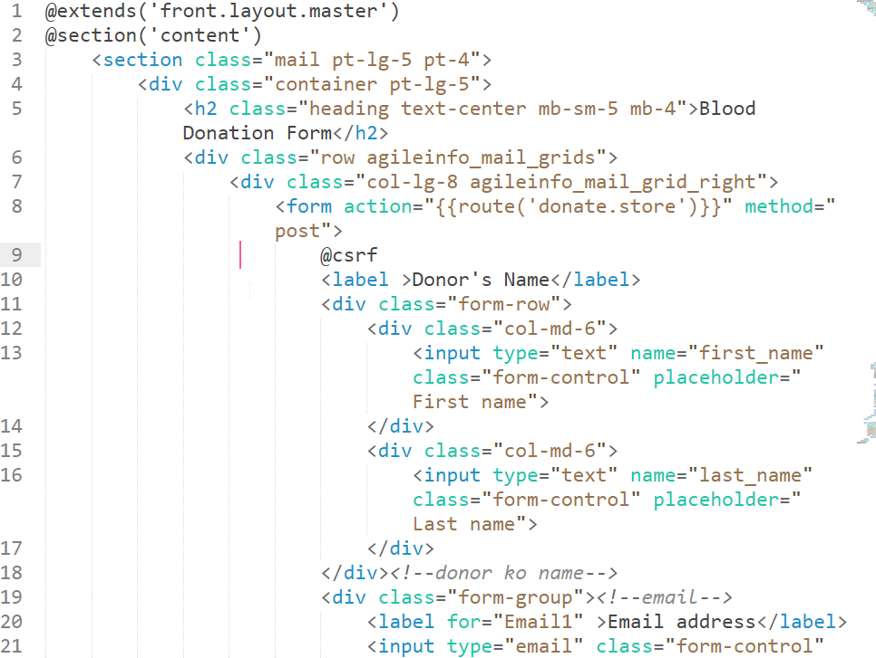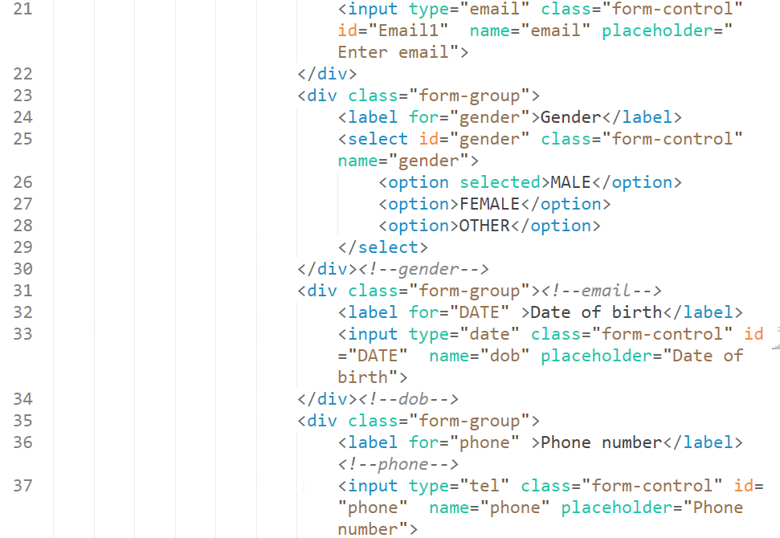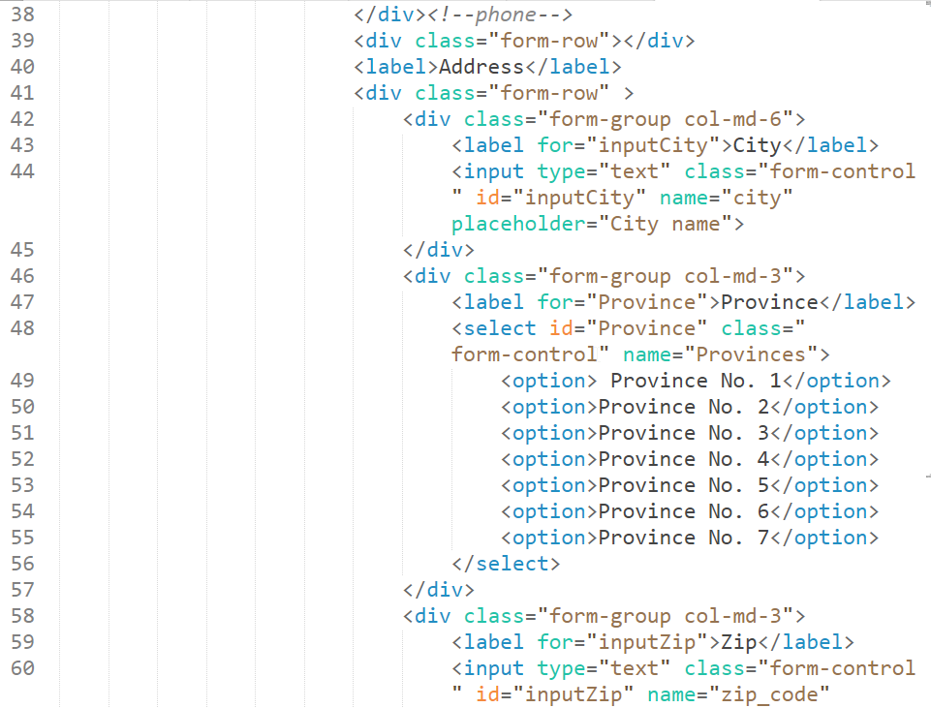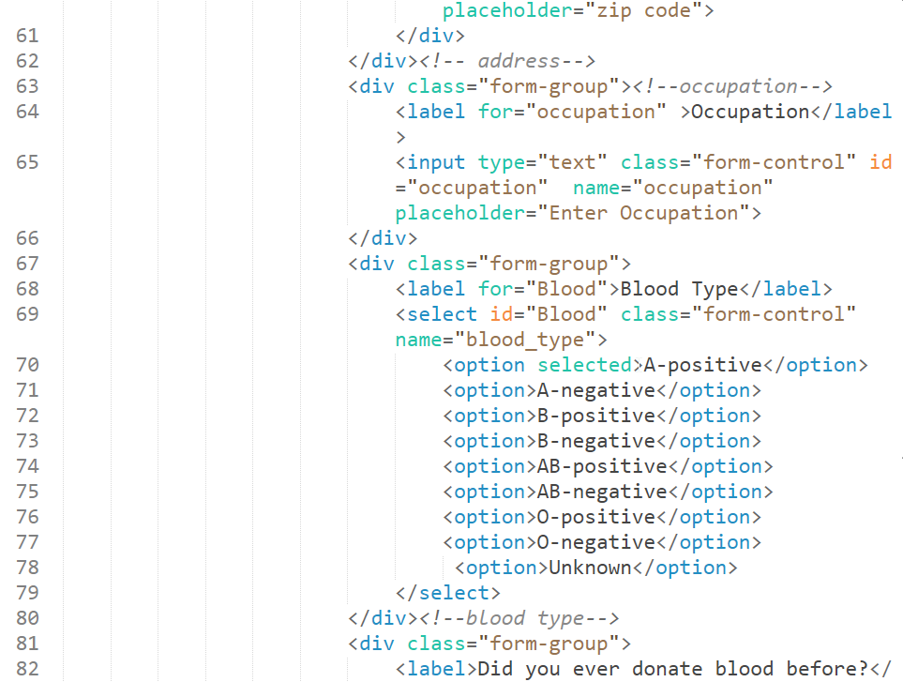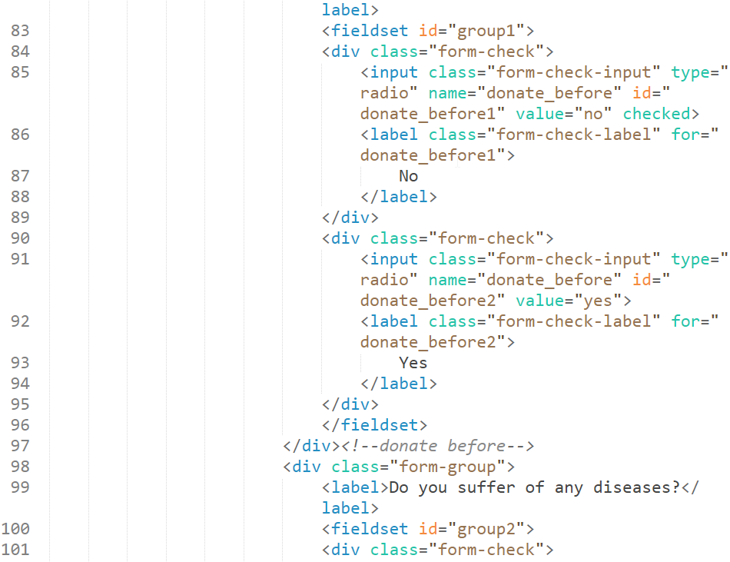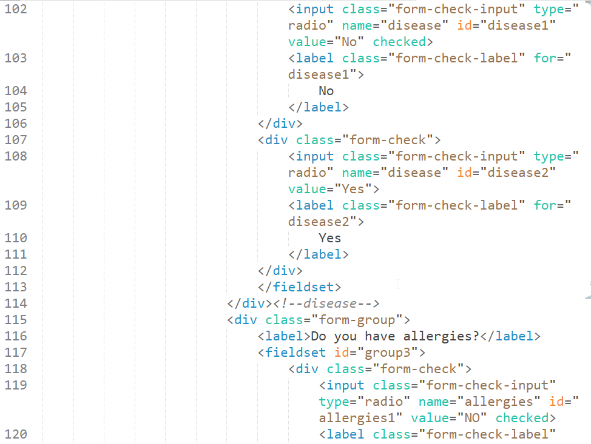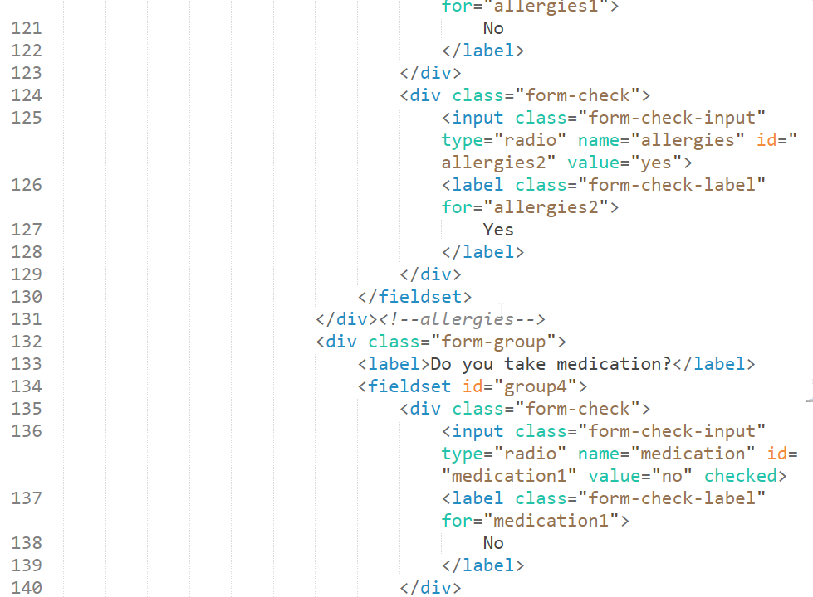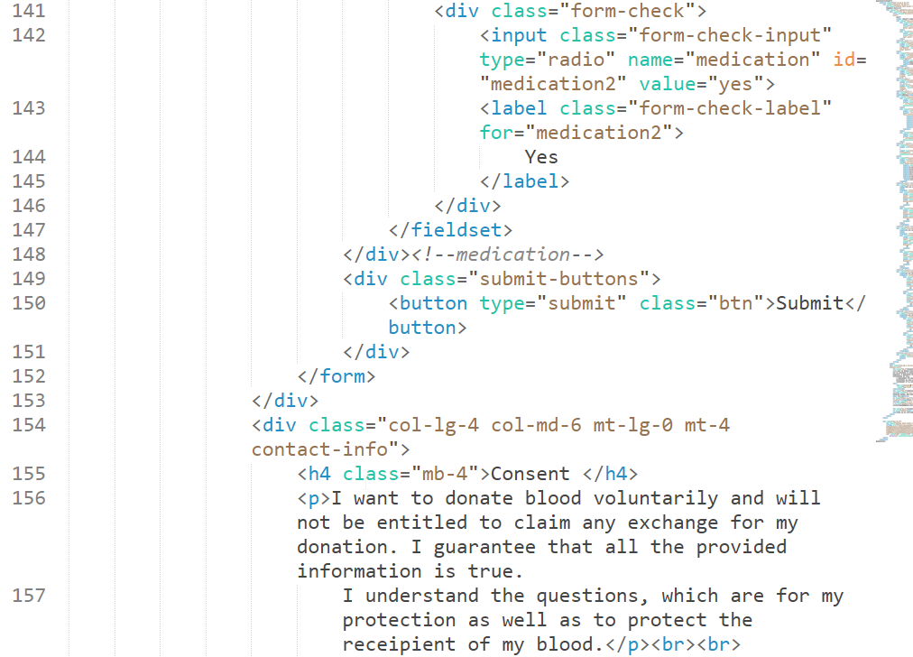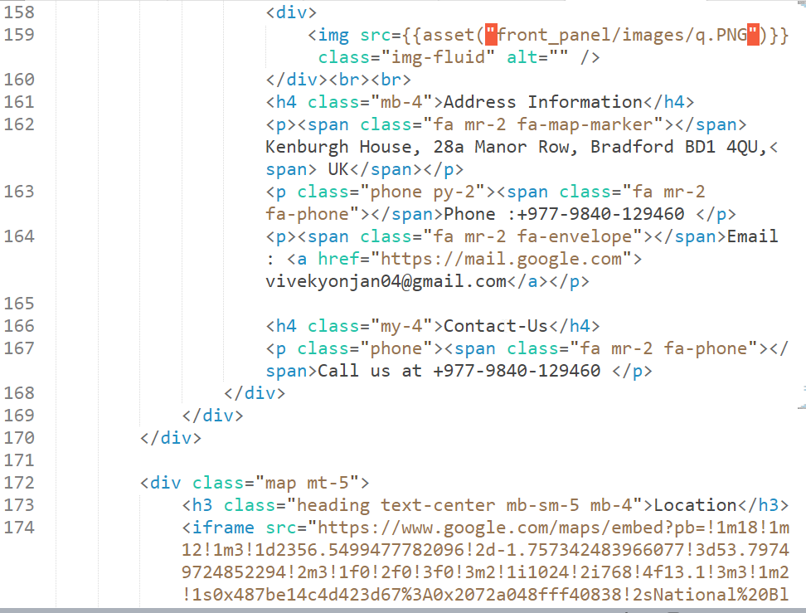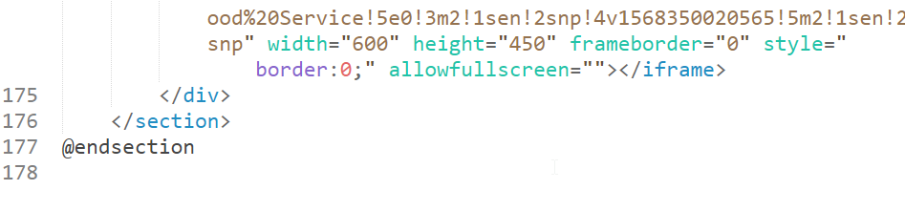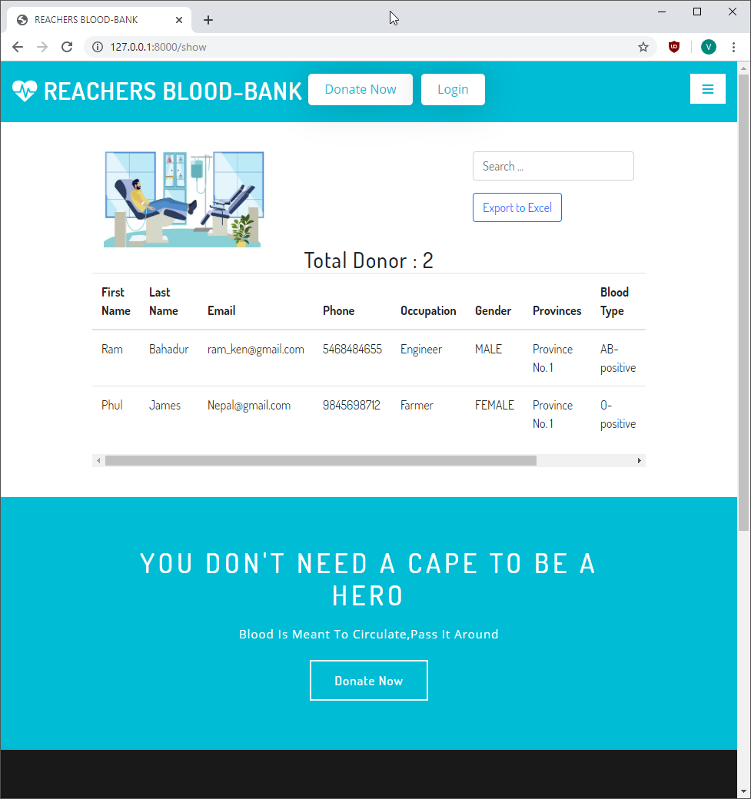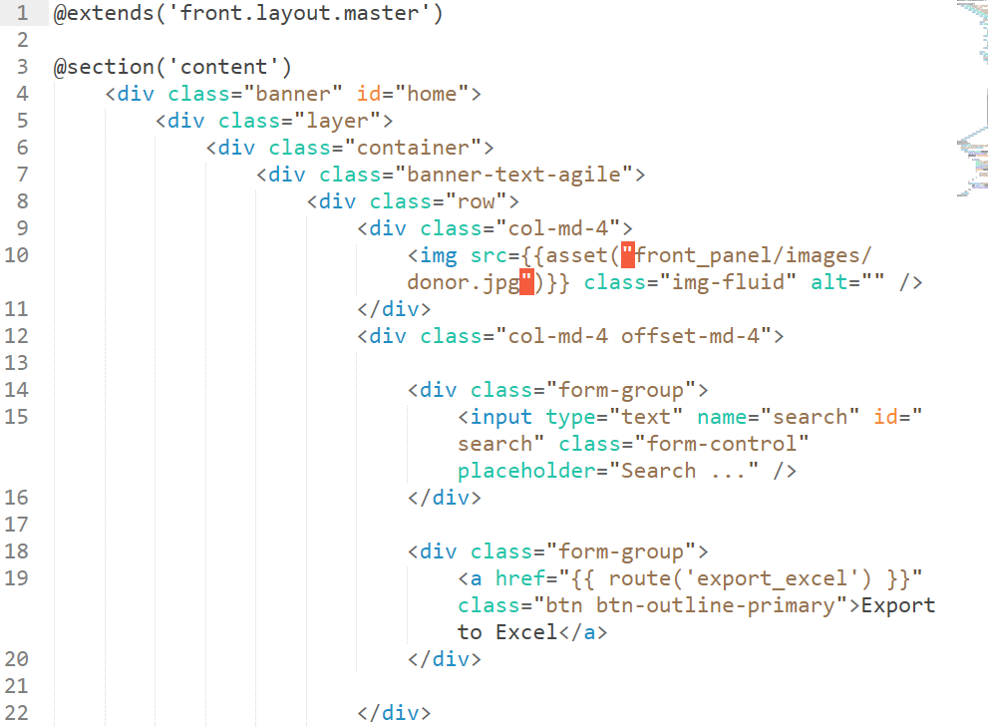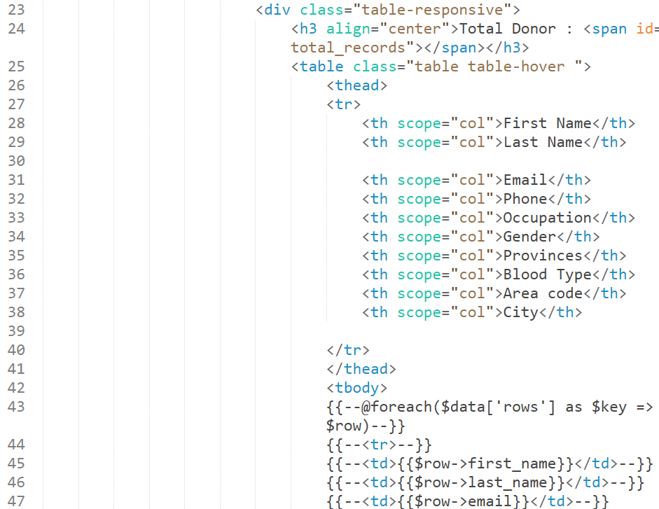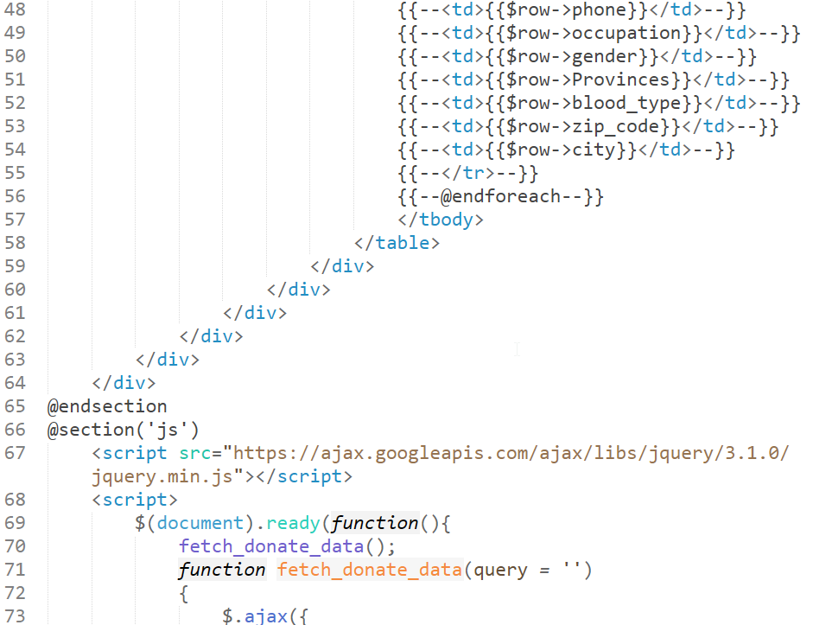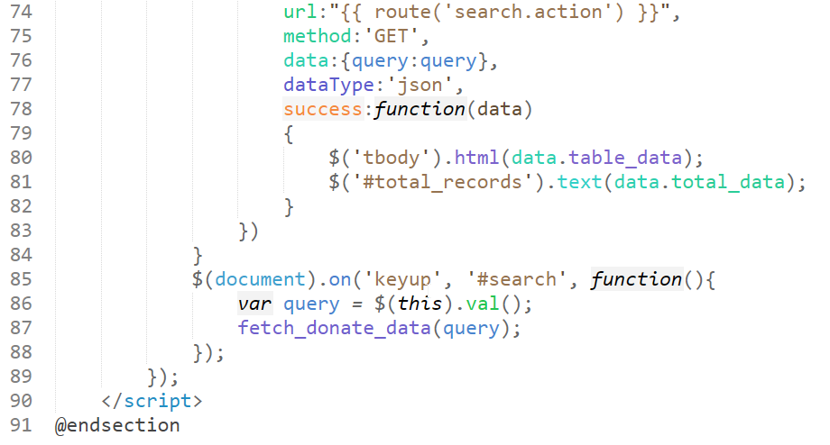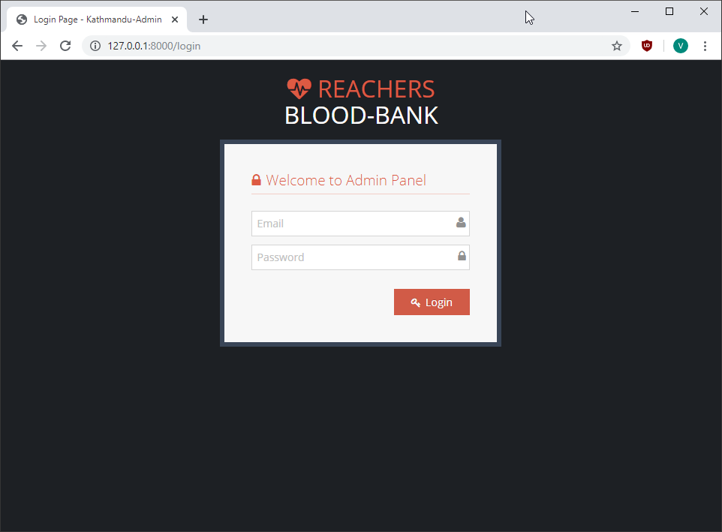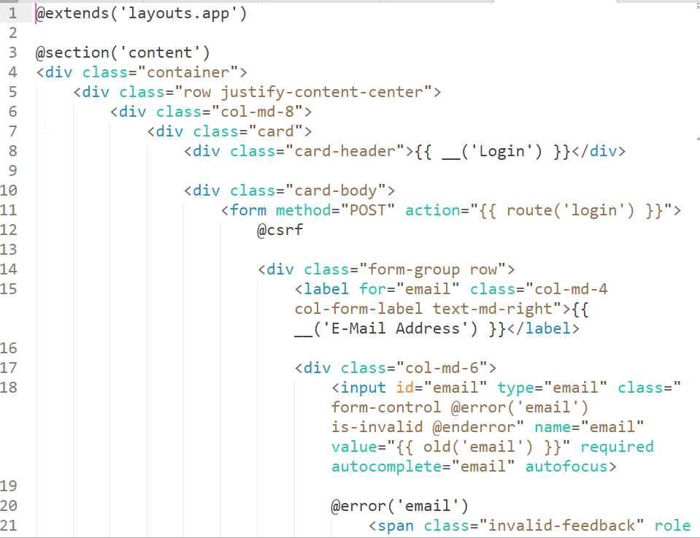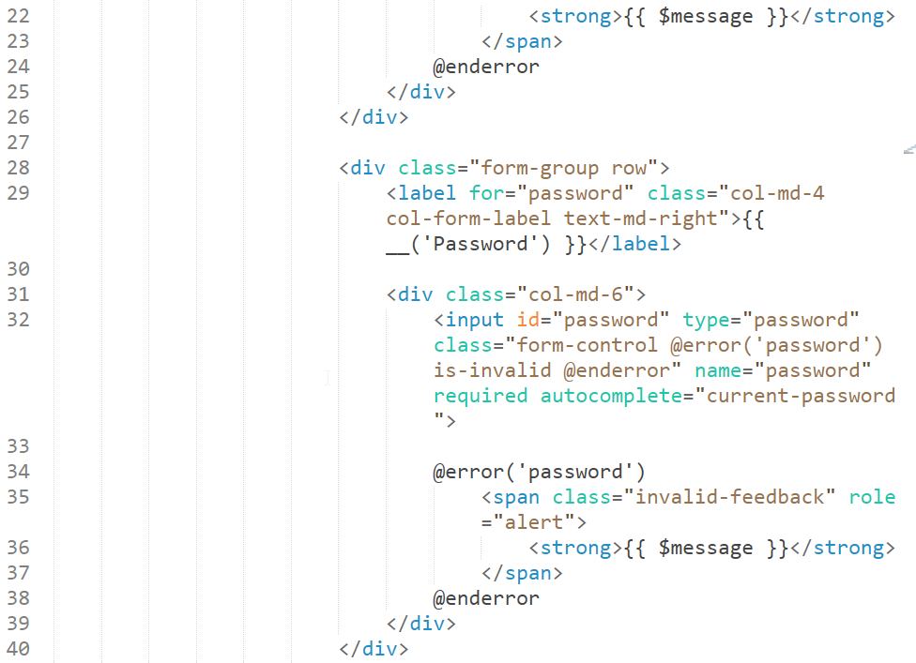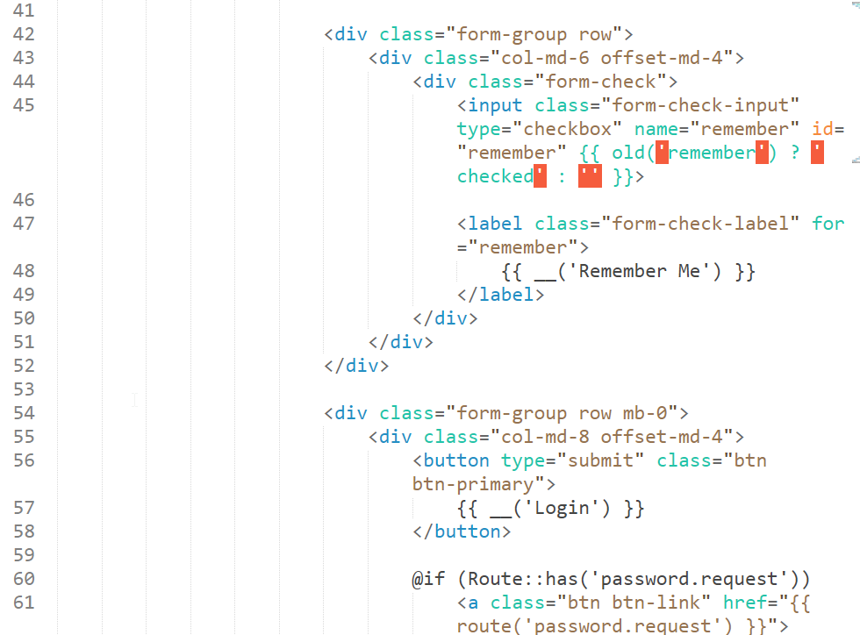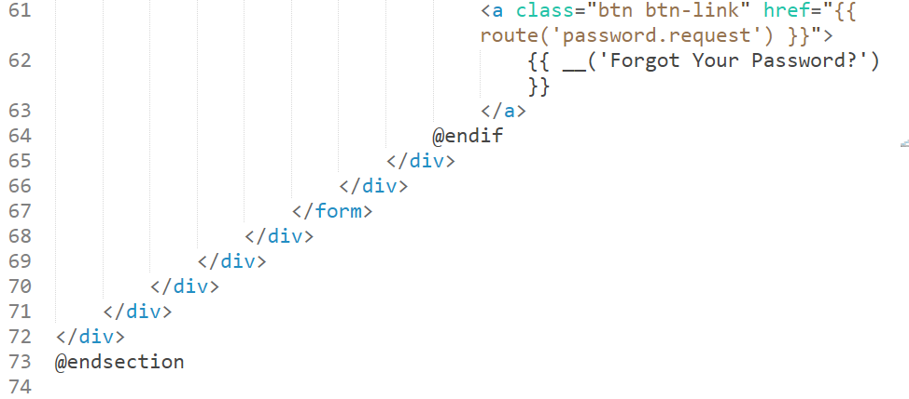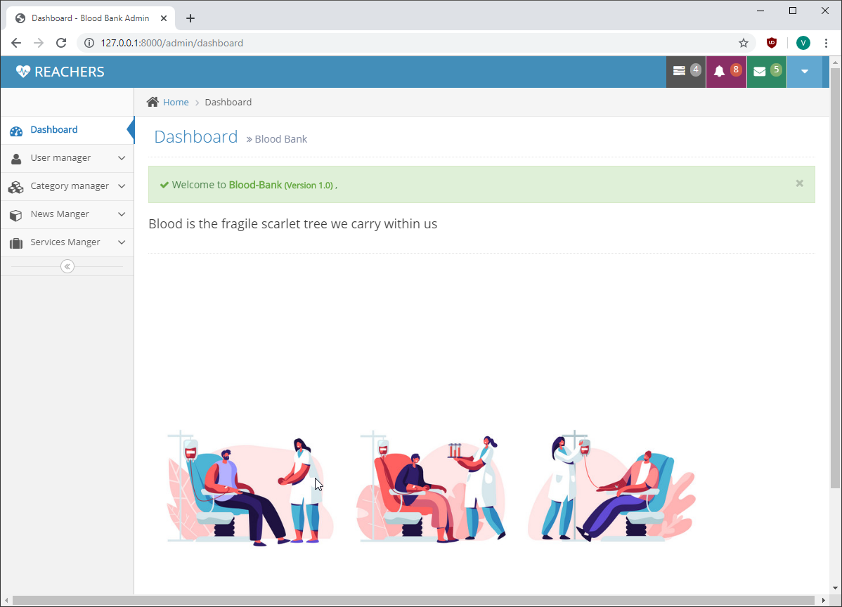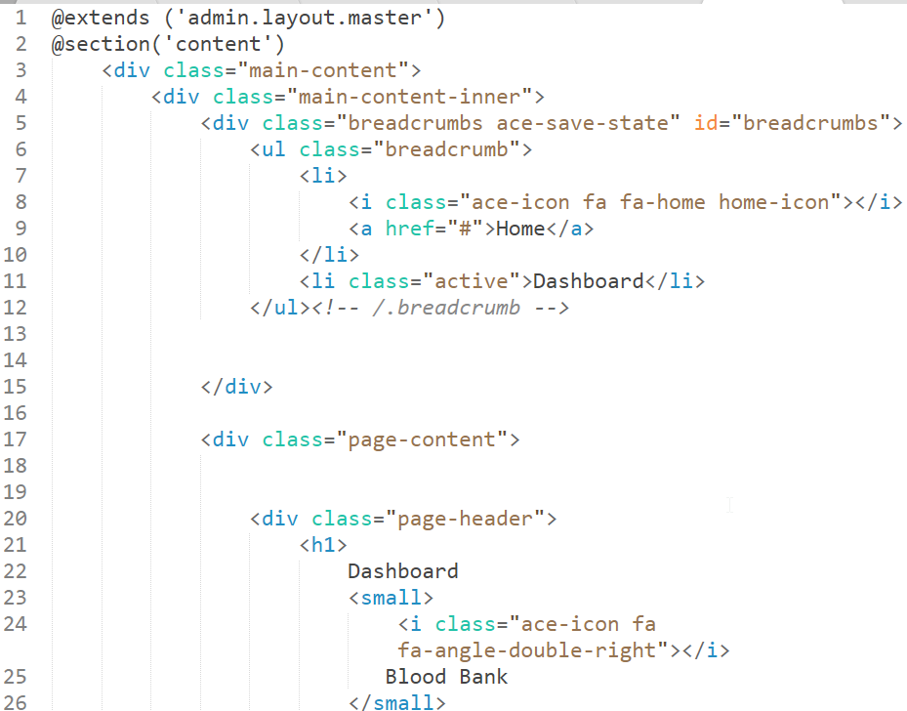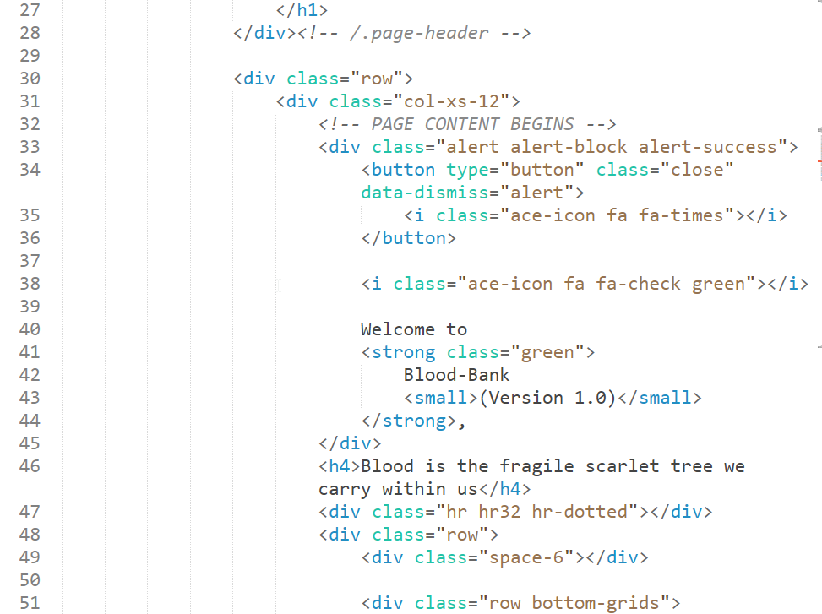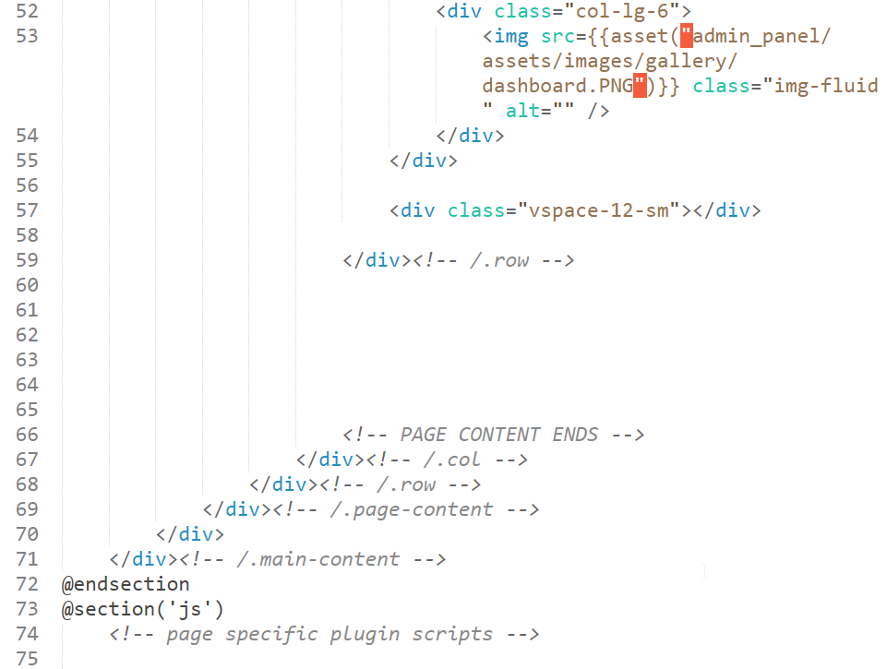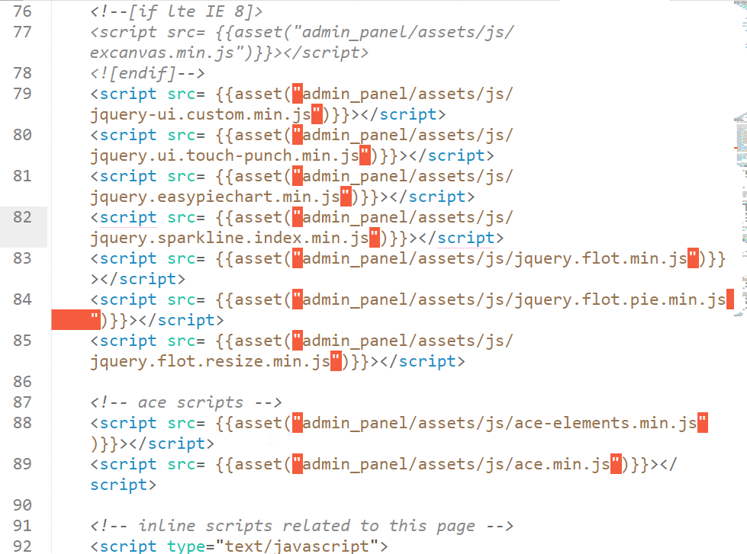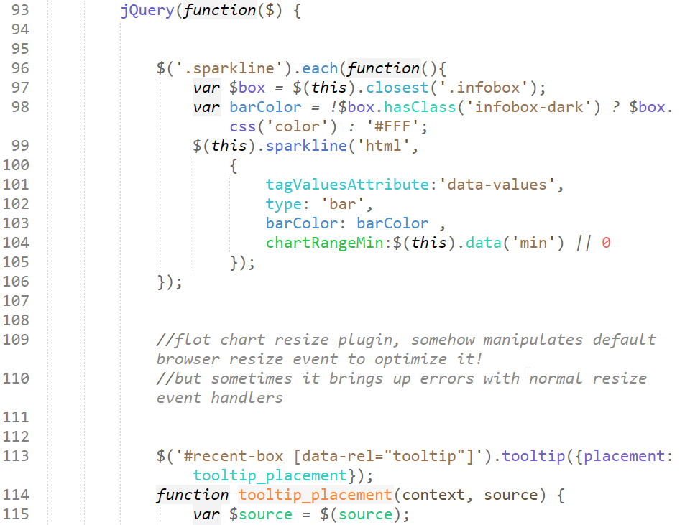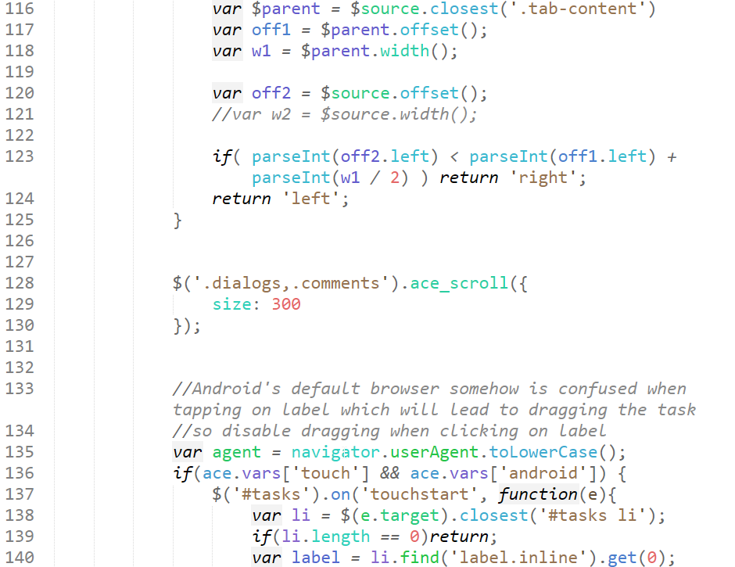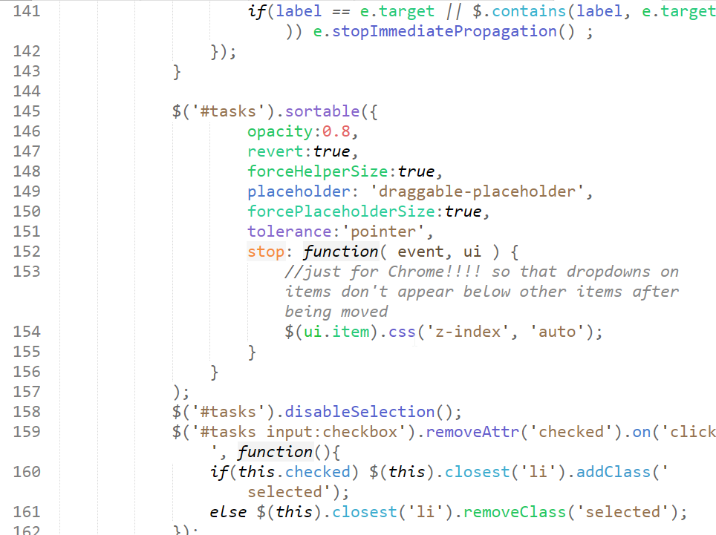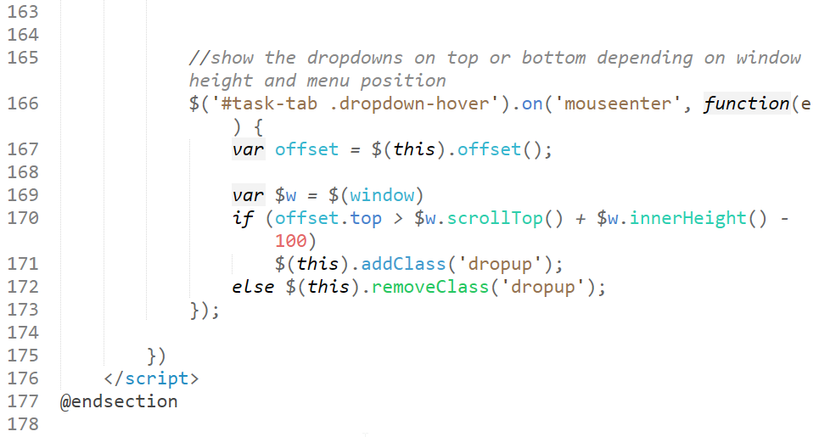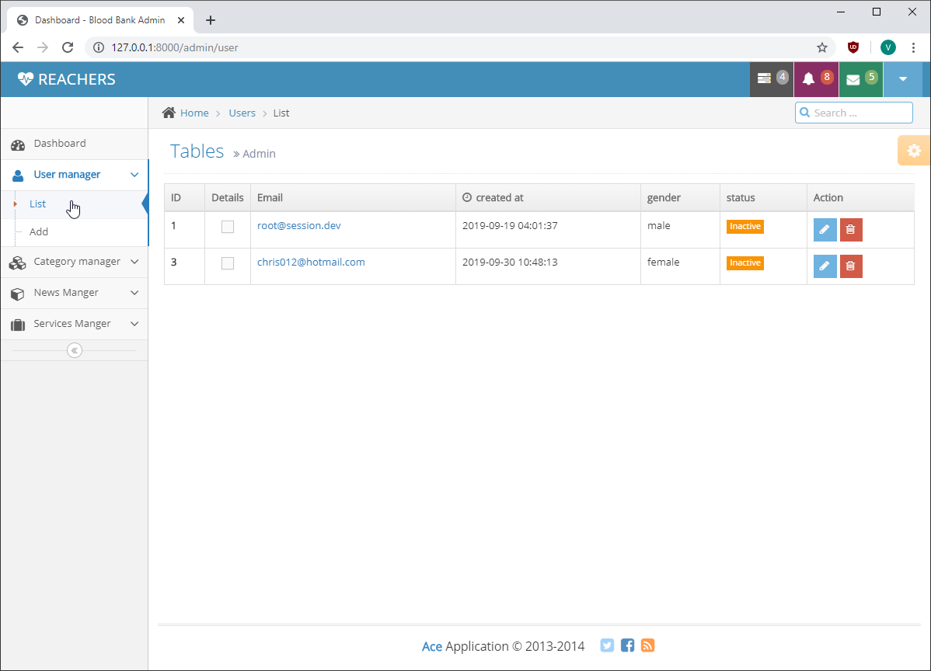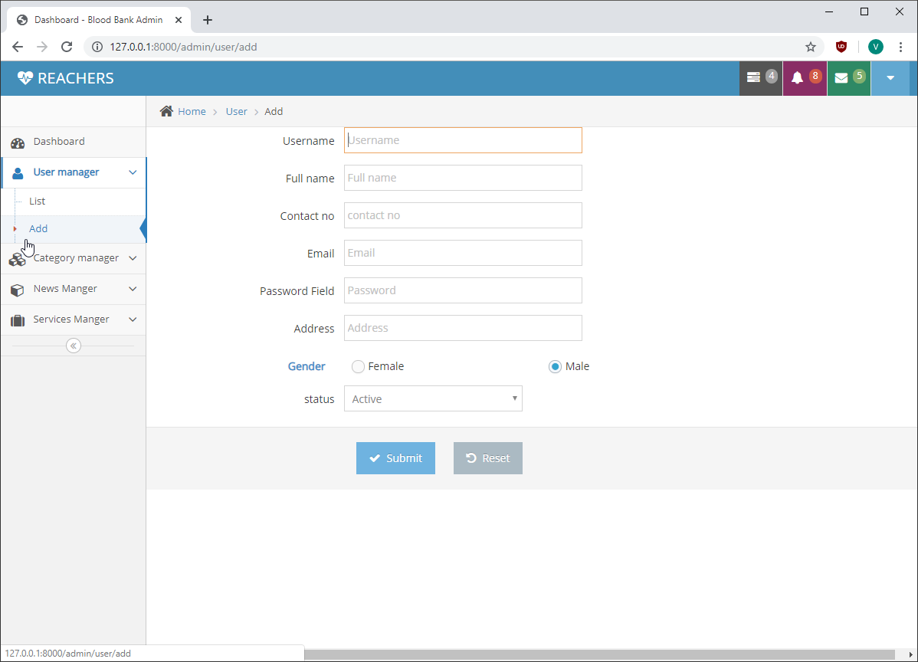

**Code for add user:**

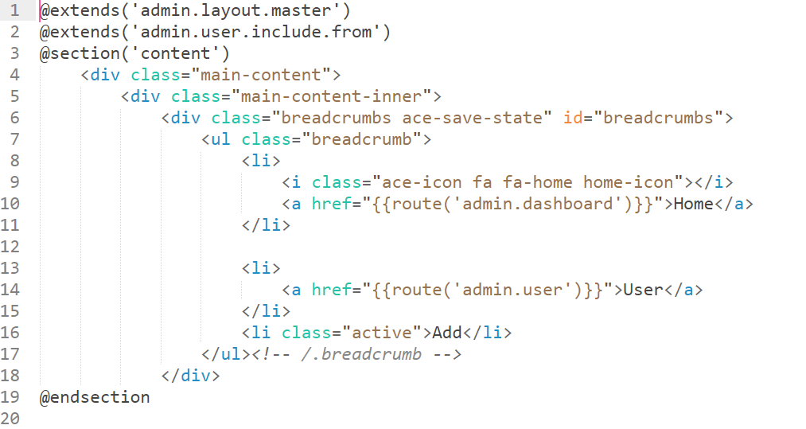

**Code for edit user information:**

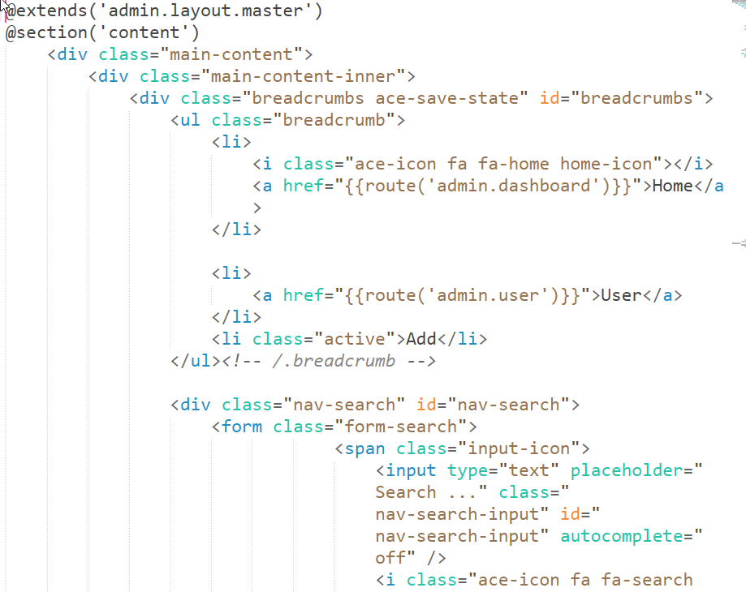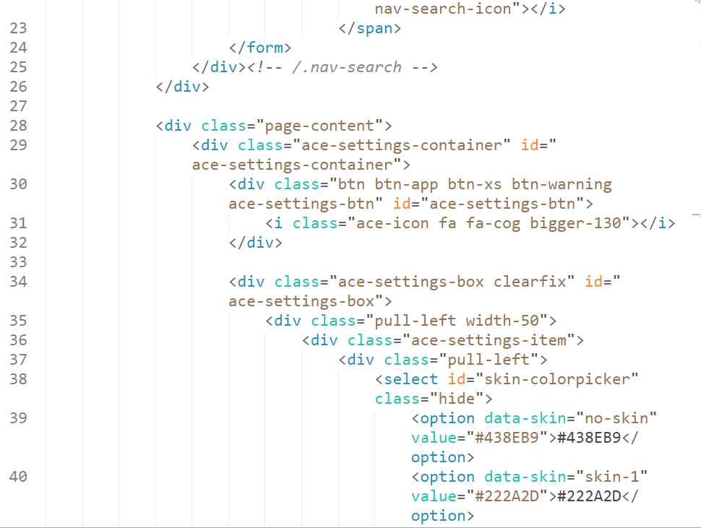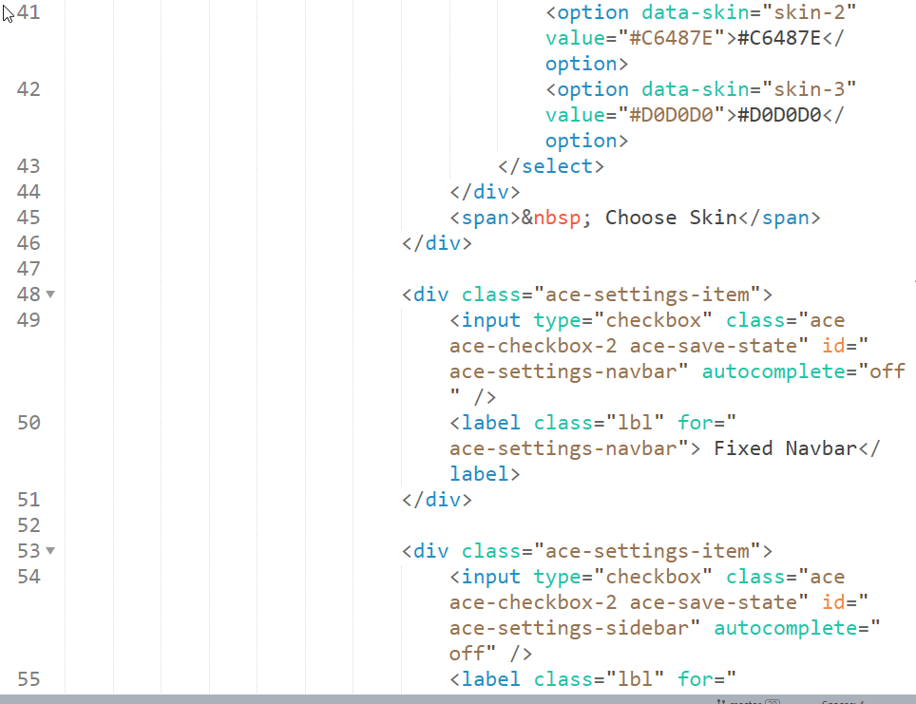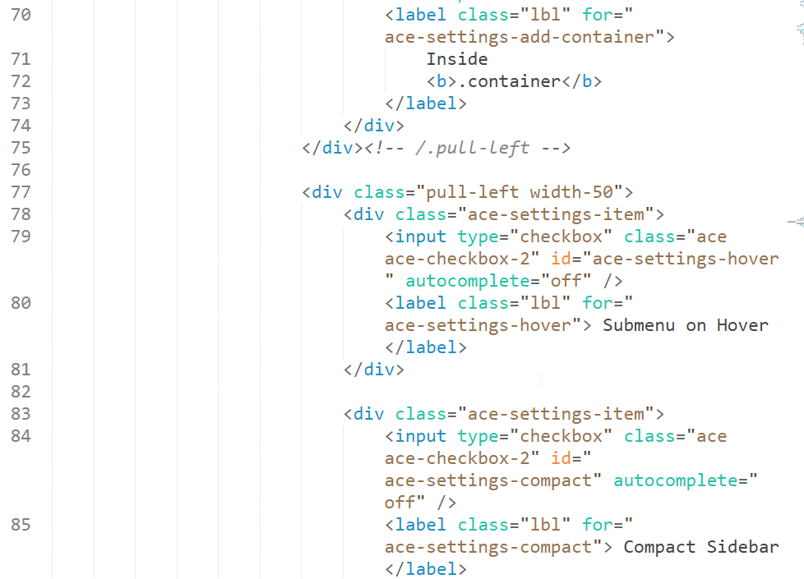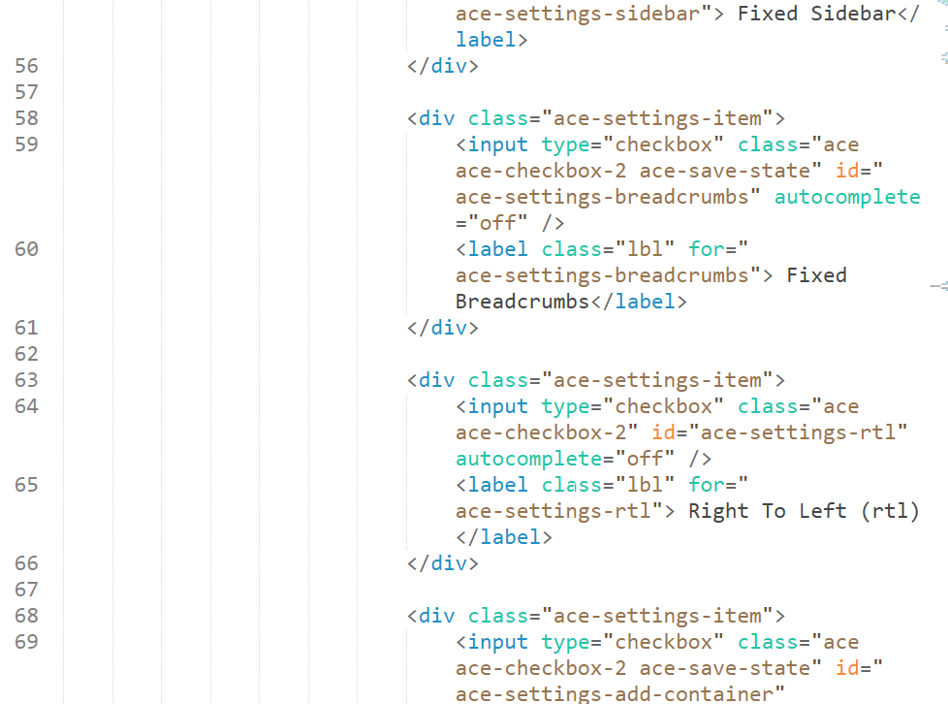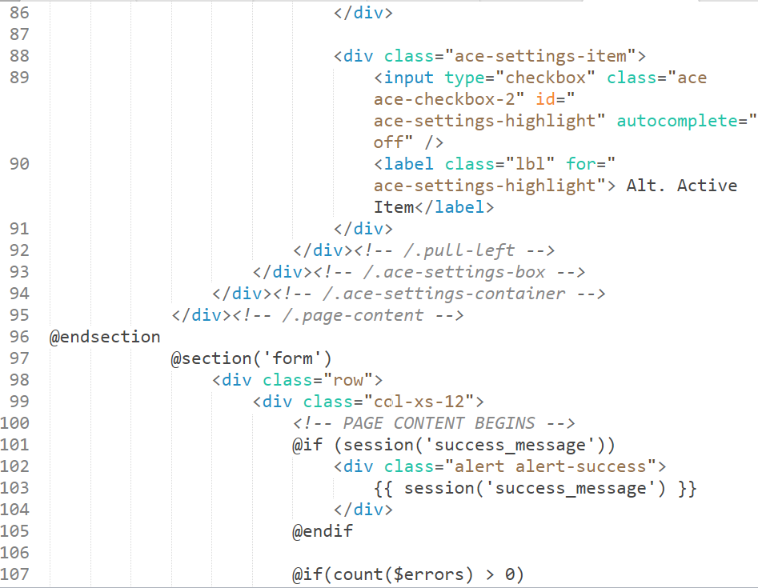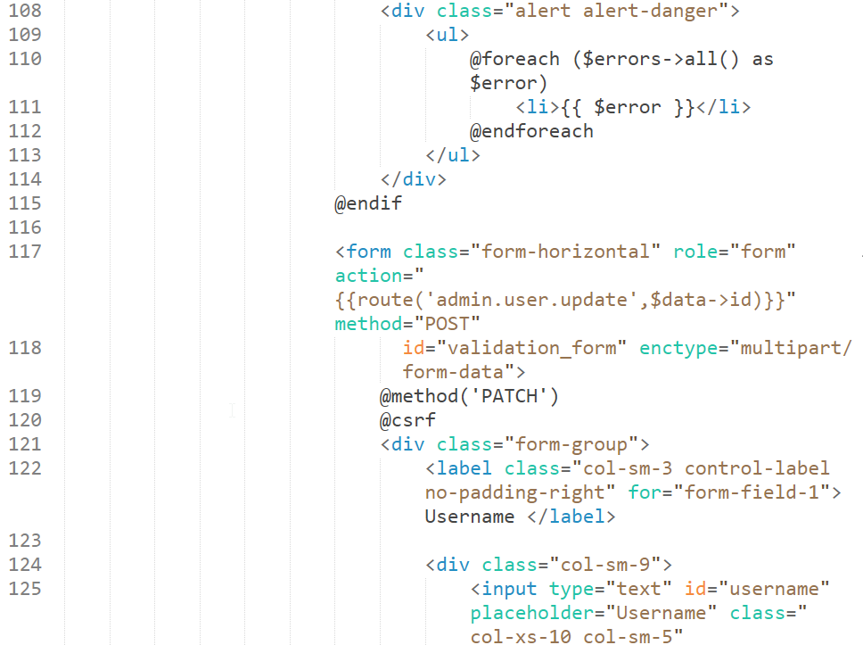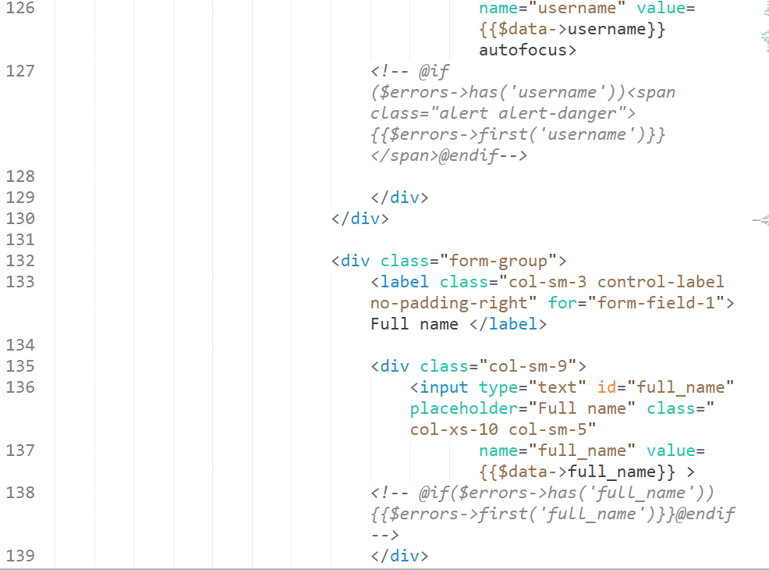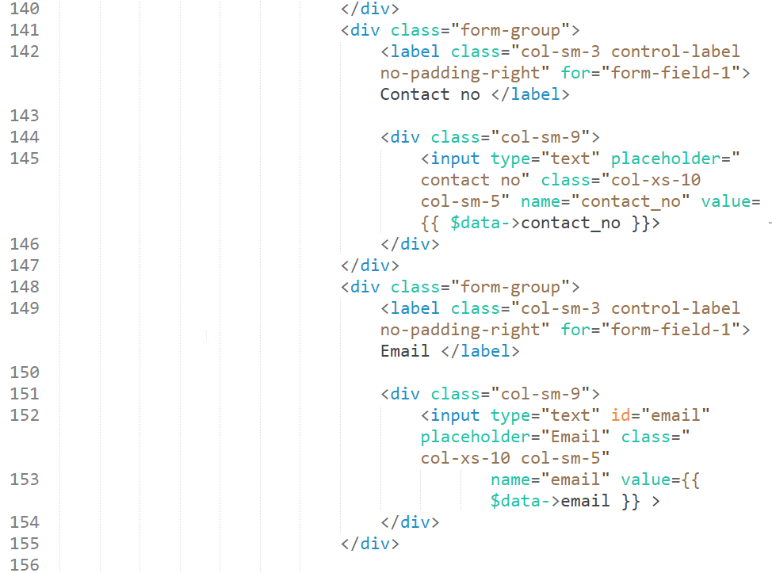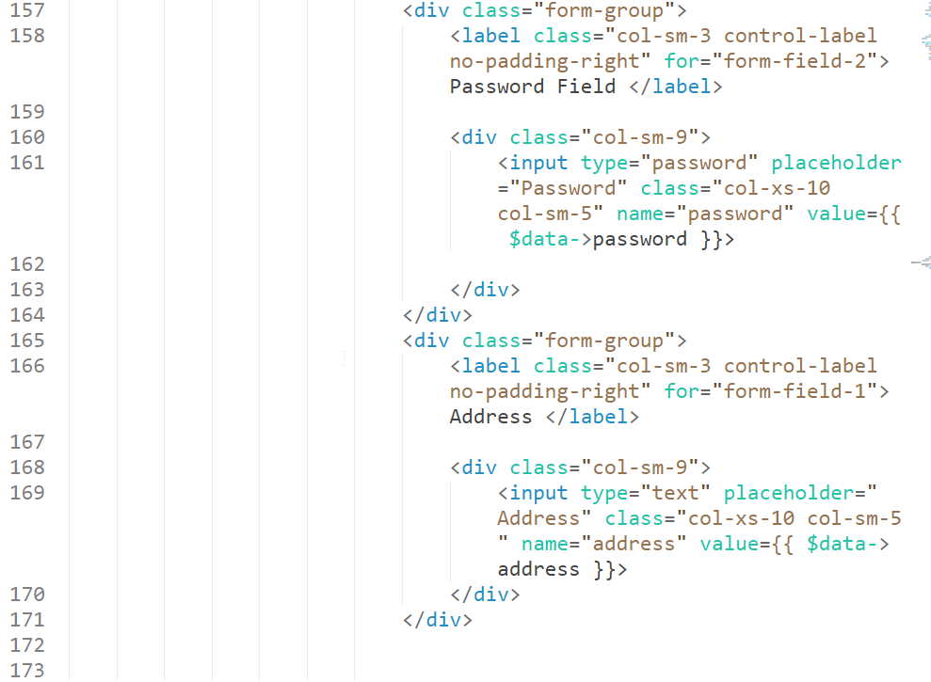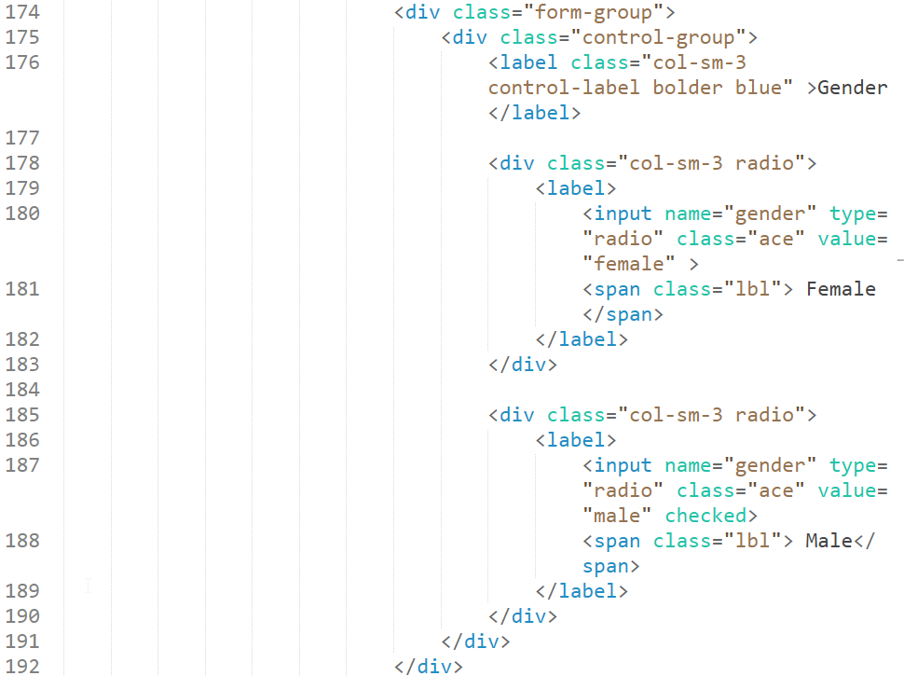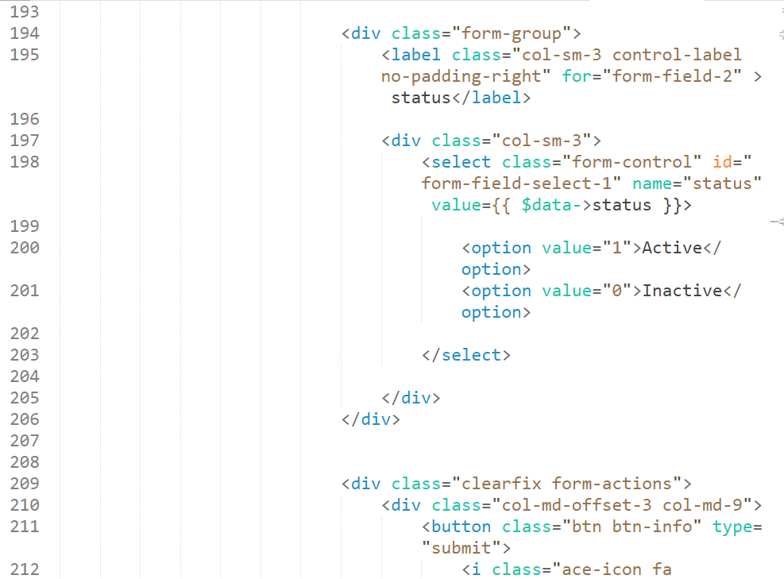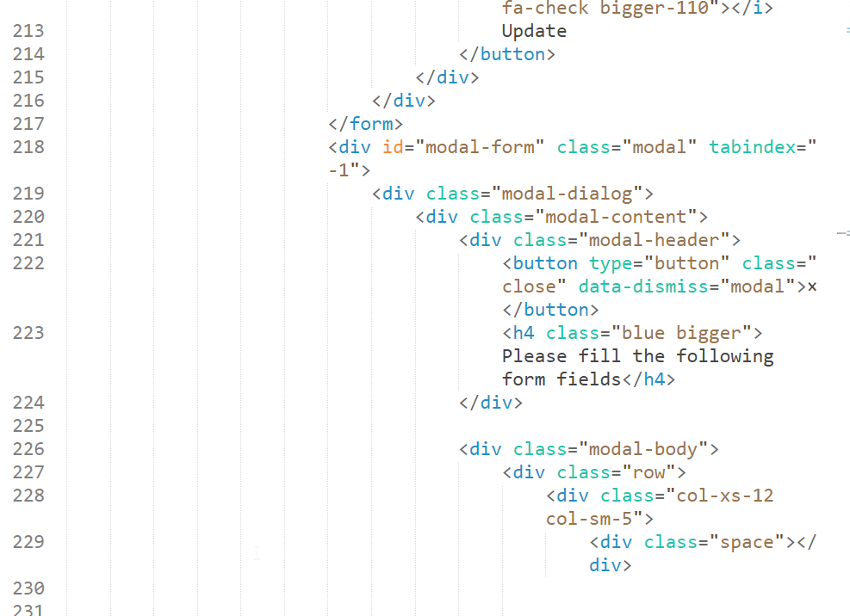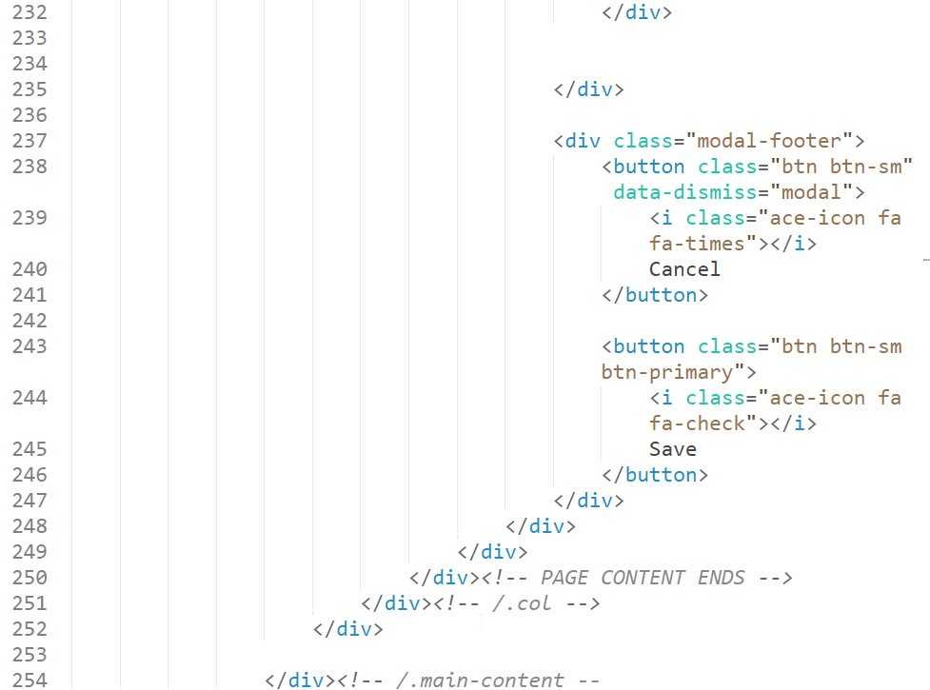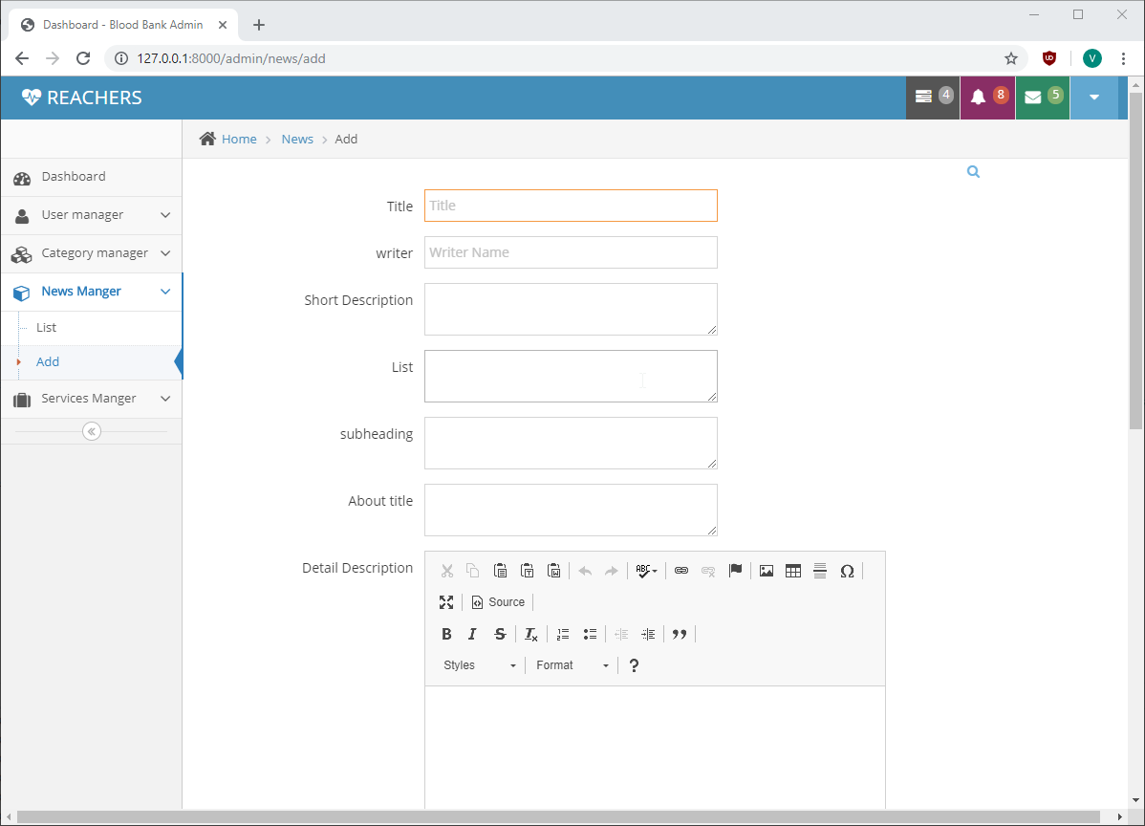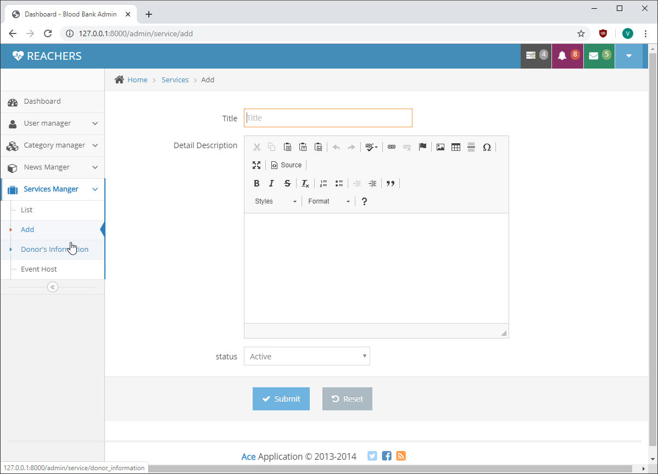

**Code for Add news from admin:**

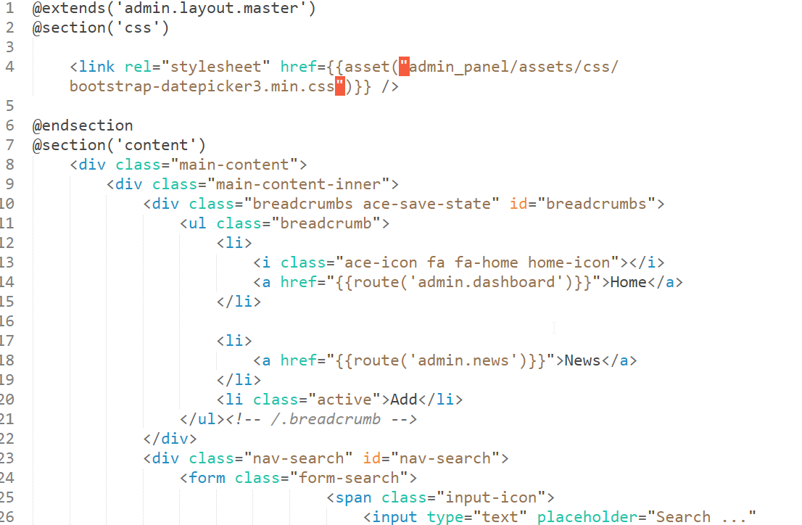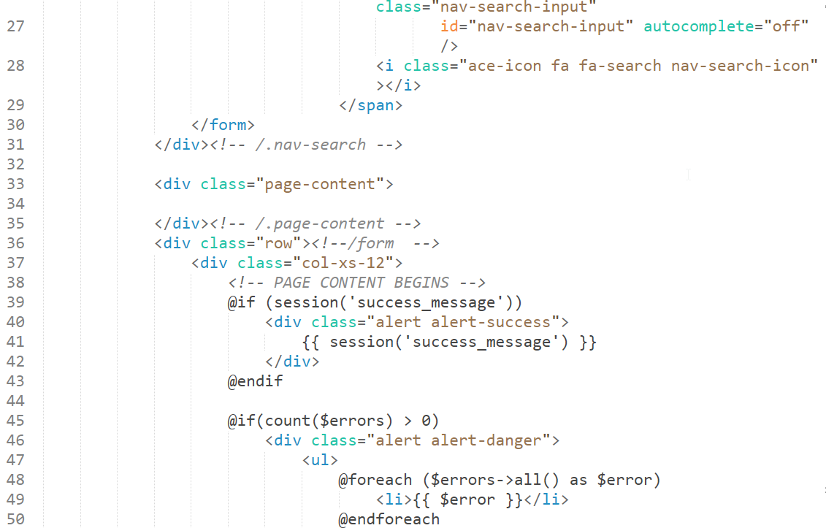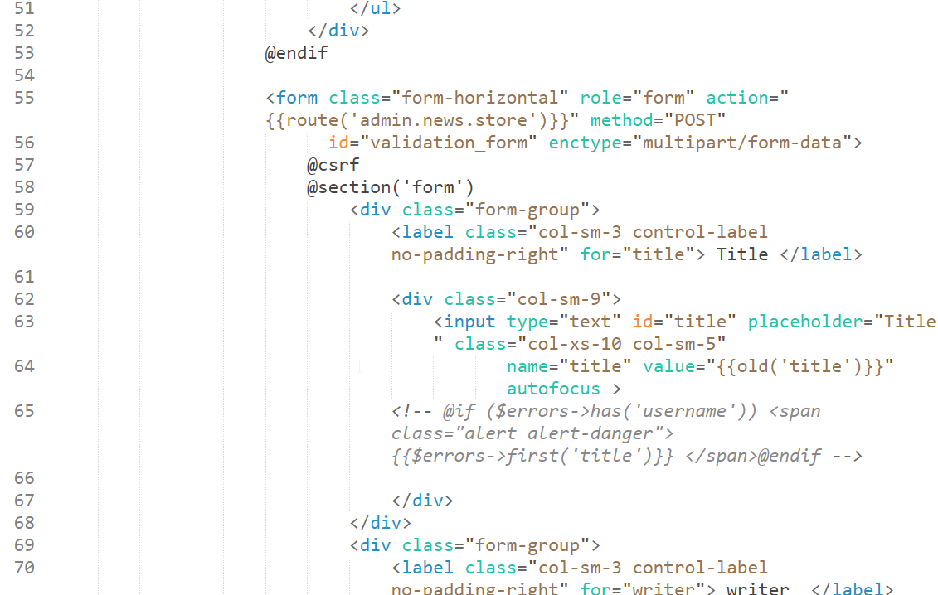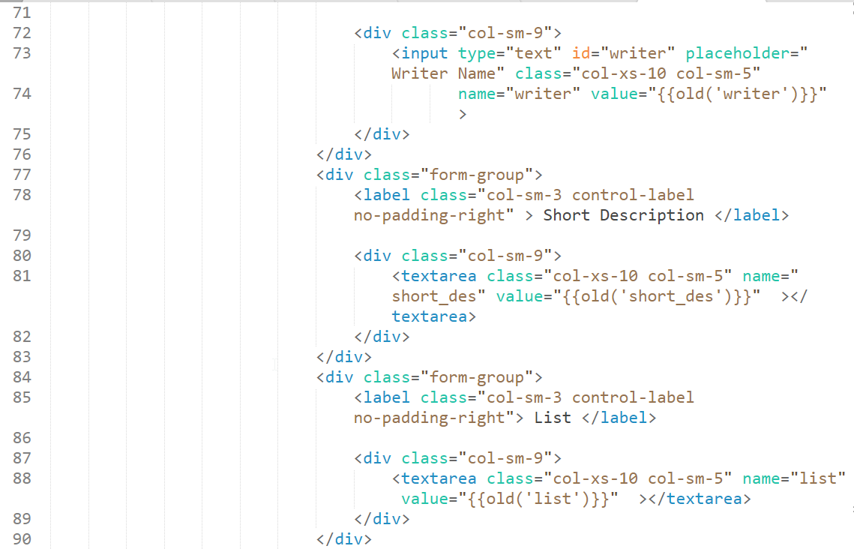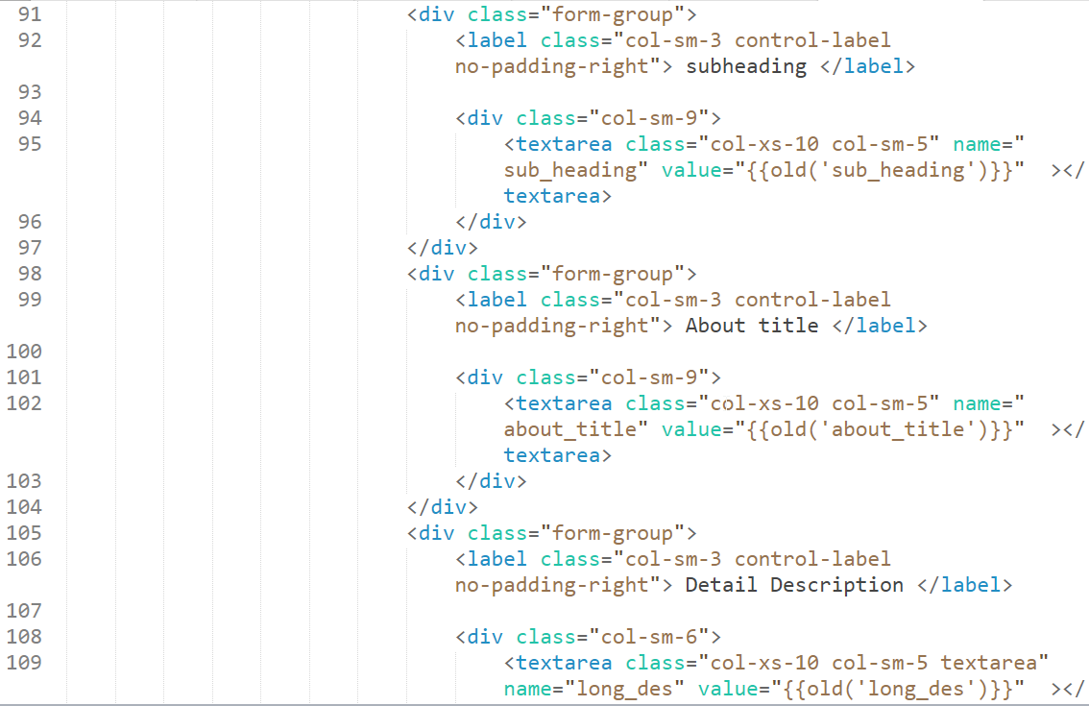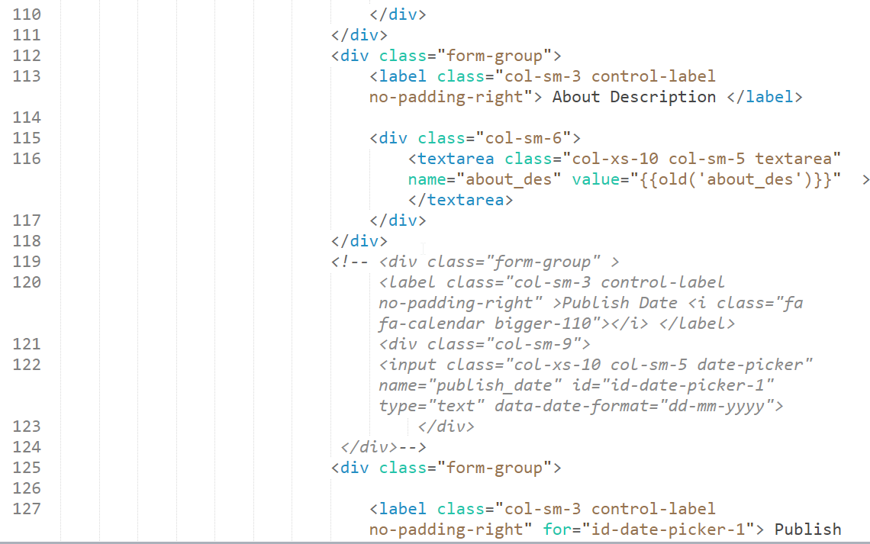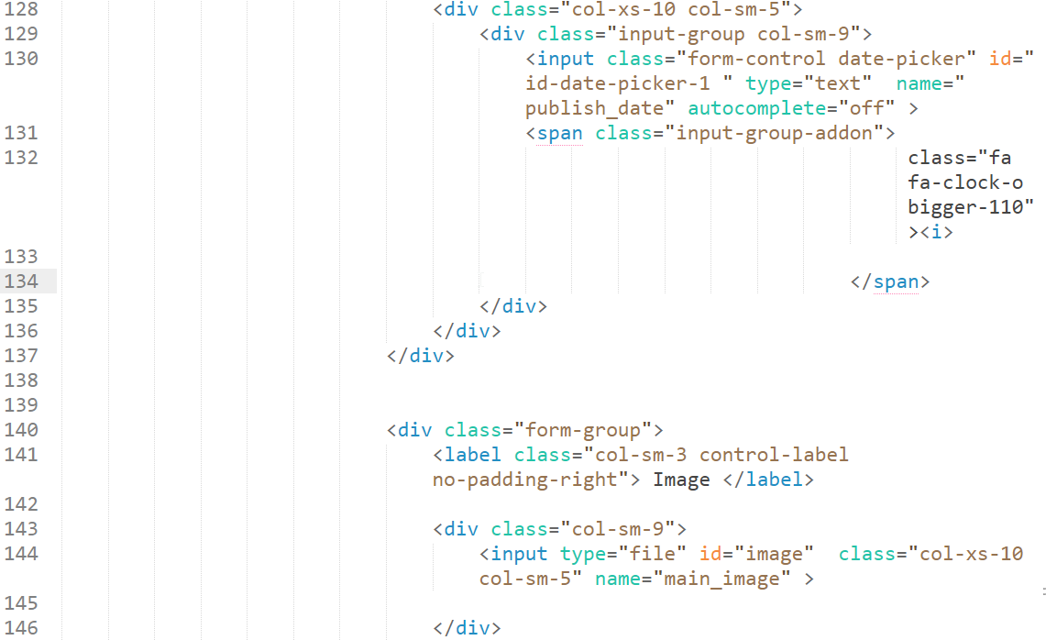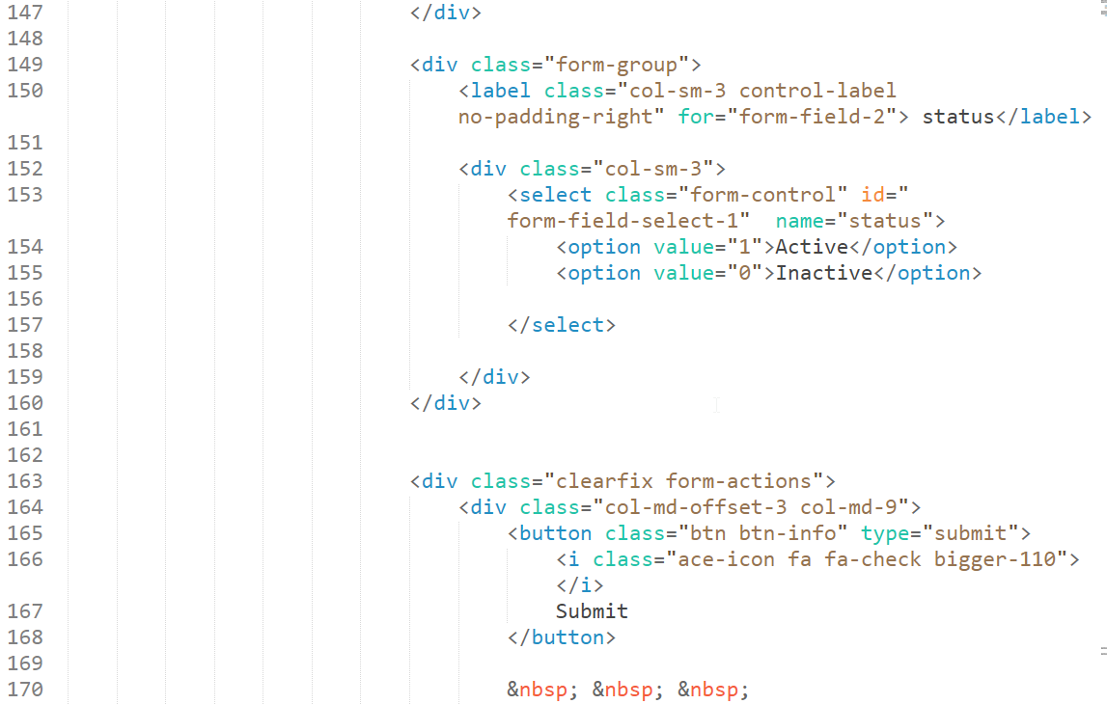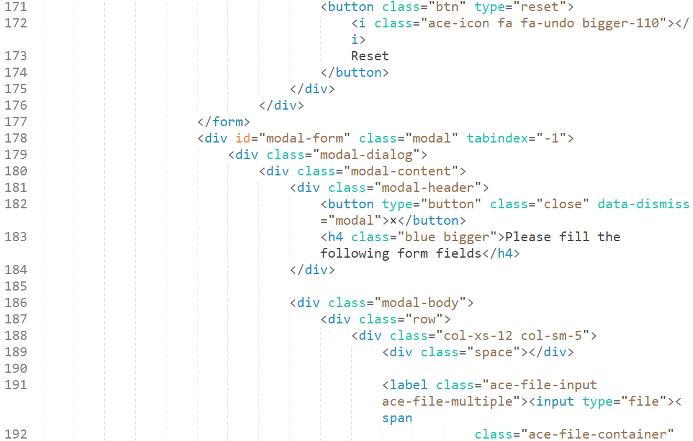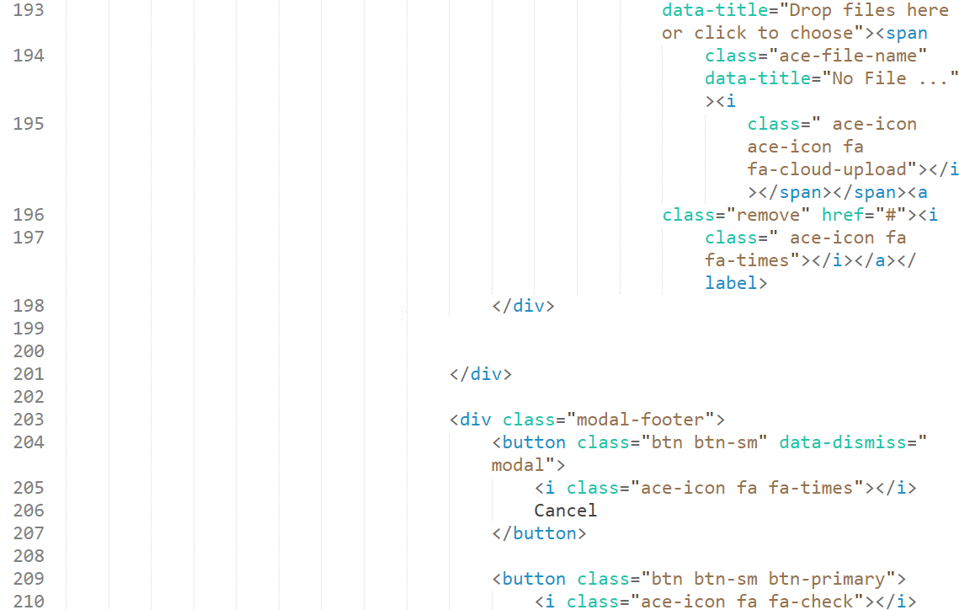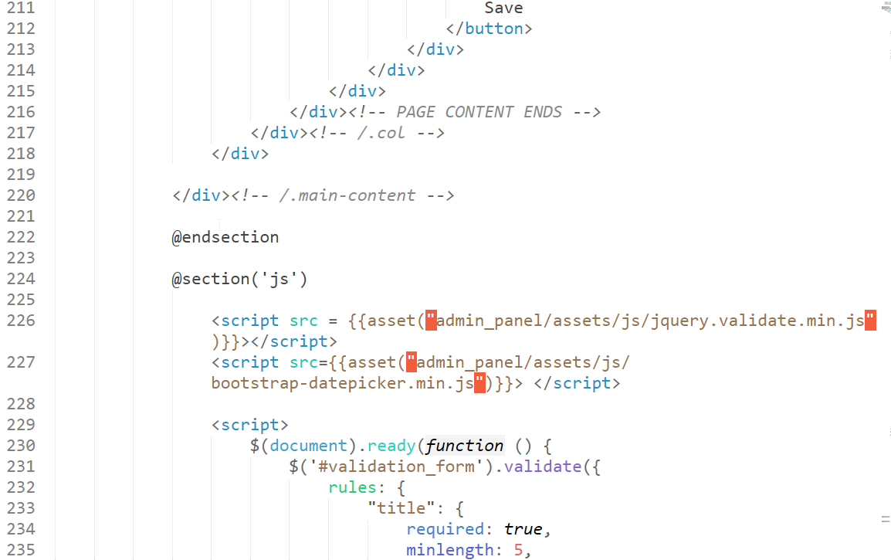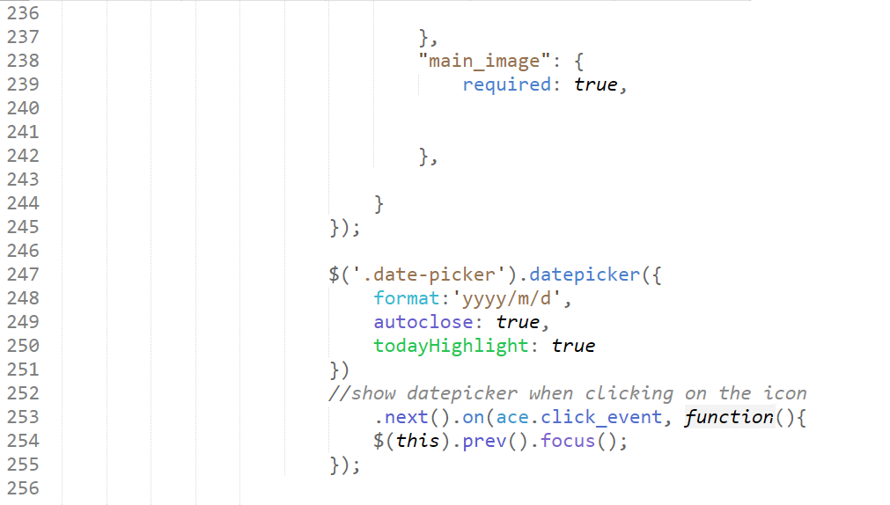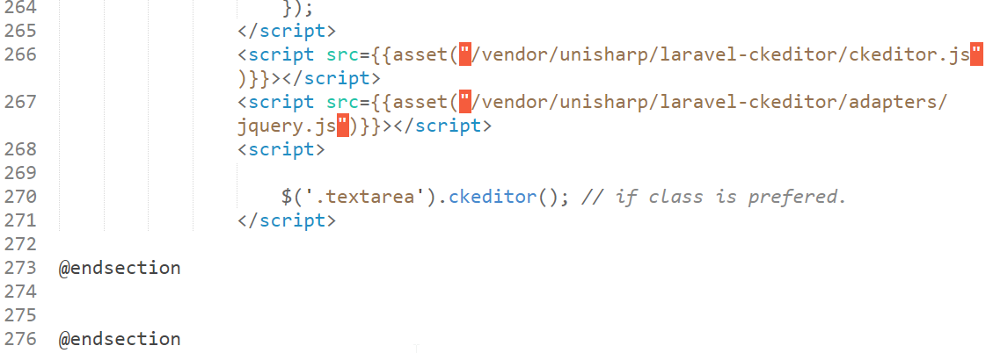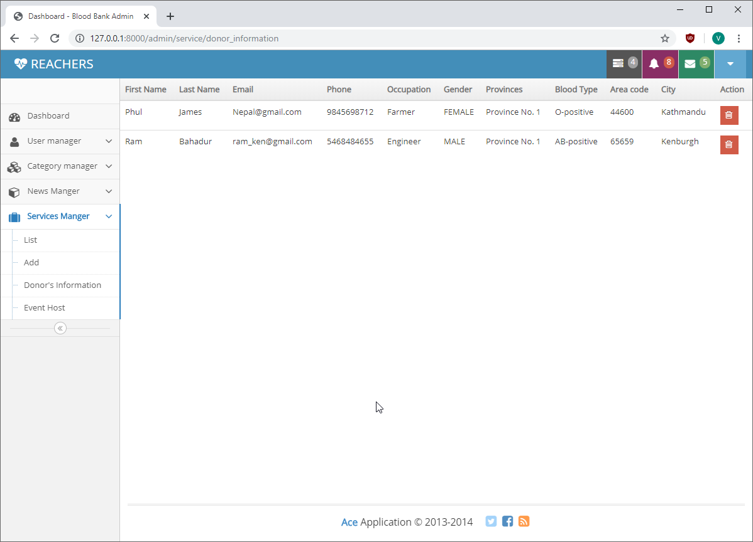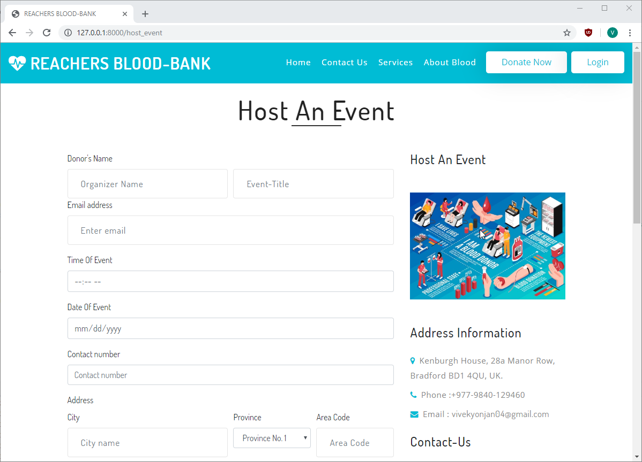

**Code for host event:**

